NPS Form 10-900 OMB No. 1024-0018

United States Department of the Interior
National Park Service

National Register of Historic Places DRAFT Registration Form
This form is for use in nominating or requesting determinations for individual properties and districts. See instructions in National Register Bulletin, How to Complete the National Register of Historic Places Registration Form. If any item does not apply to the property being documented, enter "N/A" for "not applicable." For functions, architectural classification, materials, and areas of significance, enter only categories and subcategories from the instructions. Place additional certification comments, entries, and narrative items on continuation sheets if needed (NPS Form 10-900a).

1. Name of Property

historic name Girard Historic District other names/site number name of related multiple property listing
Location
street & number
not for publication
city or town Girard
vicinity
state Pennsylvania code county Erie code zip code 16417

3. State/Federal Agency Certification

As the designated authority under the National Historic Preservation Act, as amended,
I hereby certify that this X nomination _ request for determination of eligibility meets the documentation standards for registering properties in the National Register of Historic Places and meets the procedural and professional requirements set forth in 36 CFR Part 60.
In my opinion, the property X_ meets _ does not meet the National Register Criteria. I recommend that this property be considered significant at the following level(s) of significance:
national statewide local

Signature of certifying official/Title Date

State or Federal agency/bureau or Tribal Government
In my opinion, the property meets does not meet the National Register criteria. Signature of commenting official Date

Title State or Federal agency/bureau or Tribal Government
4. National Park Service Certification
I hereby certify that this property is:

entered in the National Register determined eligible for the National Register

determined not eligible for the National Register removed from the National Register

other (explain:)

Signature of the Keeper Date of Action

1

- Classification

Ownership of Property
(Check as many boxes as apply.)
Category of Property
(Check only one box.)
Number of Resources within Property
(Do not include previously listed resources in the count.)

Contributing Noncontributing
x

x

private building(s) 35 2 buildings

public - Local public - State public - Federal
district 1 0 sites

site 1 1 structures

structure 0 0 objects

object 37 3 Total

Name of related multiple property listing
(Enter "N/A" if property is not part of a multiple property listing)
Number of contributing resources previously listed in the National Register

N/A 0

- Function or Use
Historic Functions
(Enter categories from instructions.)

COMMERCE/business, professional, specialty

Current Functions
(Enter categories from instructions.)

store, financial institution, restaurant COMMERCE/business, specialty store, restaurant

EDUCATION/library DOMESTIC/multiple dwelling

RELIGION/church RELIGION/church

- Description
Architectural Classification
(Enter categories from instructions.)

MID-19th CENTURY: Greek Revival, Gothic

Materials
(Enter categories from instructions.)

Revival foundation: Stone, concrete LATE VICTORIAN: Italianate, Romanesque walls: Brick, wood frame, synthetic Revival
LATE 19th/20th CENTURY REVIVAL: Classic roof: asphalt Revival, Colonial Revival, Neoclassical Revival other: MODERN MOVEMENT: International Style

Narrative Description

(Describe the historic and current physical appearance of the property. Explain contributing and noncontributing resources if necessary. Begin with a summary paragraph that briefly describes the general characteristics of the property, such as its location, setting, size, and significant features.)

Physical Description Summary Paragraph

The Girard Historic District is a historic commercial corridor stretching between Penn Avenue and the railroad tracks along Route 20 in the Borough of Girard, Erie County, PA. The district contains many historic nineteenth and early-mid-twentieth century commercial buildings with some religious properties and is anchored at the east, north, and south ends by residential areas and at the west end by the railroad tracks which
provide clear visual enclosures to the nominated area. The majority of buildings exemplify interpretations of the range of architectural styles that were popular from the nineteenth to the mid-twentieth century, being built between 1825 to 1955. Route 20, running east-west, forms the spine of this linear district and was historically a street where many of Girard’s leading business owners constructed commercial buildings. The historic pattern of development along this section of Route 20 remains visible in the historic fabric of the district, with buildings and streetscape characteristics illustrating the transition from a rural road to a commercial core. The district includes thirty-five contributing buildings, one site and one structure. The buildings were constructed in stages between 1825 and 1955. None of the buildings in the district have been previously listed in the National Register.

Narrative Physical Description

Topography

The Township of Girard is located within a portion of the Great Lakes Basin which extends in a relatively narrow corridor along the shore of Lake Erie. The topography of the area is characterized by a substantial level area known as the lake plain. The Borough of Girard occupies the second rise above the lake shore plain. In the district, Route 20 runs east from Penn Avenue towards the railroad tracks and includes a small portion of the east side of Olin Avenue. The elevation rises to the west and crests at the railroad tracks where it starts to slope down further west. Olin Avenue is relatively flat. The surrounding neighborhood is residential and consists largely of medium to large scale residences constructed in the late nineteenth and early twentieth century.

Street Plan

The street plan for the Girard Historic District has its origins in one of the earliest routes through this area along Lake Erie. Route 20 originated as the Ridge Road. Opened in 1805, the Ridge Road was largely an extension of the Buffalo Road. It followed the line of the First Ridge and traversed the western part of Mill Creek and the entire width of Fairview, Girard, and Springfield townships to the Ohio state line.^{i} Before it was paved, the road passed over a hard, gravelly bed, making it the best road in the county, seldom becoming muddy in winter or dusty in summer.^{ii}

i The History of Erie County, (Chicago: Warner, Beers & Co.), 1884, 234.
^{ii} The History of Erie County, 1884, 234.

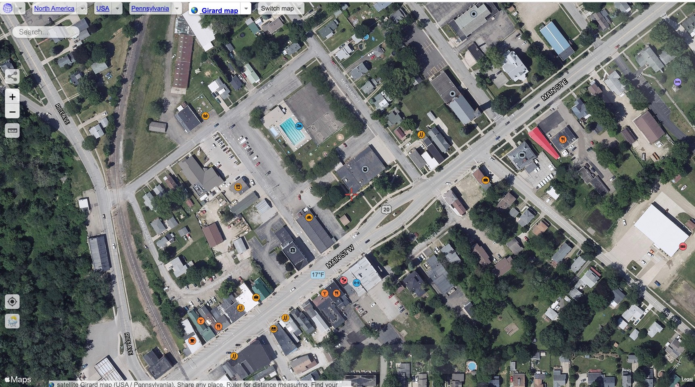

Figure 1: Current Aerial View^{iii}

Building Types

The majority of properties in the Girard Historic District are commercial. The commercial core developed as the heart of downtown Girard with mostly commercial buildings constructed during the apex of the transportation and commercial prosperity of the district (1825-1955). The commercial resources are predominantly one-to- three-stories in height, are of masonry and frame construction, and consist of a variety of commercial building types such as a tavern, pharmacy, restaurants, and novelty stores. There are two churches in the district, St.
John the Evangelist Church (1945) on Olin Avenue, and the First Methodist Church (1868) on the northwest corner of Olin Avenue and Main Street. There is one post office (1941) located at the southeast corner of Walnut Avenue.

^{iii} “Satellite Girard Map // USA, Pennsylvania,” accessed January 11, 2022, https://satellites.pro/Girard_map.Pennsylvania_region.USA#42.000920,-80.317649,18.

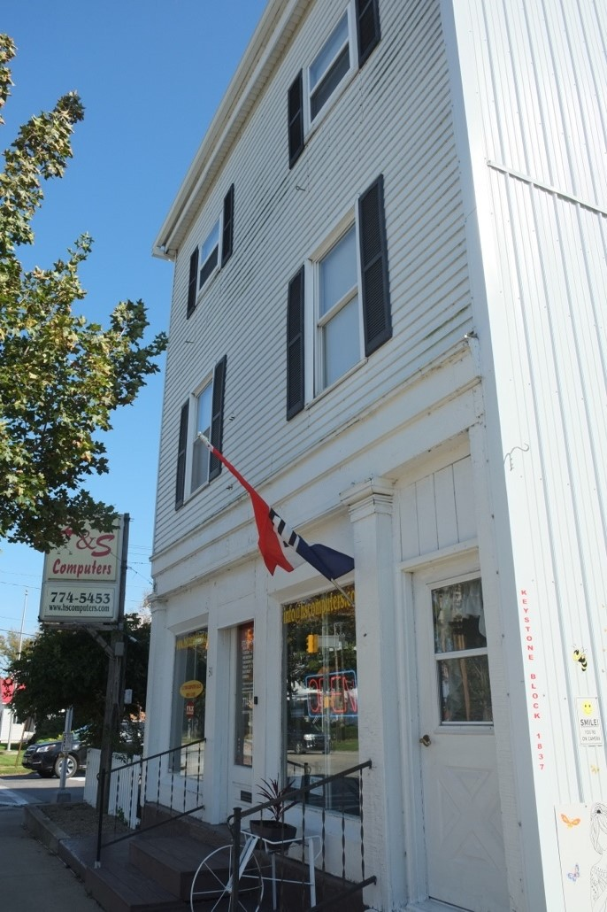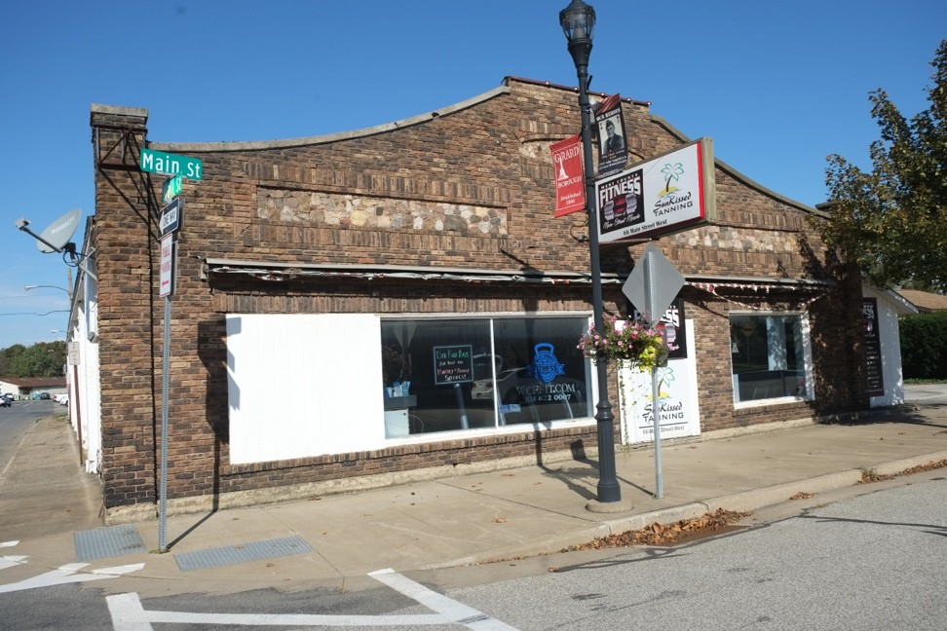

Photo 1 (left): Frame building, Keystone Block, 31 Main Street East, ca. 1832, view southeast
Photo 2 (right): Masonry building, Lutz Garage, 66 Main Street West, ca. 1928, view northeast

Spatial Organization and Streetscapes

Streetscapes in the district are characterized by rectilinear lots that are deeper than they are wide, sidewalks that run parallel to the street, and relative consistency in setback, orientation, and massing of buildings. Route 20 runs at an angle to the street grid and the most common lot size in the district is approximately 30 x 125 feet (Figure 2). Overall, the variety of lots in the Girard Historic District reflects its development and evolution over time. All buildings are located parallel to the street and set back approximately ten feet. Additionally, the majority of buildings on Route 20 in the district are built out to a straight concrete sidewalk parallel to the street. Some of the buildings, particularly on the easternmost section of the district, feature a narrow apron between the sidewalk and the curb with grass and occasional trees that vary in size and species.

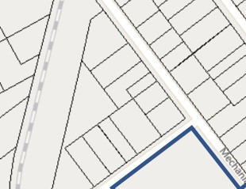

Figure 2: GIS lot map with district boundary highlighted.

Architecture: General Characteristics

Buildings in the Girard Historic District vary in architectural character, displaying a diversity in style and materials; this variety reflects the long period in which the commercial corridor developed, during which architectural fashions and building techniques changed considerably. The most consistent architectural feature is height, with most buildings being one-to-three- stories tall. Most display regular fenestration, are vertically oriented, and are generally in continuous rows along both sides of Route 20. Most buildings have storefronts with large display windows and recessed entrances. Aside from a few mid-century buildings, the character of the built environment is relatively similar. It contains a mix of buildings from before the Civil War, after the Civil War, and in the early-twentieth century as the population of Girard continued to grow. The eastern section of Main Street contains the oldest buildings, such as 172 Main Street East (extant, ca. 1825, Photo 8), 31 Main Street East (extant, ca. 1832, Photo 1), 18 Main Street East (extant, ca. 1855, Photo 3), and 138-140 Main Street West (extant, ca. 1855, Photo 4). Buildings at the easternmost section of the boundary as well as those toward the middle and western end of the district remain largely true to original nineteenth and early-mid-twentieth- century design (except for storefronts that have been modernized both during the period of significance and in contemporary times).

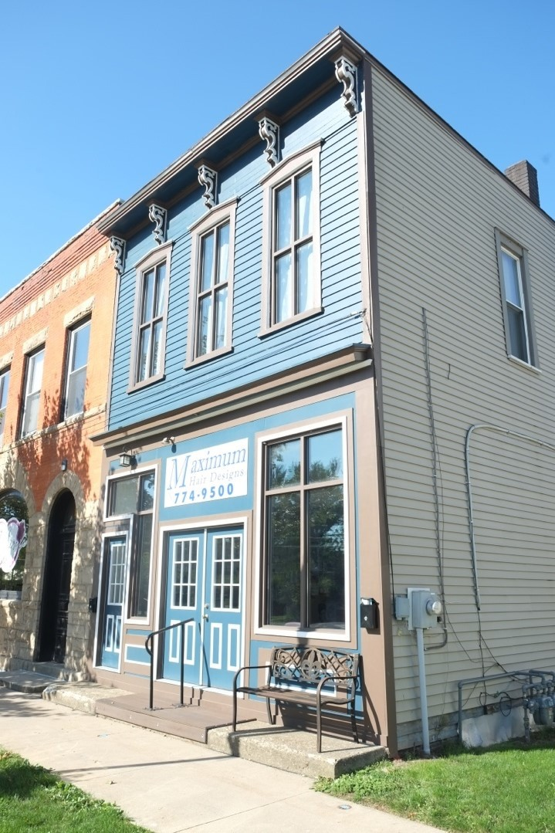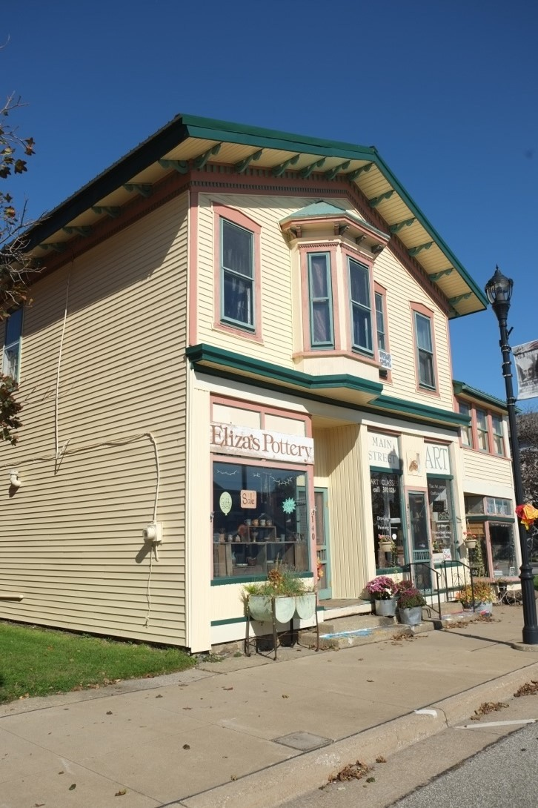

Photo 3 (left): 18 Main Street East, Josiah Nece Cabinet Shop, ca. 1855, view northwest
Photo 4 (right): 138-140 Main Street West, J. T. Simmons Saddlery Shop/Eugene H. Hiler, Jeweler, ca. 1855, view northeast

Buildings in the district reflect a range of popular architectural styles from the early-nineteenth century Georgian to the Modern Movement. Other popular styles in the district from the nineteenth to early twentieth century include Greek Revival, Gothic Revival, Italianate, Romanesque Revival, and Classical Revival as well as some examples of mid-twentieth century Modern architecture.

While the overall integrity of the district is high, most buildings reflect some level of alteration and change. The majority of buildings present during the period of significance (1825-1955) are still extant and recognizable.
Common alterations include style updates for some of the district’s oldest buildings, modernized storefronts, and window replacement either in original openings or in openings altered to accommodate standard replacement units. An example of an older building with style updates is 138-140 Main Street West (extant, Photo 4) which displays characteristics of both the Greek Revival and later Italianate styles. Examples of late nineteenth century buildings featuring storefronts that illustrate the historic evolution of these buildings can be seen at 77-83 Main Street West (extant, Photo 6) and 229 Main Street West. Both buildings feature storefronts with glass block transoms, popular and affordable commercial updates in the 1930s and 1940s.^{iv}

^{iv} Gabrielle Esperdy, Modernizing Main Street: Architecture and Consumer Culture in the New Deal, (University of Chicago Press: Chicago), 2008, 3.

Integrity and Contributing/Non-Contributing Criteria
The following criteria were used to evaluate the contributing/non-contributing status of buildings in the district.
- Date: the building must have been present during the period of significance (1825-1955). Buildings constructed after the end of the period of significance are non-contributing.

- Location: the building must be in its original location or must have been moved to its present site during the period of significance.
In addition, the building must retain enough integrity of design, workmanship, materials, and feeling to convey its historic appearance and significance in the context of the district according to the following:

Form:
- The original form of a building must be legible. Alterations to a building that do not obscure its historic form and footprint are acceptable and considered contributing. Additions that significantly change or obscure the historic form are noncontributing with one exception: commercial buildings sometimes display a hybrid character – as in a residence converted to a store. If these changes have taken place during the period of significance, they are considered to contribute to the district under the theme of commerce.
Exterior cladding:
- Contributing commercial buildings should retain a predominance of materials that date from the period of significance, including both original and/or historic materials from upgrades up until 1955. Given the pressure on commercial owners to continually upgrade their buildings, more contemporary materials (such as windows, see below) may have been added subsequently. The building will remain contributing as long as these later materials do not significantly obliterate design.
Fenestration:
- Replacement windows in the same openings do not make a building non-contributing as long as the trim and the size of the windows have been maintained. Replacement windows in altered openings may be acceptable if the original opening remains readable and can be restored. Replacement windows outside the period of significance that completely change the fenestration by removing all trim and/or changing window shape render buildings non-contributing. An isolated window (or windows) may be ignored if the building meets other integrity measures.
Storefronts:
- Alteration of storefronts is a common and expected change made to most commercial buildings, as owners sought to attract new generations of shoppers and as businesses changed. Loss of original design and materials on the first floor does not make a building non-contributing if the upper floors retain integrity.
Streetscape:
- The building continues to contribute to the continuity of the streetscape.

- Integrity of Design: Changes during the period of significance that reflect original or long-term functions are acceptable if the changes themselves retain integrity. Buildings with two primary elevations, one which retains full integrity and one which does not, will be considered contributing. Additionally, buildings must retain their original scale. Changes in scale that reflect new uses may be considered contributing based on an assessment of other elements of integrity.

- Buildings that are categorized as non-contributing may be re-evaluated if materials that obscure original form, scale, design, materials, and workmanship are removed, and original or historic elements are rediscovered. This guideline acknowledges that blocked windows may be unblocked, facades may be removed to reveal the original wall treatment, and other changes may be reversed that will enable a building to contribute to the district.
The majority of commercial and mixed-use buildings constructed in the district during the height of development, between 1825 and 1955, remain. The buildings that remain typically retain integrity of location, design, materials, workmanship, feeling, and association. Several of the older buildings have been altered by the replacement of their original windows or removal of secondary details. Regardless of these losses, these buildings retain the other cited aspects of integrity. Taken as a whole, the Girard Historic District contains the largest and most intact collection of historic commercial buildings along this area of Main Street.

Summary of Resources:
The district contains 35 contributing primary buildings, one contributing site, and one contributing structure. The three non-contributing resources are a building and structure at 34 Main Street West and one building at 239 Main Street West.
.

Resource List

Main Street – South Side
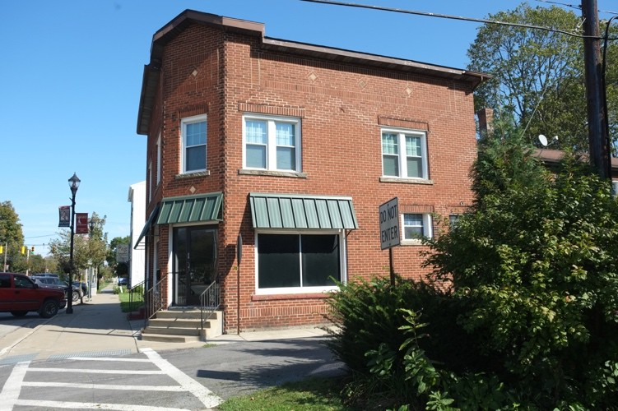

9-13 Main Street East
Property name: Shillaci House and Shop^{v}
Date of Construction: ca. 1897 Status: one contributing building Parcel Number: 23015052004602

Description: A two-story, three-bay red brick commercial building with a flat asphalt roof, and a rear two-story, brick portion with a flat asphalt roof on a concrete foundation. Angled corner bay with entry and brick pediment above. Centered entry with fully-glazed aluminum door and large vinyl storefront windows with bisected transoms and aluminum awning on storefront; single and paired six-over-one sash vinyl replacement windows with stone sills and brick lintels elsewhere. Decorative brick friezes with stone lozenges on main block. Vinyl clapboard siding on east elevation. Simple cornice with vinyl soffit. Brick chimney above rear addition.

History: From 1898 through 1912, this building was listed as a Grocer on the Sanborn Fire Insurance Maps. According to the Erie County Directory, in 1920, Joseph Shillaci lived in the building and operated a shoe shop there. From 1938 to 1948, the building housed a restaurant.^{vi}

v Shirley R. French, National Register of Historic Places Nomination: Girard Historic District, Erie County, Pennsylvania, Girard, PA, December 30, 1987, Master List of Buildings, 3.
^{vi} Sanborn Fire Insurance Maps, 1920, 1929, 1938, 1948.

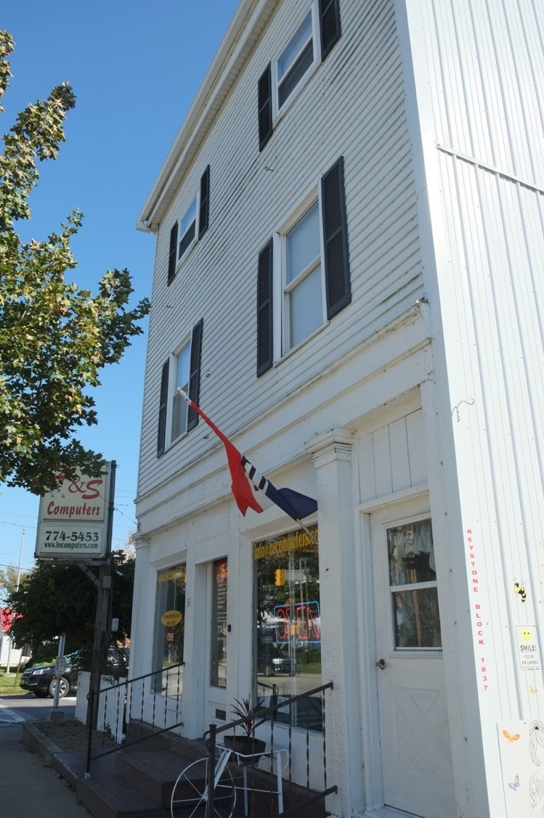

31 Main Street East
Property name: Keystone Block Date of Construction: ca. 1832 Status: one contributing building Parcel Number: 2301505200300

Description: A two-and-a-half story, two-bay frame commercial and residential building with an asphalt shingled side-gable roof and a rear one-story shed-roofed addition on a concrete foundation. Vinyl clapboard and corrugated aluminum siding and vinyl one-over-one sash replacement windows with vinyl shutters. Wood storefront on first story of façade with wood pilasters and simple cornice. Storefront has a central fully-glazed wood door and two wood single-pane storefront windows; a secondary entry with a half-glazed vinyl door occupies adjacent bay.

History: This store, the W.T. Ryman hat manufactory, was opened by Theodore Ryman in 1832 and later passed down to his son who converted it to a boots and shoes shop. Theodore came to Girard to enter the hat manufacturing business and was joined by other men who each built a section for their business of what would become known as Keystone Block A middle section was added to this building shortly after 1832 and an end section about twelve years after that. The middle and end sections have since been demolished.^{vii}

^{vii} “Ryman Store The Oldest on Route 20,” Erie Daily Times, August 14, 1946.

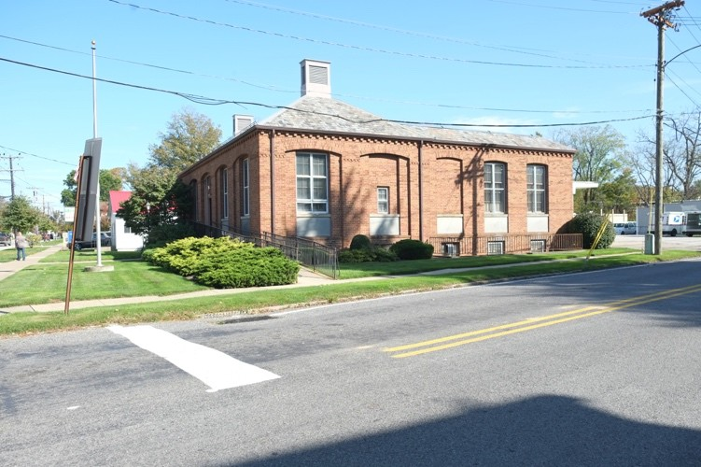

113 Main Street East
Property name: United States Post Office
Date of Construction: 1941 Status: one contributing building Parcel Number: 23015048000500

Description: A one-story, five-by-five-bay brick post office building with a slate cross-gable hipped roof and a rear loading bay on a concrete foundation. Recessed bays with segmented arches and decorative brick crowns. Centered entryway on façade with a fully glazed replacement aluminum door, wood-framed sidelights with carved wood pilasters, and an arched transom light inset with a carved wood eagle. Wood eight-over-twelve sash windows with aluminum storms and cast stone sills. Brick dentil course below roofline; louvered vents on roof line.

History: This historic post office was built with federal Treasury funds and houses an example of New Deal artwork.^{viii}
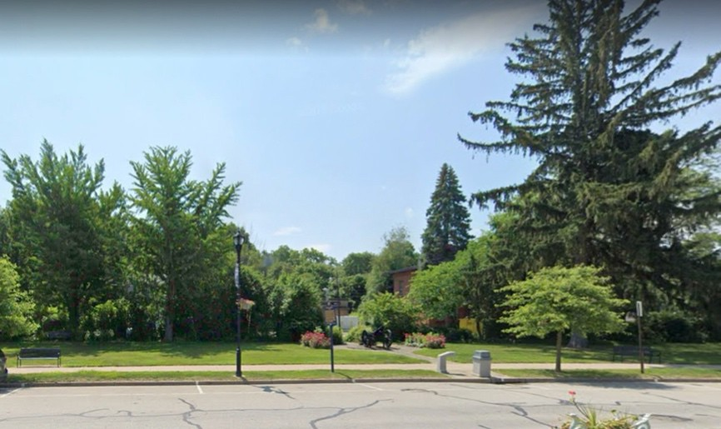

Main Street East
Property name: Wells Park Village Green
Date of Construction: ca. 1846
Status: one contributing site

^{viii} “Post Office – Girard PA,” Living New Deal, n.d., accessed January 18, 2022, https://livingnewdeal.org/locations/post-office-girard- pa/.

Parcel number: 23015051000100

Description: Large open green space with old growth trees. In the center of the Green, a cement path lined with flowering shrubs encircles a historic cannon.

History: Joseph Wells owned much of the land in Girard and dedicated the property for the Village Green when the town was laid out.

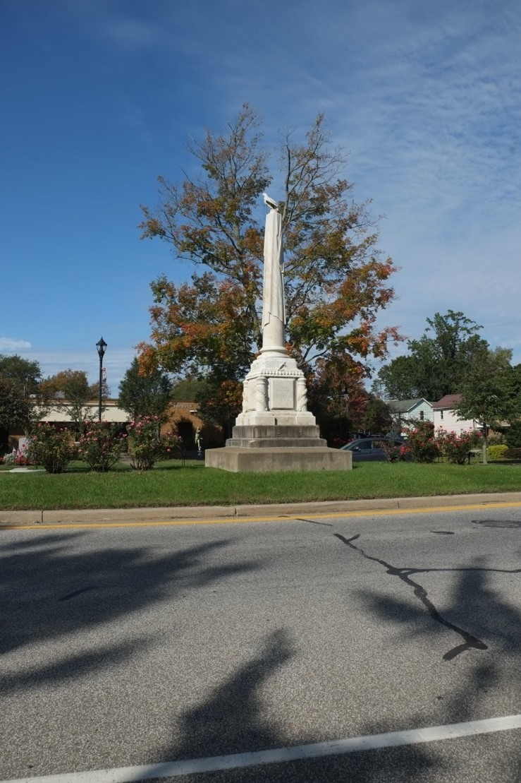

Main Street East
Property name: Civil War Monument Date of Construction: November 1, 1865 Status: one contributing object

Description: Seventeen-foot Corinthian columns draped in the American flag and topped by an eagle, sculpted by Leonard Volk.

History: This Civil War Monument was erected and dedicated on November 1, 1865, at a cost of $6000 by Daniel McLaren, a.k.a. Dan Rice as a tribute to the officers and soldiers who served their country.

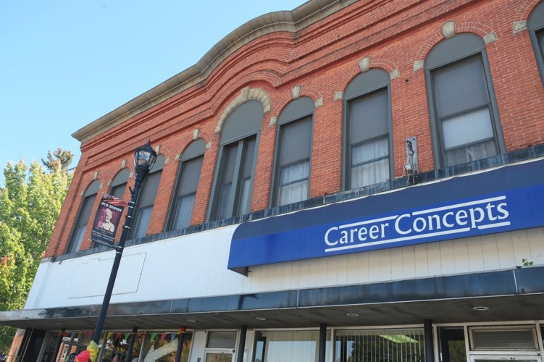

65-71 Main Street West Property name: Union Block Date of Construction: ca. 1865^{ix} Status: one contributing building Parcel Number: 23015052003900

Description: A two-story, nine-bay red brick commercial building with a flat asphalt roof on a parged foundation. Fully-glazed storefront on first story with aluminum doors with transoms and large single-pane windows. Wood vertical board frieze between first and second story; cast stone sill course above. Window bays with rounded arches, cast stone keystones and springers, and replacement aluminum one-over-one sash windows. Center bay on façade has paired windows and cast stone voussoirs with bas relief letters reading “Union Block.” Decorative brick frieze and stone cornice with central arch. New windows and storefront.

History: Built by John Gulliford Jr. and David M. Olin to carry on their family businesses, which were established in 1839 and previously housed in separate structures. Gulliford housed his business in the western portion of the store and sold silver, hardware, and furniture. Olin sold woolens from the eastern portion.^{x} Gulliford died in 1899 and Olin in 1876. From 1898 to 1904, this building housed a furniture and a hardware store. By 1912, a lodge was located on the second floor above the two stores The lodge remained in the building until at least 1948.^{xi}

^{ix} F.W. Beers, Atlas of Erie County, Pennsylvania, (New York: F.W. Beers, A.D. Ellis & G.G. Soule), 1865, Map.
^{x} Geoffrey Domowicz, Girard and Lake City Through Time, Arcadia Publishing, 2017, 43; United States Federal Census, 1850-1880.
^{xi} Sanborn Fire Insurance Maps, 1898, 1904, 1912, 1929, 1938, 1948.

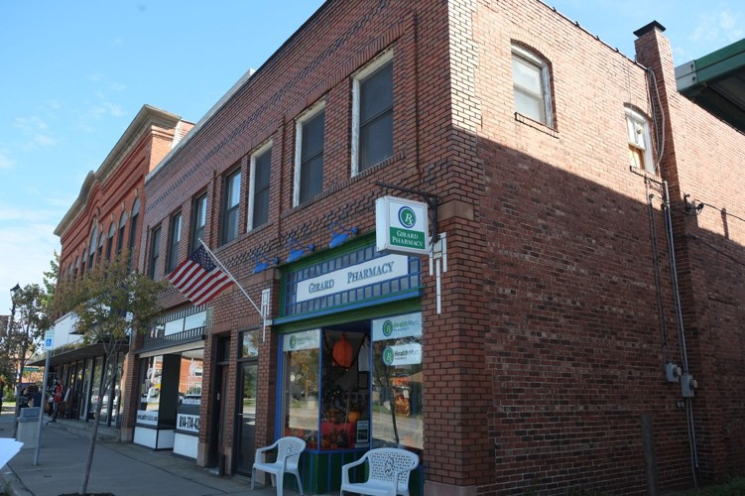

77-83 Main Street West
Property name: McClelland Grocery Date of Construction: ca. 1897 Status: one contributing building Parcel Number: 23015052003800

Description: A two-story, seven-bay brick commercial building with flat asphalt roof on a concrete foundation. Two wood storefronts on first story with single-pane wood windows, fully-glazed recessed center-bay aluminum doors, and transoms with glass block above: two doors between storefront with transom windows and flat brick arches. Decorative brick courses between first and second story and at the frieze. Second story window openings with brick sills and lintels, wood frames, and aluminum one-over-one sash windows on façade; windows are also aluminum one-over-one sash on west elevation with segmented arches. Ceramic coping along roof line. Brick exterior chimney on west elevation.

History: Glen McClelland operated his grocery here from ca. 1898 through ca. 1940.^{xii} Overtime, other businesses operated in the building alongside his shop: a W.U.T. office in 1898, a millinery in 1904; and a brick and tile shop from 1929 to ca.1948.^{xiii}

^{xii} United States Federal Census, 1900-1940.
^{xiii} Sanborn Fire Insurance Maps, 1898, 1904, 1929, 1938, 1948.

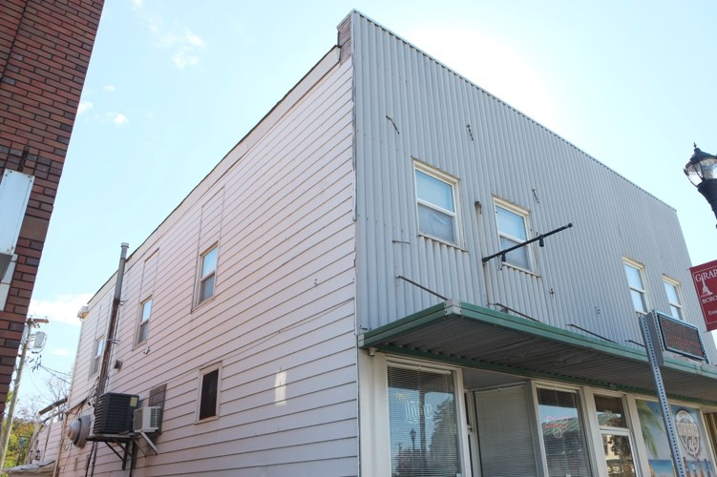

103-105 Main Street West Date of Construction: ca. 1897 Status: one contributing building
Parcel Number: 23015052003600

Description: A two-story, four-bay aluminum-clad commercial building with flat asphalt roof on a concrete foundation. Two fully-glazed aluminum storefronts on first floor with single panes and recessed fully-glazed aluminum doors with transoms above; one fully-glazed aluminum door between storefronts with transom.
Overhanging flat-roofed aluminum awning between first and second story. Second story window openings contain vinyl one-over-one sash windows.

History: The post office was housed in the western section of this building from around 1904 until at least 1938. Other shops that operated here were a drug store and millinery in 1898, a grocery in 1904, and a restaurant from around 1938 to 1948.^{xiv}
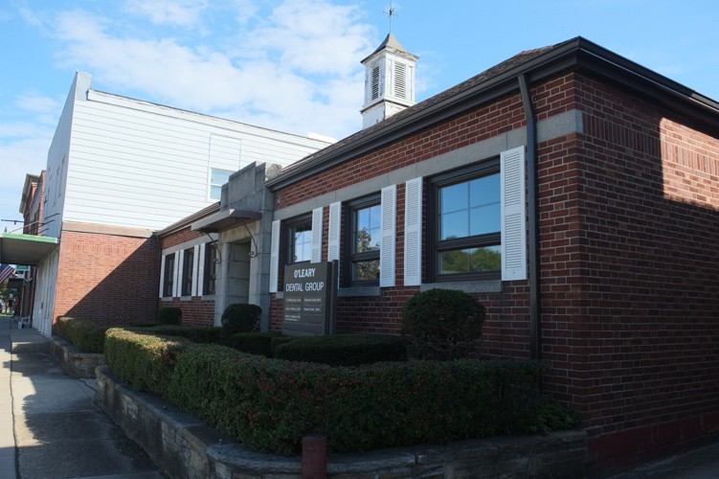

111 Main Street West
Date of Construction: ca.1940s. Status: one contributing building Parcel Number: 23015052003500

^{xiv} Sanborn Fire Insurance Maps, 1898, 1904, 1912, 1929, 1938, 1948.

Description: A one-story, seven-bay brick veneer with concrete block commercial building with an asphalt shingled hipped roof, and two rear one-story sections on a concrete foundation. Center entry with cast stone block portico and a fully glazed aluminum door with a transom window. Window openings with cast stone sills, aluminum casement replacement windows, vinyl shutters, and a cast stone lintel course. Large louvered wood cupola with vents, pyramidal roof, and weather vane centered above entry.

History: This building first appears on the 1948 Sanborn Fire Insurance map as a shop.
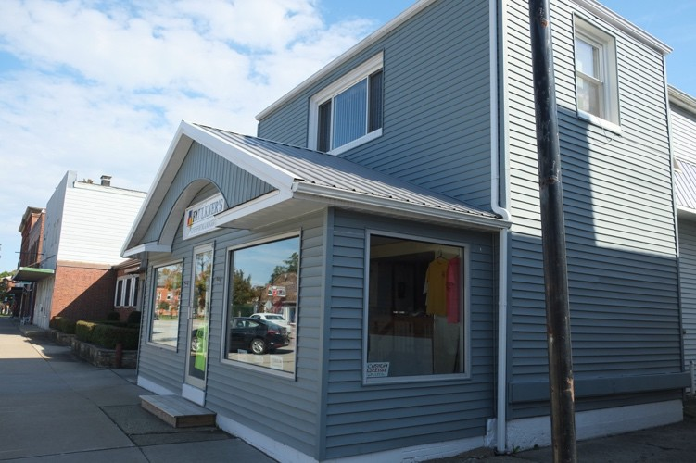

123 Main Street West
Property name: Mutual Telephone Exchange
Date of Construction: ca. 1928
Status: one non-contributing building due to significant alteration
Parcel Number: 23015052003400

Description: A two-story, three-bay frame mixed-use building with vinyl siding and a combination of single pane, casement, and one-over-one sash vinyl replacement windows throughout. Due to several two-story flat- roof rear additions, the foundation is a combination of concrete block, brick, and parged stone. The first floor features an enclosed three-bay one-story porch with a front-gable aluminum roof. The enclosed porch has large, single-pane storefront windows and a fully-glazed central aluminum door with a broken pediment above. The second floor is recessed behind the porch and features a flat asphalt roof and single bay with casement window. A central interior brick chimney rises through the roofline.

History: From around 1929 to 1948, this building housed the Mutual Telephone Exchange.^{xv}

^{xv} Sanborn Fire Insurance Maps, 1929, 1938, 1948.

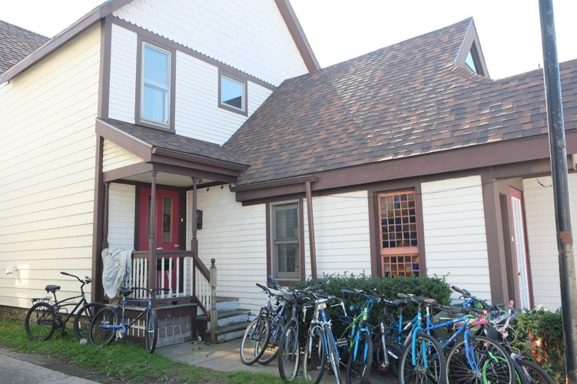

129 Main Street West
Date of Construction: ca. 1897 Status: one contributing building Parcel Number: 23015052003300

Description: A two-and-a-half story, three-bay frame mixed use building with an asphalt shingled cross-gable roof, a two-story enclosed porch, and a stone foundation. Wood clapboard siding with wood scallop shingles in half-story beneath front gable. Vinyl one-over-one sash replacement windows with aluminum storms throughout. Fully-glazed wood door with sidelight on porch entry; partially-glazed wood door in secondary entry on façade. Multi-pane wood sash window on east elevation of porch. Brick interior chimney.

History: This building was originally a residence. Sometime after 1948, it was converted to a mixed-use building.^{xvi} The porch was extended sometime after 1948.
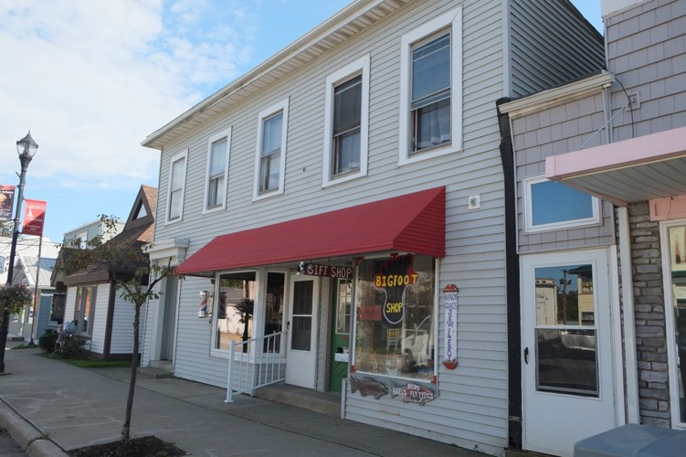

137-141 Main Street West
Property name: Kuenzig Real Estate^{xvii}
Date of Construction: ca. 1897
Status: one contributing building

^{xvi} Sanborn Fire Insurance Maps, 1898, 1904, 1912, 1929, 1938, 1948.
^{xvii} French, National Register of Historic Places Nomination: Girard Historic District, Erie County, Pennsylvania, Girard, PA, Master List of Buildings, 3.

Parcel Number: 23015052003200

Description: A two-story, five-bay frame commercial building with a flat asphalt roof on a concrete foundation. Storefront with two half-glazed vinyl doors and single-pane storefront windows on either side; one original wood storefront window remains on the west side of the front elevation. Shed roof aluminum awning above.
Entry to the east features a half-glazed vinyl door, wood-framed sidelights and transom, and wood and aluminum pediment above. Vinyl clapboard siding and wood one-over-one sash windows with aluminum storms and vinyl surrounds.

History: From around 1898 to 1904, this building was a two-story dwelling. In 1912, it was converted to a mixed-use building. At that time, a separate entrance was made in the east bay of the first floor to access apartment space on the second floor. On the first floor, the two storefronts housed a millinery and a barber shop. In the 1920s and 30s, the first floor storefronts were still occupied by shops. By 1948, an office and two shops were located in the building.^{xviii}
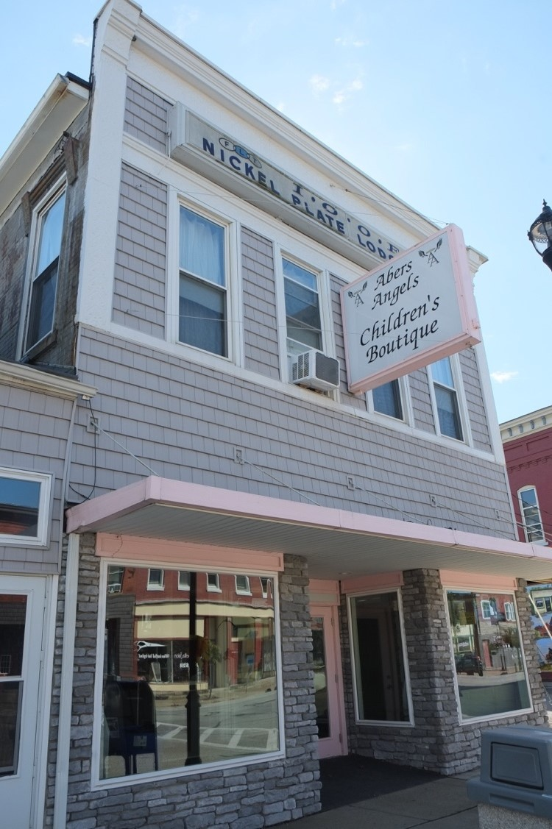

143-145 Main Street West
Property name: Independent Order of Oddfellows, Nickel Plate Lodge/Girard Pharmacy
Date of Construction: ca. 1865 Status: one contributing building Parcel Number: 23015052003100

^{xviii} Sanborn Fire Insurance Maps, 1898, 1904, 1912, 1929, 1938, 1948.

Description: A two-story, four-bay frame commercial building with a flat parapeted asphalt roof on a concrete foundation. Storefront with recessed glazed wood door, single-pane aluminum storefront windows, and simulated stone siding. Wood lintels above entry door and storefront windows. Flat-roofed aluminum awning above. Vinyl shingles on façade; aluminum siding on west elevation; applied brick on east. Vinyl one-over-one sash replacement windows on second story. Decorative wood pilasters, wood frieze, and decorative wood cornice frame the second story. A rectangular projecting wood sign on the frieze reads, “ I.O.O.F., Nickle Plate Lodge. Maintains fenestration and storefront configuration from the mid 1950s, different siding, same sign.

History: In 1898, this building housed a grocery. By 1904, a boots and shoes shop, drug store, and grocery were located here. The Independent Order of Oddfellows, Nickel Plate Lodge operated in the building from around 1912 to possibly as late as 1948; a Sanborn Map from 1948 refers to the second floor as a “Hall.” The drug store remained on the first floor until around 1938.^{xix} In 1956, the first floor was the Girard Pharmacy.^{xx}

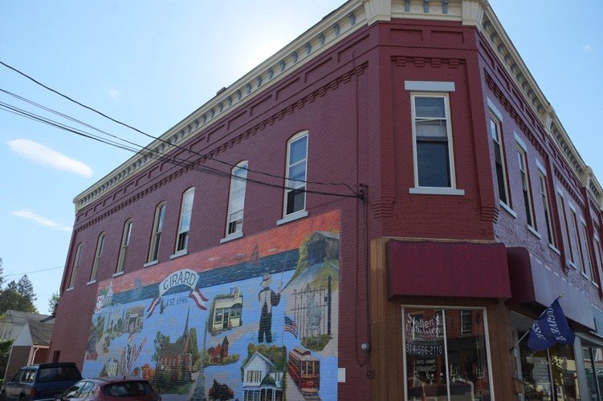

209-217 Main Street West
Property name: Lodge 29/Kibler Block^{xxi}
Date of Construction: 1886^{xxii} Status: one contributing building Parcel Number: 23015048001100

Description: A two-story, seven-bay brick commercial building with a flat asphalt roof on a concrete foundation. Two storefronts with single-pane aluminum windows and recessed fully-glazed aluminum doors on façade. East storefront has vertical wood board siding and cloth awning above; west storefront has aluminum paneling and wood vertical board frieze above. Angled corner bay with single-pane aluminum storefront windows and wood vertical board on first story with a single window on the second floor. Wood one-over-one sash windows with aluminum storms and cast stone lintels and sills on second story; windows on east elevation have segmented arches. A series of four decorative brick pilasters with corbeling frame the windows on the second floor and a belt course of dentiled brick runs above the windows. The frieze features a line of continuous recessed brick panels, and the wood cornice has small decorative brackets.

^{xix} F. W. Beers, Atlas of Erie County, 1865; Sanborn Fire Insurance Maps, 1898, 1904, 1912, 1929, 1938, 1948.
^{xx} Geoffrey Domowicz, Girard and Lake City Through Time, Acadia Publishing, 2017, 41.
^{xxi} The 1907 Erie County Directory lists this building as the Kibler Block
^{xxii} French, National Register of Historic Places Nomination: Girard Historic District, Erie County, Pennsylvania, Girard, PA, Section 8, 3.

History: George Kibler became a merchant sometime between 1870 and 1880.^{xxiii} He apprenticed under and lived with Lemuel Jones who owned a general store on this site from 1855 to at least 1876.^{xxiv} Jones’ building is shown as frame on maps from 1865 and 1876; Kibler replaced the frame building with the current two-story brick building in 1886. By 1898, there was an office and Lodge on the second floor. The lodge appears on maps from 1898 through 1912 under the name “Lodge 29.” Kibler died in 1937. ^{xxv} The building remained as a shop with a wareroom in the rear until at least 1948. ^{xxvi}
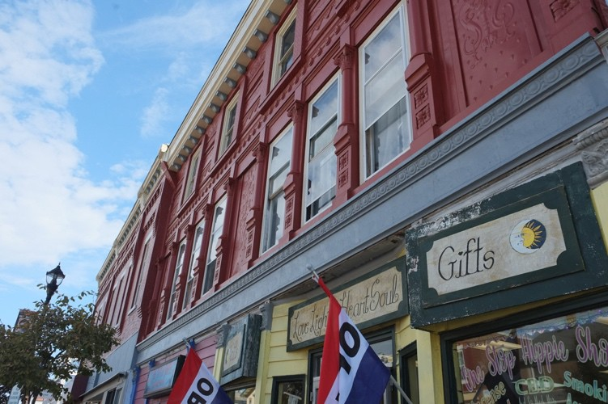

219-223 Main Street West
Date of Construction: ca. 1900^{xxvii} Status: one contributing building Parcel Number: 23015050000300

Description: A three-story, nine-bay ornamental sheet metal clad commercial building with a flat asphalt roof on a concrete foundation. Two storefronts with original single-pane wood windows, wood clapboard siding, ornamental sheet metal pilasters, and fully-glazed aluminum doors on façade. Plain wood frieze between first and second story. Wood one-over-one sash windows with vinyl storms on second and third stories. Detailed ornamental sheet metal façade features decorative Corinthian pilasters, panels, and friezes with various relief patterns. Wood frieze with brackets and rosettes caps on façade.

History: Between 1904 and 1912, this building housed a jeweler, wallpaper shop and furniture store. By 1929, a shop was either built or a current one was attached to this building, creating three storefronts and housing three shops listed in the front portion of building. Between 1938 and 1948, shops and a restaurant occupied the storefronts.^{xxviii}

^{xxiii} United States Federal Census, 1870, 1880.
^{xxiv} J. Chase, O. McLeran, and Isaac W. Moore, Map of Erie County, Pennsylvania; from actual surveys, (Philadelphia: O. McLeran: Isaac W. Moore, 1855, https://www.loc.goov/item/2012592169; F. W. Beers, Atlas of Erie County, 1865; P.H. Dowling, Map of Girard, 1876, https://www.ancestry.com.
^{xxv} “George W. Kibler, Sr. (1852-1937) Buried in Girard Cemetery Located in Girard, PA |People Legacy,” accessed January 14, 2022, https://peoplelegacy.com/george_w kibler sr-0N3M4t.
^{xxvi} Sanborn Fire Insurance Maps, 1898, 1904, 1912, 1929, 1938, 1948.
^{xxvii} Sanborn Fire Insurance Map, 1904.
^{xxviii} Sanborn Fire Insurance Maps, 1904, 1912, 1929, 1938, 1948.

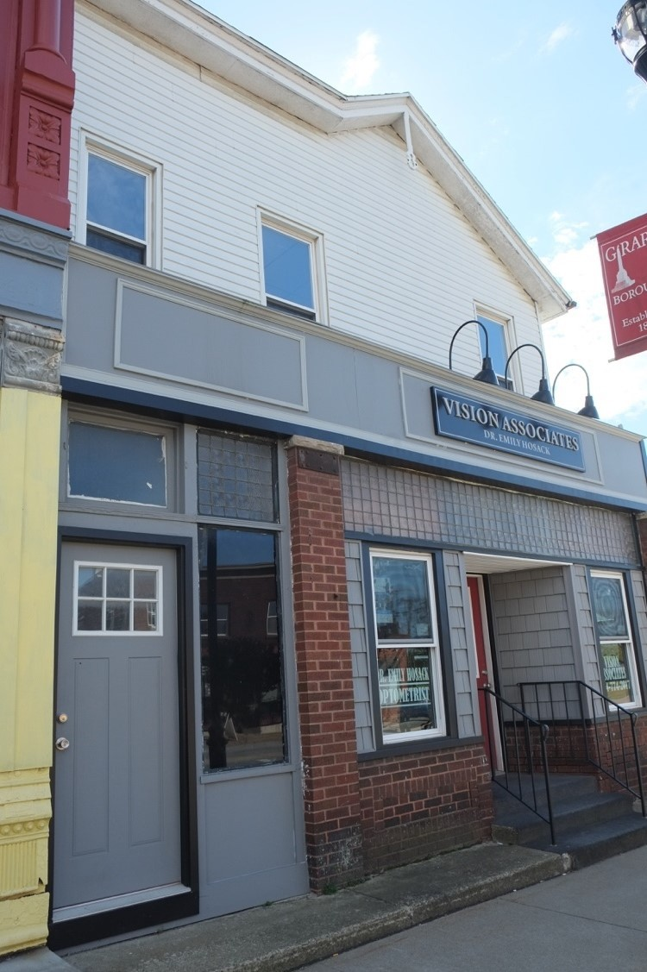

229 Main Street West
Property name: James H. Nichols Grocery
Date of Construction: ca. 1865 Status: one contributing building Parcel Number: 23015050000200

Description: A two-and-a-half story, three-bay frame mixed use building with a brick storefront, a rear one- story section, and an asphalt shingle cross-gable gable roof on a concrete foundation. Aluminum clapboard siding and vinyl one-over-one sash replacement windows. Storefront has half-glazed vinyl doors, vinyl shingle siding, one-over-one sash windows, and a combination of glass block and plate glass transoms across the storefront.

History: James H. Nichols operated his grocery business out of this building from around 1865 to 1900; he died in 1907. ^{xxix} Shortly after his death, a printing business occupied the building and remained there until at least 1948. The building was extended to the east sometime after 1948.^{xxx}

^{xxix} F. W. Beers, Atlas of Erie County, 1865; United States Federal Census, 1870, 1880, 1900.
^{xxx} United States Federal Census, 1870-1900; Sanborn Fire Insurance Maps, 1904, 1912, 1929, 1938, 1948.

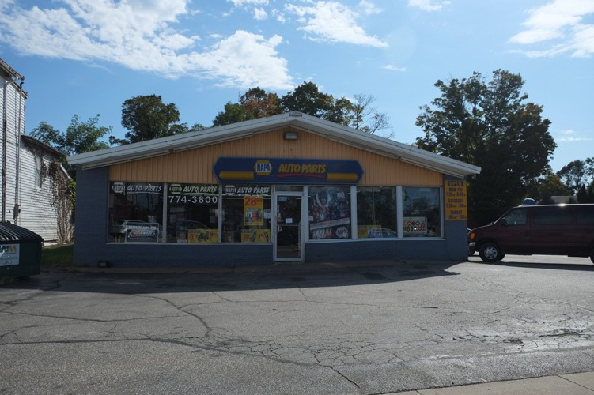

239 Main Street West
Date of Construction: ca. 2001
Status: one non-contributing building due to date of construction
Parcel Number: 23015050000100

Description: A one-and-a-half story, seven-bay frame commercial building with an aluminum front gable roof on a concrete foundation. Aluminum plate glass windows and fully-glazed aluminum door on storefront with brick pilasters. Aluminum siding below gable on façade and on side elevations.

Main Street – North Side

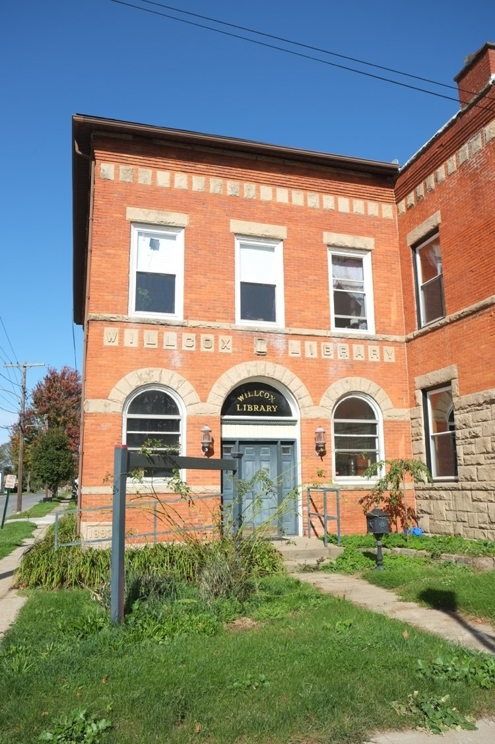

8 Main Street East
Property name: Wilcox Library Date of Construction: 1893 Status: one contributing building Parcel Number: 23012027002200

Description: A two-story, thee-bay red brick commercial building with a flat asphalt roof on a stone foundation. Round arches with limestone voussoirs in each bay of the first story on façade; wood panel door with paneled sidelights and a circular transom window in center bay; wood one-over-one sash windows with aluminum storms and transoms in flanking bays. Limestone blocks with letters reading “Wilcox Library” in relief between first and second story. All other bays contain wood one-over-one sash windows with aluminum storms, limestone lintels, and limestone sills in a course. Alternating limestone blocks and a brick frieze cap each elevation. Attached to the R. S. Battles Bank at 12 Main Street.

History: Mr. Robertson Wilcox, of Girard, bequeathed $5000 for this public library to be built in the

borough. ^{xxxi}
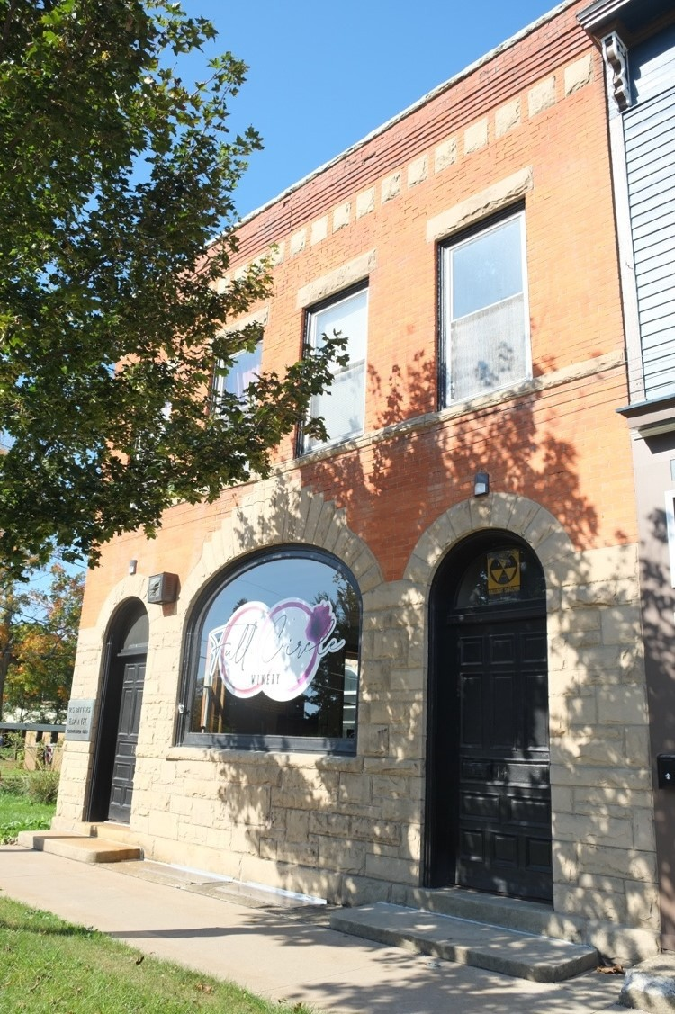

12 Main Street East
Property name: R. S. Battles Bank Date of Construction: 1893 Status: one contributing building Parcel Number: 23012027002100

Description: A two-story, thee-bay red brick commercial building with a flat asphalt roof and rusticated stone first floor on a stone foundation. Arches with limestone voussoirs in each bay of the first story on façade; basket handle arch wood storefront window in center bay; wood panel doors with round arch transoms in flanking bays. All other bays contain wood one-over-one sash windows with aluminum storms, limestone lintels, and limestone sills in a course. Alternating limestone blocks and a brick frieze cap each elevation. Attached to the Wilcox Library at 8 Main Street.

History: Rush Battles, successful Girard banker and businessman, constructed this bank in 1893. He spared no expense on the structure or on the vault room where two large safes were placed. Constructed of steel, stone, and brick, the building was completely fireproof with foundation walls measuring nineteen inches thick. Rush installed an elaborate alarm system that was connected to the electric light plant and also alerted Girard’s fire department in case of fire.^{xxxii}

xxxi Laura G. Sanford, The History of Erie County, Pennsylvania from its first settlement, (Erie County: Laura G. Sanford), 1894, 432.
^{xxxii} “The Battles Bank: When Honesty Was Collateral and Chickens Paid the Interest,” Pennsylvania Heritage Magazine, accessed
January 14, 2022, http://paheritage.wpengine.com/article/battles-bank-honesty-collateral-chickens-paid-interest/ .

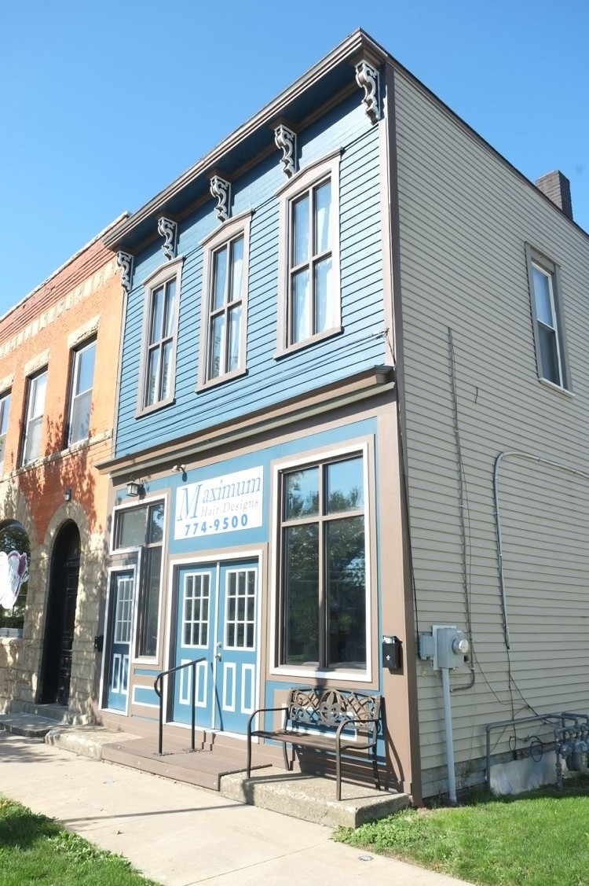

18 Main Street East
Property name: Josiah Nece Cabinet Shop
Date of Construction: ca. 1855 Status: one contributing building Parcel Number: 23012027002000
Description: A two-story, three-bay frame commercial building with a flat asphalt roof on a stone foundation. Storefront on first story with paired, half-glazed vinyl panel doors in the center bay, aluminum storefront windows in the east bay, and a half-glazed vinyl panel door with a transom and a large sidelight in the west bay. Wood cornice between first and second story. Wood clapboard and aluminum two-over-two sash windows with wood surrounds on second story. Wood cornice with scrolled brackets caps façade. Vinyl clapboard on east elevation.

History: Josiah Nece, a successful cabinet maker constructed his cabinet shop here just east of Mechanic Street around 1855. The shop housed his cabinet business until at least 1880 and later became a harness and carriage shop operated by Emmett L. Hanson from 1898 until the early 1920s. Hanson died in 1925. In 1948, this building housed a “Paints” shop.^{xxxiii}

^{xxxiii} United States Federal Census, 1860-1900; J. Chase, Map of Erie County, 1855, F. W. Beers, Atlas of Erie County, 1865; Sanborn Fire Insurance Map, 1898, 1904, 1912, 1929, 1938, 1948.

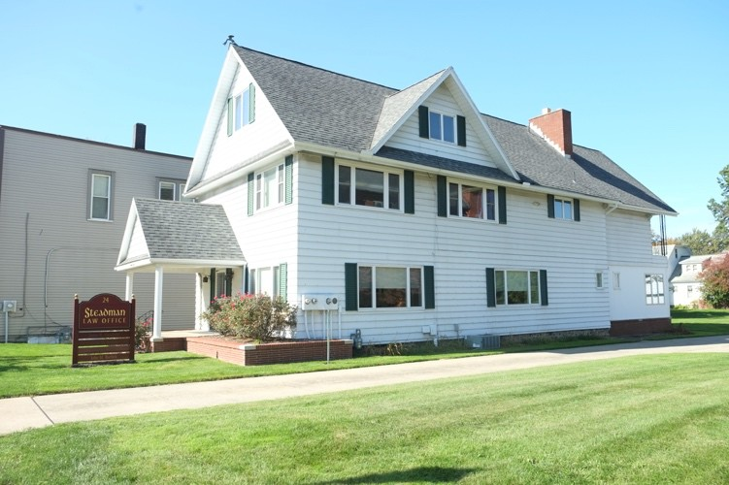

24 Main Street East
Date of Construction: ca. 1903 Status: one contributing building Parcel Number: 23012027001900

Description: A two-and-a-half-story, two-by-four-bay frame mixed-use building with asphalt shingle front gable roof and a rear two-and-a-half story addition on a stone foundation. Vinyl clapboard siding and vinyl one- over-one sash replacement windows with sidelights and vinyl shutters. Brick porch with large portico with vinyl columns; entry beyond with half-screened aluminum door. Full raking cornice between second story and half story beneath gable. Gable dormer above east elevation. Rear chimney.

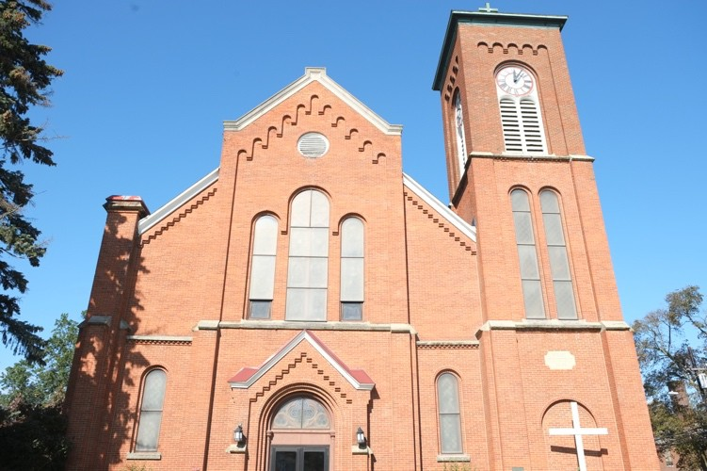

48 Main Street East
Property name: First Methodist Episcopal Church and School
Date of Construction: 1868, tower addition 1904, school addition 1955
Status: one contributing building
Parcel Number: 23012027001700

Description: A two-and-a-half-story, four-bay-by-six-bay brick religious building with an asphalt shingle front- gable roof, a large two-story, flat-roofed rear school addition, and a three-story tower on a stone foundation.
Features round arch windows with stone sills and stained glass panes on main block; aluminum one-over-one hopper windows on rear school addition. Centered entry features a round arch transom with trefoil and quatrefoil glazing, paired fully-glazed aluminum doors and pediment above. Brick buttresses and corbeling on side elevations.

History: The congregation of this church was organized in 1815 and its first church was built in 1828. This church was constructed in 1868 at a cost of $30,000.^{xxxiv} The tower was constructed in 1904 and donated by the Battles family. In 1950, a storm damaged the steeple which was removed and never replaced. The school was added to the rear of the church in 1955.

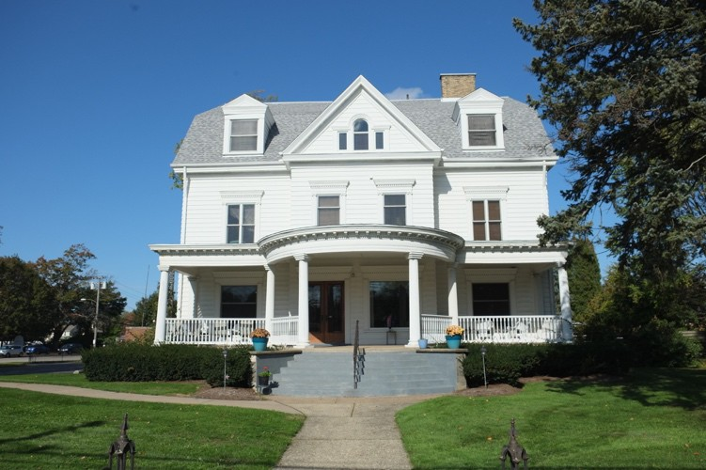

142 Main Street East
Property name: Culbertson House Date of Construction: ca. early 1900s Status: one contributing building Parcel Number: 23012032001601

Description: A two-and-a-half-story, four-bay by four-bay commercial frame building with an asphalt shingle cross-gambrel roof on a concrete foundation. Clad in wood clapboard with a combination of one-over-one aluminum sash and two-over-two wood sash windows with dentiled lintels supported by fluted Ionic pilasters on first and second stories. Full-facade one-story flat-roofed porch with a deep rounded center entry supported by fluted columns and a simple balustrade. The porch features a dentiled cornice with modillions above. The entrance has double fully glazed wood doors flanked by fluted Ionic pilasters with dentiled architrave above. Central gable projects from second floor and features a Palladian window in the half-story flanked by front- gable dormers. East elevation has a projecting bay on the first floor and a central Palladian window in the gable flanked by elliptical windows.

History: This house was constructed sometime between 1904 and 1912.^{xxxv} William C. Culbertson was a Congressman, an enterprising businessman, and an extensive lumberman, who became a millionaire in his

^{xxxiv} The History of Erie County, (Chicago: Warner, Beers & Co.), 1884, 84.
^{xxxv} Sanborn Fire Insurance Maps, 1904, 1912.

lumbering operations in Michigan and Wisconsin.^{xxxvi} He also owned a major interest in the Girard Wrench Manufacturing Company.^{xxxvii} His son, William MacFarland Culbertson, operated the Girard Wrench Manufacturing Company until it closed sometime in the 1920s and retired shortly thereafter. William F. Culbertson lived in this house until his death in 1946.^{xxxviii}

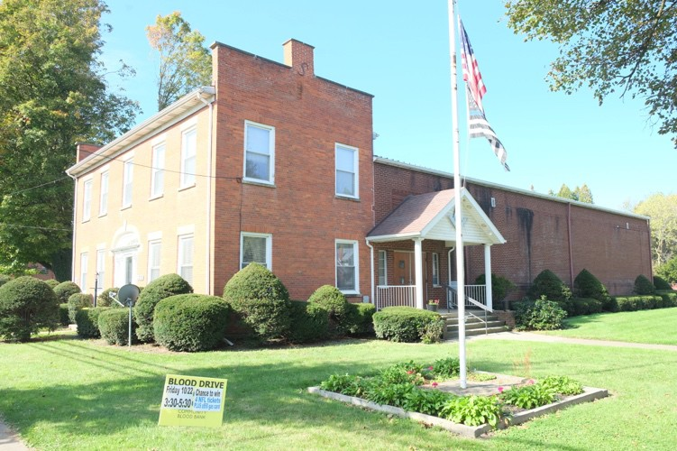

172 Main Street East
Property name: Wells-Hutchinson House^{xxxix}
Date of Construction: 1825, one-story rear addition by 1929/second-story rear addition added by 1938^{xl}
Status: one contributing building
Parcel Number: 23012032001500

Description: A two-story, five-bay by two-bay brick commercial building with a side-gable asphalt roof on a concrete foundation. One-over-one aluminum sash windows with stone lintels and sills. Center hall entry with fanlight beneath a stone arch with keystone and sidelights framed by pilasters. Wood entry-door with a large single light and small wood panel beneath. Side elevations of main block feature stepped Dutch gables at the roofline and windows with brick lintels and stone sills. Rear, one-story, front-gabled portico addition with entry on the east side.

History: Maps from 1855 and 1865 show that this property belonged to Monroe Hutchinson, farmer and one- time Girard Postmaster.^{xli} In 1876, David W. Hutchinson, a lawyer, is listed as the owner. David was a Master of the Lake Erie Freemason Lodge # 347 from 1865 to 1866 and again in 1884.^{xlii} Charles M. Hutchison, son of Monroe, moved into the home sometime in the early 1900s. Charles was the president and owner of the Erie

^{xxxvi} “Girard Boasts Numerous Historical Resources,” Erie County, August 11, 1948.
^{xxxvii} “Girard Wrench Mfg. Co.|Tool Archives,” accessed January 14, 2022, https://toolarchives.com/node/149.
^{xxxviii} “Monkey Wrenches: Part IV,” Tooling Around the Matheson History Museum, accessed January 14, 2022, https://mathesontools.weebly.com/blog/monkey-wrenches-part-iv; United States Federal Census, 1920-1940.
^{xxxix} French, National Register of Historic Places Nomination: Girard Historic District, Erie County, Pennsylvania, Girard, PA, Section 8, 2.
^{xl} French, National Register of Historic Places Nomination: Girard Historic District, Erie County, Pennsylvania, Girard, PA, Section 8, 2; Sanborn Fire Insurance Maps, 1929, 1938.
^{xli} J. Chase, Map of Erie County, 1855, F. W. Beers, Atlas of Erie County, 1865; U.S. Appointments of U.S. Postmasters, 1832-1971, www.ancestry.com.
^{xlii} “THE 347 – Past Masters,” accessed January 17, 2022, https://www.lakeerielodge347.com/past-masters; P.H. Dowling, Map of Girard, 1876.

City Manufacturing Company, initially a manufacturer of “wooden ware” located in Erie City. Hutchinson owned and operated his company from the early 1900s until his death in 1938. His widow continued to live in the house until at least 1940. ^{xliii} Today it houses the Lake Erie Lodge #347, F.& A.M., Hutchinson Memorial Hall.^{xliv}
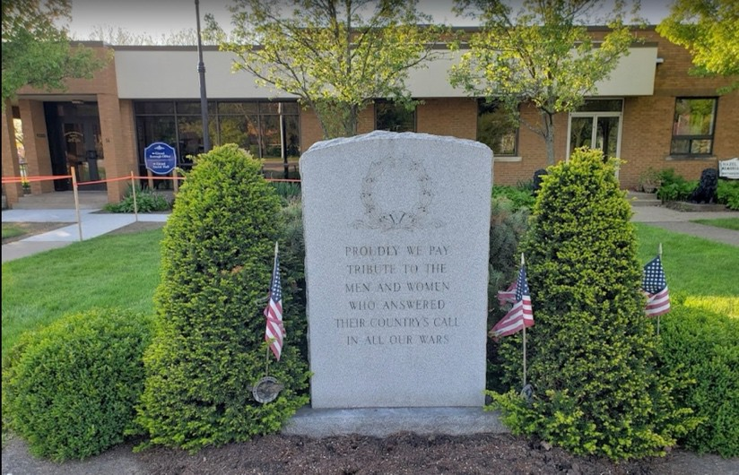

34 Main Street West
Property name: Girard Borough Hall
Date of Construction: ca. 1970s
Status: one non-contributing building and one-non-contributing structure due to date of construction.
Parcel Number: 23011026000100

Description: A one-story, ten-bay brick municipal building with a flat asphalt roof on a cement foundation. Main entrance is in the westernmost bay beneath a flat-roofed brick portico with brick columns. Large plate glass window east of the main entrance. Two secondary entrances are located in the center and east bay. All entry doors are fully glazed with transoms above. Windows are one-over-two casements with stone sills. An open air wood gazebo with front gable asphalt roof, wood columns and a surrounding balustrade is located on the eastern end of the property.

^{xliii} United States Federal Census, 1900-1940; Erie County Directories, 1909-1938.
^{xliv} “The 347,” accessed January 17, 2022, https://www.lakeerielodge347.com/.

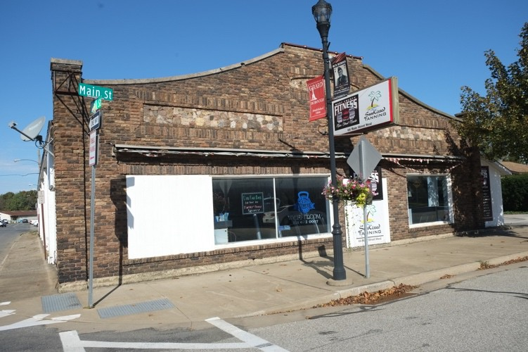

66 Main Street West Property name: Lutz Garage^{xlv} Date of Construction: ca. 1920
Status: one contributing building
Parcel Number: 23011026000300

Description: A one-story, three-bay brick commercial building with a clipped front gable parapet on a concrete foundation framed by pilasters that rise above the roofline on the facade. Storefront features large plate glass windows with brick lintels and sills on the outer bays. Two narrow rectangular panels of inlaid stone above the storefront and an oval panel of inlaid stone centered in the gable are framed by brick soldier courses. East elevation has a one-story asphalt shingle shed-roofed addition clad in vertical board with central entrance.
Remainder of this elevation is clad in stucco and contains a central entrance with a vinyl door and third porticoed entrance toward the rear.

History: George Lutz operated this garage in 1920.^{xlvi} From 1929 to at least 1948, it was an auto sales & service shop.xlvii

^{xlv} French, National Register of Historic Places Nomination: Girard Historic District, Erie County, Pennsylvania, Girard, PA, Master List of Buildings, 2.
^{xlvi} United States Federal Census, 1920.
^{xlvii} Sanborn Fire Insurance Maps, 1929, 1938, 1948.

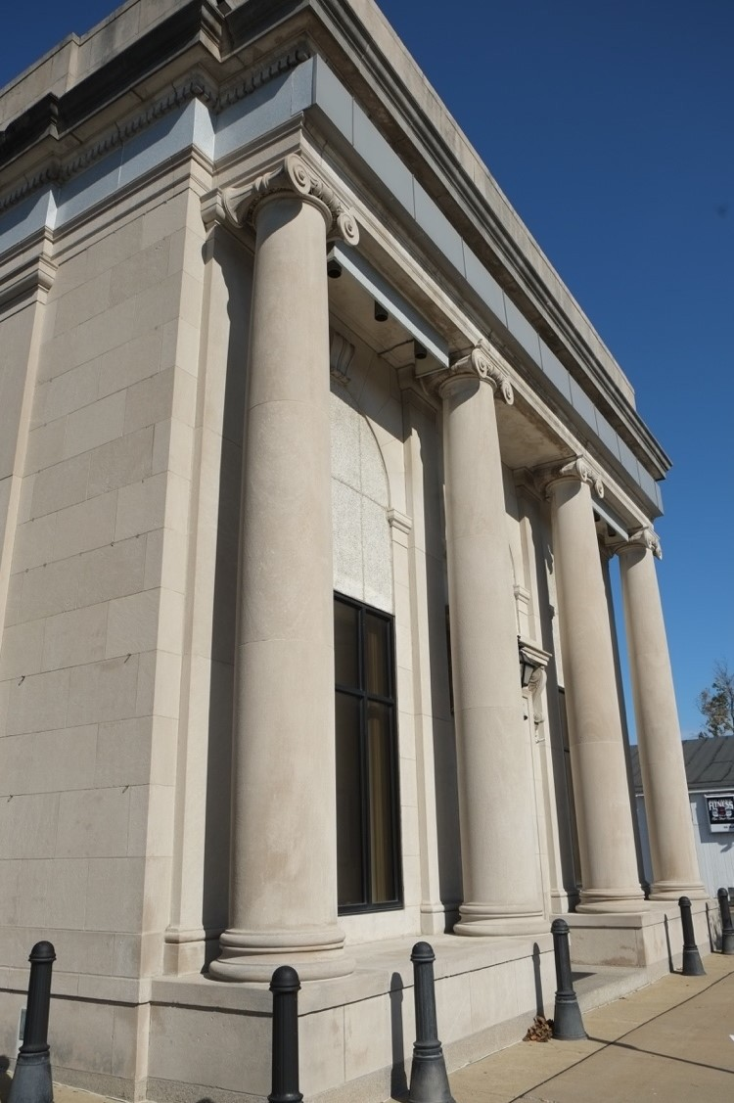

110 Main Street West
Property name: The National Bank^{xlviii}
Date of Construction: ca. 1915/addition 1978
Status: one contributing building
Parcel Number: 23011025000700

Description: A one-story, three-bay by five-bay flat asphalt roofed bank covered in sandstone on a cement foundation. A colonnade of four Ionic columns forms a short porch, framing the three round-arched bays that feature keystones and engaged pilasters. Central entry features a fully glazed double aluminum door, transom, and architrave with dentils supported by decorative brackets. East elevation has five identical bays with a dentiled cornice. All doors and windows are aluminum. Rear one-story flat-roofed concrete addition with a series of open arches was constructed in 1978.

History: The National Bank was organized in Girard in 1907 and the bank was constructed circa 1915.^{xlix} The National Bank operated in the building until at least 1948 and later became Penn Bank.^{l} Penn Bank was eventually taken over by Conneaut Savings Bank.

^{xlviii} Sanborn Fire Insurance Map, 1929.
^{xlix} “The Battles Bank,” http://paheritage.wpengine.com/article/battles-bank-honesty-collateral-chickens-paid-interest/.
^{l} Sanborn Fire Insurance Map, 1948.

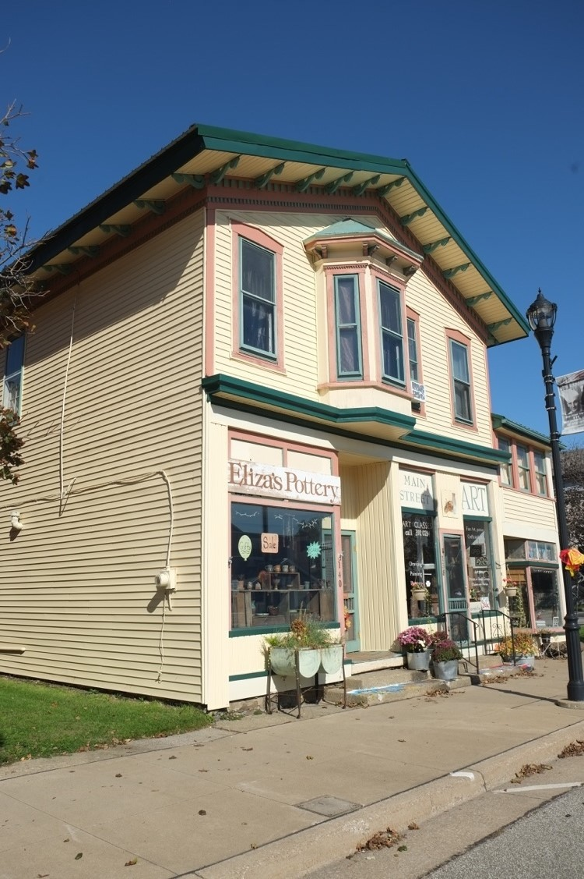

138-140 Main Street West
Property name: J. T. Simmons Saddlery Shop/Eugene H. Hiler, Jeweler
Date of Construction: ca. 1855^{li} Status: one contributing building Parcel Number: 23012032001601

Description: A two-story four-bay, front-gabled frame commercial building with a one-and-a-half story addition on the eastern side of the facade. The building has an aluminum roof, is clad in vinyl, and rests on a stone foundation. The first floor has three separate storefronts. From west to east, the westernmost storefront features a large wood frame plate glass window with recessed wood panels above a recessed entry. The central storefront features a central entry flanked by two large wood-framed plate glass windows with recessed panels above. The eastern storefront features a recessed entry with a large wood-framed plate glass window with a divided light transom above. All storefront doors have historic decorative wood-frame screen doors. The second floor has a hipped roof projecting bay with bracketed cornice in the second bay from the west; all windows on the second floor of the facade are one-over wood sash with wood surrounds. The roof features overhanging eaves with decorative brackets. The east elevation has multiple asymmetrical bays; the windows are a

^{li} J. Chace, O. McLeran, and Isaac W. Moore, Map of Erie County, Pennsylvania; from actual surveys, (Philadelphia: O. McLeran: Isaac W. Moore), 1855, Map.

combination of one-over-one wood sash or one-light casements, all with wood surrounds. The main block has center and rear brick chimneys.

History: John T. Simmons operated his saddlery and harness shop out of this building from around 1855 until around 1898. His son-in-law, Eugene Hiler, opened a jeweler business in the building around the time of Simmons death in 1898. A feed store also occupied a portion of the building at this time. Hiler added to the building by constructing two additions on the east side. Eugene’s son Carl joined him as co-owner of the Jeweler business by 1910 and they operated it together until 1918, when Carl died.^{lii} From 1929 through 1948, a combination of shops and restaurants operated out of the first floor with dwellings on the second floor.^{liii}
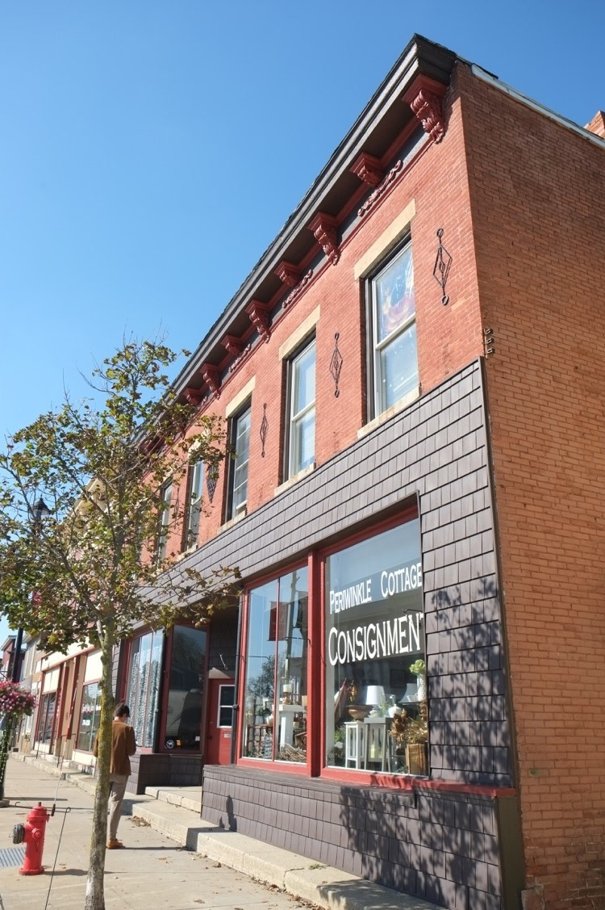

146-150 Main Street West Property name: Rockwell Block^{liv} Date of Construction: ca. late 1800s. Status: one contributing building Parcel Number: 23011025001000

^{lii} United States Federal Census, 1850-1920.
^{liii} Sanborn Fire Insurance Maps, 1898, 1904, 1912, 1929, 1938, 1948.
^{liv} French, National Register of Historic Places Nomination: Girard Historic District, Erie County, Pennsylvania, Girard, PA, Master List

Description: Two-story, six-bay by six-bay flat asphalt roofed commercial building covered in brick and vinyl shingle siding. Foundation is not visible. The first floor has three separate entrances and two storefronts. The entrances, which are recessed and centered on the first floor, contain partially glazed aluminum doors with vinyl surrounds. Each storefront has a series of three wood-framed plate glass windows that frame the entry doors.
All windows on the second floor are one-over-one aluminum sash with stone lintels and sills interspersed with decorative triangular iron ornament applied to the brick. The cornice features decorative scrolled brackets. The east elevation is entirely clad in brick and first and second-story windows are a combination of rectangular four- over-one and two-over-two aluminum sash with partially infilled segmental arch brick lintels and brick sills.

History: Charles F. Rockwell was a dry goods merchant who operated a business at this site from around 1855 to at least 1880.^{lv} The original building on the site was frame but appears as a brick dry goods store with a one- story frame portion in the rear on the 1898 Sanborn Fire Insurance Map. The current building was constructed sometime between 1877-1898. From 1904-1948, various shops such as a drugstore, dry goods, and millinery were operating in the building; the one-story frame portion was a ware room. In 1929, a two-story addition was added on the rear west side. The ware room was converted to a dwelling sometime between 1929 and 1938.^{lvi}

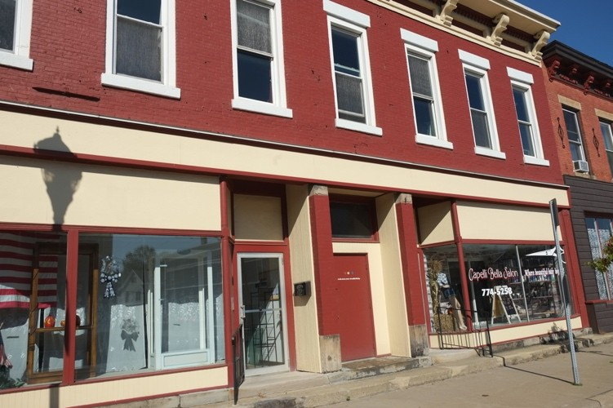

202 Main Street West
Property name: Kessel Block^{lvii} Date of Construction: ca. late 1800s Status: one contributing building Parcel Number: 23011025001100

Description: Two-story, seven-bay flat asphalt-roofed commercial building covered in brick with a concrete foundation. The first floor has two storefronts with two central recessed entries containing a fully glazed and solid aluminum door. Four brick pilasters capped in stone frame the entrances and storefronts. Each storefront has a series of two wood-framed plate glass windows with a large, recessed panel above. A similar panel acts as a belt course dividing the first and second floors. All windows on the second floor are one-over-one aluminum

^{lv} J. Chace, Map of Erie County, Pennsylvania; from actual
surveys, 1855; F. W. Beers, Atlas of Erie County, 1865; P.H. Dowling, Map of Girard, 1876; United States Federal Census, 1880.
^{lvi} Sanborn Fire Insurance Maps, 1898, 1904, 1912, 1929, 1938, 1948.
^{lvii} French, National Register of Historic Places Nomination: Girard Historic District, Erie County, Pennsylvania, Girard, PA, Master List

sash with stone lintels and sills. The dentiled cornice features recessed brick panels and decorative scrolled brackets.

History: John Kessel operated a barbershop in this location until at least 1880. The original building on the site was frame but appears as a two-story brick building with a one-story frame portion on the rear on the 1898 Sanborn Fire Insurance Map. The current building was constructed sometime between 1877-1898. ^{lviii} From 1904-1948, various shops such as a wallpaper shop, drugstore, laundry, and a bank and bookkeeping exchange operated in the building. By 1929, the rear frame addition was converted to a dwelling and an additional one- story addition was built on the rear west side of the building.^{lix}
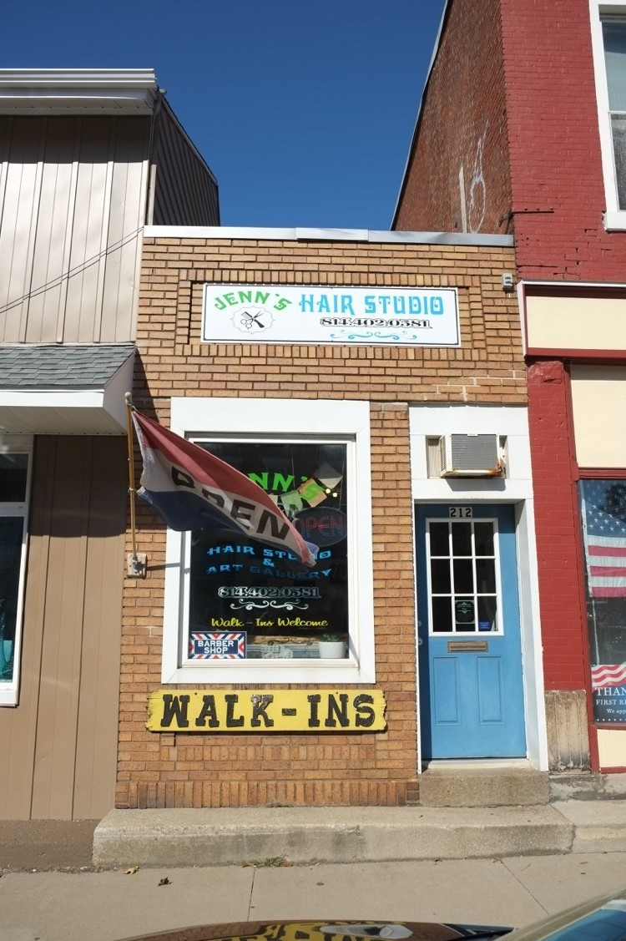

212 Main Street West
Date of Construction: ca. 1897 Status: one contributing building Parcel Number: 23011025001200

Description: One-story, two-bay flat asphalt roofed commercial building covered in brick. Foundation is not visible. Partially glazed vinyl entrance door in the east bay and rectangular fixed light with aluminum surround in the west bay. Soldier courses of brick frame the bottom of the facade as well as a recessed brick panel near the roofline. Roofline is capped in sheet metal.

History: In 1898, this was a jewelry shop. From 1912-1948, it operated as an insurance office.^{lx}

^{lviii} J. Chace, Map of Erie County, Pennsylvania; from actual
surveys, 1855; F. W. Beers, Atlas of Erie County, 1865; P.H. Dowling, Map of Girard, 1876; Sanborn Fire Insurance Map, 1898, United States Federal Census, 1880.
^{lix} Sanborn Fire Insurance Maps, 1898, 1904, 1912, 1929, 1938, 1948.
^{lx} Sanborn Fire Insurance Maps, 1898, 1904, 1912, 1929, 1938, 1948.

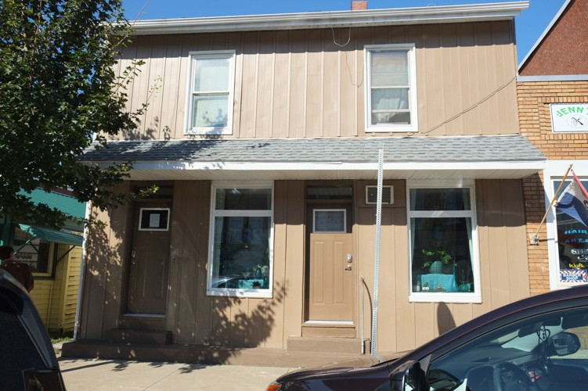

214-218 Main Street West
Property name: Strodmeyer Barber Shop
Date of Construction: ca. 1855 Status: one contributing building Parcel Number: 23011025001300

Description: Two-story, two-bay, side-gabled asphalt-roofed residence covered in aluminum siding on a stone foundation. First floor is divided into two sections, each has a partially glazed aluminum door with transom and a single casement window with transom. Full-facade shed roof divides the first and second floors. Second story windows on facade are one-over-one vinyl sash. West elevation has three, fixed-pane asymmetrical windows and a one-story shed-roofed addition in the rear.

History: Henry Strodmeyer worked as a barber in this building in the 1890s before passing along the business to his son, James Henry. James Henry lived in the building with his wife Kathryn and operated the shop through the 1940s. Burt Hathaway ran it for forty more years before retiring in the 1990s. Cady took over the shop in 1996 and today it is known as Cady’s Barbershop.^{lxi}

^{lxi} “Barbershop claims to be county’s oldest,” article from unspecified newspaper in Girard Town archives, October 27, 2001.

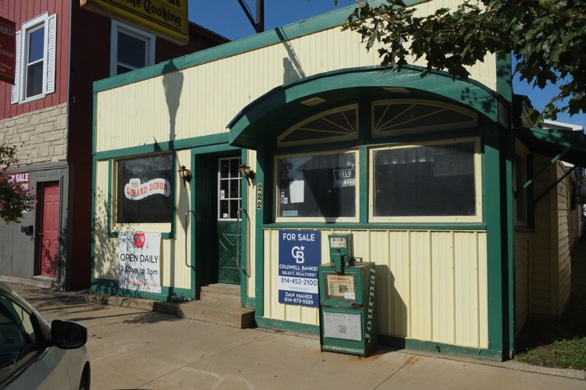

222 Main Street West Property name: Girard Dinor Date of Construction: 1913
Status: one contributing building
Parcel Number: 23011025001400

Description: One-story, four-bay, flat aluminum-roofed frame commercial building covered in aluminum siding. Foundation not visible. The roof, windows, door, and base of the facade are all framed in wood. From west to east, the front elevation features a plate glass window, a recessed entry with a partially glazed wood door, and paired plate glass windows with fanlights. A half-round wood canopy projects out over the paired windows. The east elevation contains one fixed-light window with a wood surround and an aluminum awning supported by brackets above. Three rear additions with no fenestration are visible on the east elevation

History: The Girard Dinor opened in 1913 and has been operating continuously as a diner through the present.^{lxii}
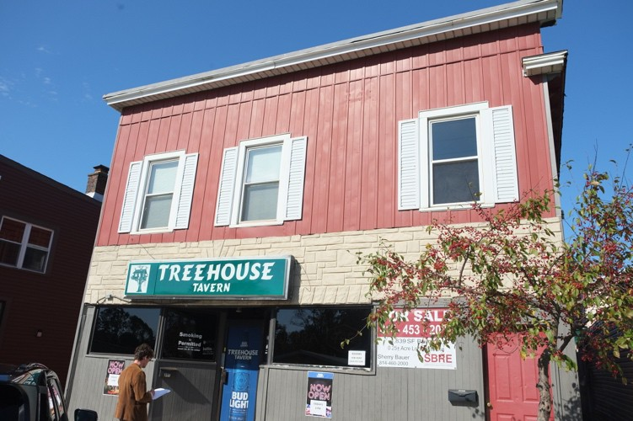

228 Main Street West
Date of Construction: ca. late 1800s
Status: one contributing building

^{lxii} “Community Gem: Girard Dinor,” accessed January 17, 2022, https://www.erienewsnow.com/story/45366552/community-gem- girard-dinor.

Parcel Number: 23011025001500

Description: Three-bay by ten-bay, flat asphalt-roofed frame commercial building covered in vinyl siding and wood vertical board. Foundation is not visible. From west to east, the first floor contains an off-center recessed entry with a fully-glazed aluminum door framed by four rectangular plate glass windows. The easternmost bay contains a six-panel aluminum door. All second-floor windows are two-over-two vinyl sash throughout.
Second-floor facade windows have vinyl shutters. West elevation has a projecting bay with a shed roof on the first floor and ten bays on the second floor.

History: From 1898 to 1904, this building operated as a saloon. It had a one-story portion in the rear and a detached one-story ice house. In 1912 it was “Ferrs” Hotel and Bar. From 1938 until at least 1948, the building housed a restaurant.^{lxiii}

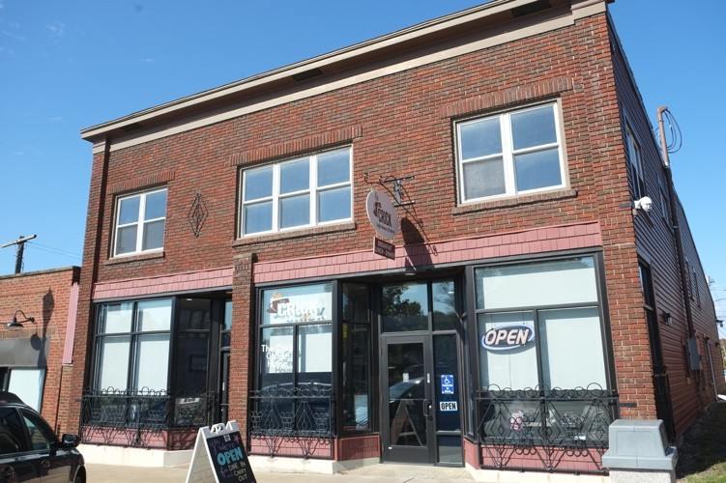

236 Main Street West
Property name: Plum Fish-Business
Date of Construction: Front portion ca. late 1800s, rear portion, ca. 1845
Status: one contributing building
Parcel Number: 23011025001600

Description: Two-story, three-bay by five-bay, flat asphalt-roofed commercial building covered in brick and vinyl siding with a stone and concrete foundation. A series of three brick pilasters interspersed with vinyl shingle siding, frame the two storefronts on the first floor. From west to east, the western storefront features three plate glass windows with transoms and a recessed fully glazed entry with transom. The eastern storefront has a central entry with a fully glazed glass door, sidelight, and transom framed by three plate glass windows with transoms on either side. Both storefronts are framed in aluminum. The second floor has paired vinyl one- over-one sash windows in the outer bays and a tripartite bay with the same windows in the center bay. All second-floor windows have flat brick arch lintels and brick sills. Plain cornice above. The east elevation has a combination of vinyl one-over-one sash, casement, and fixed windows with a separate vinyl entry door towards the rear of the building. The roof slopes down toward the rear.

^{lxiii} Sanborn Fire Insurance Maps, 1898, 1904, 1912, 1929, 1938, 1948.

History: The Plum-Fish Business Building is a remnant of the Canal Era. The rear portion of the building was constructed circa 1845.^{lxiv} From 1898 to 1912, this building housed a harness shop in the eastern portion of the building. Shops that occupied the western portion during this time were an office, millinery, doctor’s office, and a barber. From 1938 to at least 1948, the building housed a wallpaper shop and a paint shop.^{lxv}

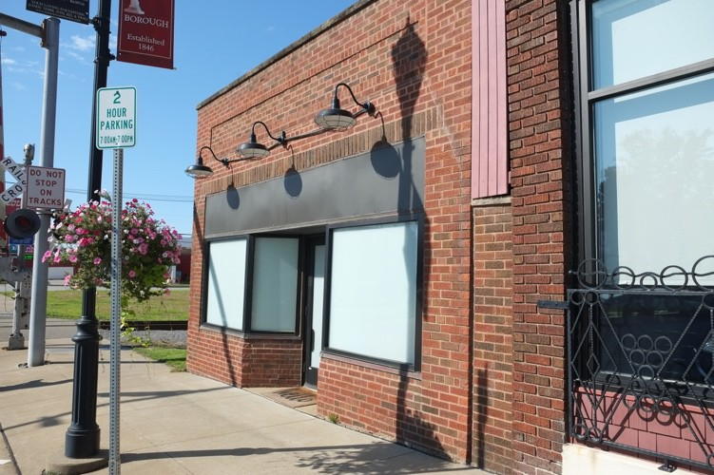

244 Main Street West
Property name: Hull Newsstand^{lxvi} Date of Construction: ca. 1920s Status: one non-contributing building Parcel Number: 23011025001700

Description: One-story, three-bay flat asphalt-roofed commercial building covered in brick. Foundation is not visible. First floor features a single store front with fully glazed recessed central entry door framed by two plate glass windows on either side. Entire storefront is framed in aluminum with an aluminum awning above. A brick soldier course runs almost the entire width of the building above the awning and a recessed brick panel is centered on the facade near the roofline which is capped in stone. The west elevation features a brick wall with a stepped gable parapet, devoid of fenestration. The roofline on this elevation is capped in metal coping.

History: This building first appears on 1929 Sanborn. In 1938, it is listed a shop.^{lxvii}

^{lxiv} French, National Register of Historic Places Nomination: Girard Historic District, Erie County, Pennsylvania, Girard, PA, Section 8, 2.
^{lxv} Sanborn Fire Insurance Maps, 1898, 1904, 1912, 1929, 1938, 1948.
^{lxvi} French, National Register of Historic Places Nomination: Girard Historic District, Erie County, Pennsylvania, Girard, PA, Master List of Buildings, 2.
^{lxvii} Sanborn Fire insurance Maps, 1929, 1938.

Olin Avenue – North Side of Street

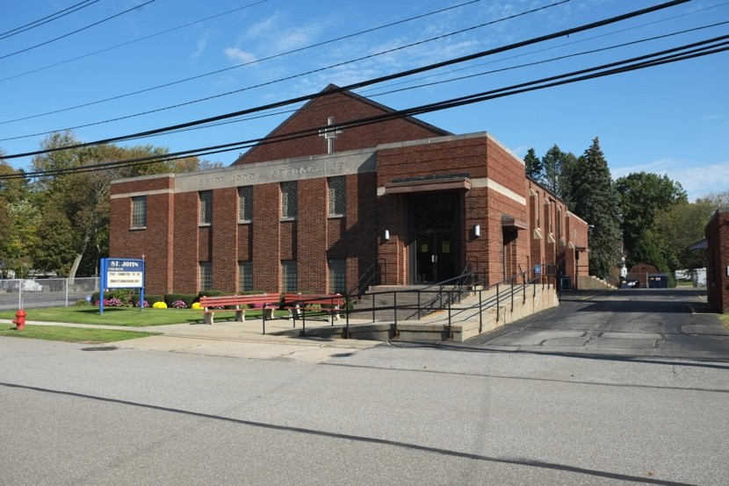

101 Olin Avenue
Property name: St. John the Evangelist Church
Date of construction: 1945^{lxviii}
Status: one contributing primary building and one contributing secondary building (garage).
Parcel number:

Description: Two-story, six-by-seven bay front-gable asphalt-roofed religious building covered in brick and sited on a cement foundation. Throughout the building, the first floor contains a combination of glass block and one-over-one sash windows with brick and stone sills; second floor features stained glass windows with stone sills. A wide stone band centered above the second story windows is engraved with the name of the church.
Side hall entry with a slightly projecting shed roof above a large glass transom and paired glass doors. Side elevations feature stone-capped brick piers that separate the bays. The property also contains a one-story, three- bay, flat asphalt-roofed brick garage. Garage bay doors are overhead and constructed of wood. A large chimney projects out of the rear of the building.

History: The church was built in 1945 and continues to operate today.

^{lxviii} “Saint John the Evangelist – Girard, PA – Roman Catholic Churches on Waymarking.com,” accessed January 4, 2022, https://www.waymarking.com/waymarks/wm12Z5T_Saint_John_the_Evangelist_Girard_PA.

- Statement of Significance

Applicable National Register Criteria
(Mark "x" in one or more boxes for the criteria qualifying the property for National Register listing.)

  - Property is associated with events that have made a significant contribution to the broad patterns of our history.
x
  - Property is associated with the lives of persons significant in our past.
Areas of Significance
(Enter categories from instructions.)
Commerce

Community Development Architecture

  - Property embodies the distinctive characteristics of a type, period, or method of construction or
x
represents the work of a master, or possesses high artistic values, or represents a significant
and distinguishable entity whose components lack individual distinction.

Period of Significance
1825-1955

  - Property has yielded, or is likely to yield, information important in prehistory or history.

Significant Dates
1825, 1846, 1955

Criteria Considerations
(Mark "x" in all the boxes that apply.)

Property is:

- Owned by a religious institution or used for religious purposes.

- removed from its original location.

- a birthplace or grave.

- a cemetery.

- a reconstructed building, object, or structure.

- a commemorative property.

Significant Person
(Complete only if Criterion B is marked above.)

Cultural Affiliation
N/A

Architect/Builder
N/A

- less than 50 years old or achieving significance
within the past 50 years.

Period of Significance (justification)

Criteria Considerations (explanation, if necessary)

Statement of Significance Summary Paragraph
(Provide a summary paragraph that includes level of significance and applicable criteria.)

The Girard Historic District is significant as an intact commercial corridor in Girard Borough, Pennsylvania, retaining a collection of resources that spans the era during which the Girard Borough was at the height of its prominence and success during the early-nineteenth and well into the twentieth century. The Girard Historic District is significant under National Register Criterion A in the area of Commerce and Community Development for its association with the growth and expansion of Girard during its years of economic success. The district owes its growth to three factors – the Erie Extension of the Pennsylvania Canal, Dan Rice, and the railroad. The Girard Historic district evolved around the Erie Extension Canal in the early-to-mid-nineteenth century; its opening coincided almost exactly with the establishment of the town. The engineer’s office was located in Girard and maintenance provided employment for the local population. In the mid-1850s, the canal brought Dan Rice to Girard, making the town the winter headquarters for his famous circus. Rice’s presence attracted other traveling shows that often used Girard for the same purpose. Additionally, Rice’s wealth was demonstrated in a number of civic improvements, including the Civil War monument, a focal point in the center of the district. Between 1855 and 1865, stable residential blocks fanned out on both sides of Main Street, providing a population base to support a commercial district.^{lxix} In 1871, operations of the canal ceased but the bed was subsequently converted to a railroad right-of-way. The Bessemer and Lake Erie Railroad did much to support the local economy in Girard, particularly during the first half of the twentieth century. The B&LE connected with the major east/west line just north of the town, making Girard a transshipment point.^{lxx} The Girard Historic District experienced substantial growth and the complete build-out of the district in the mid- twentieth century.
The district is also significant under Criterion C in the area of Architecture as a largely intact commercial corridor that retains a historic streetscape and buildings illustrating the growth and development of Girard between 1825 and 1955. The thirty-five contributing buildings, one site, and one object in the district retain integrity of design, materials, and craftsmanship, and, as a group, retain integrity of setting and location. The district encompasses representative examples of popular architectural styles including Georgian, Greek Revival, Gothic Revival, Italianate, Romanesque Revival, and Classical Revival, as well as some examples of mid- twentieth century Modern architecture.
The period of significance extends from 1825-1955 and encompasses development of the district beginning with the construction of the town’s first extant historic building in 1825, its subsequent incorporation in 1846, through mid-century when the last major development project, the addition of a school at the First Methodist Episcopal Church was constructed. A bill signed by Dwight D. Eisenhower in 1956 for construction of I-90 through Pennsylvania, effectively ended further expansion of Girard.^{lxxi} The highway allowed travelers to bypass the small shops in town and Girard saw its first ever lull in population growth between 1950 and 1960.lxxii

^{lxix} J. Chace, O. McLeran and Isaac W. Moore, Map of Erie County, Pennsylvania; from actual surveys, (Philadelphia: O. McLeran and Isaac W. Moore), 1855 Map. F.W.Beers, Atlas of Erie County, Pennsylvania, (New York: F.W. Beers, A.D. Ellis & G.G. Soule), 1865, Map.
^{lxx} John R. Claridge, Historic Resource Survey of Erie County: Girard Historic District, (Erie, Pennsylvania: Erie County Historical Society), January 1987, 1-2.
^{lxxi} “Pennsylvania Highways: Interstate 90,” accessed December 28, 2021, https://www.pahighways.com/interstates/I90.html.
^{lxxii} “Index of/Prod2/Decennia/Documents,” accessed December 22, 2021, https://www2.census.gov/prod2/decennial/documents/.

Narrative Statement of Significance

Community and Commercial Development of Girard Borough
In 1790, 202,187 acres were annexed to the State of Pennsylvania on both sides of Lake Erie (Figure 3).^{lxxiii} In 1806, after improving and settling the land, John Taylor purchased 400 acres of the annexed land along the northern boundary of the state from the Commonwealth of Pennsylvania. ^{lxxiv} The site of the present borough was part of Taylor’s farm; his residence (not extant) was the first recorded building in the vicinity.^{lxxv} His home was located on the north side of the Ridge Road on the site of the present day First Methodist Episcopal Church (1868, extant, Photo 10).^{lxxvi} The Ridge Road (Route 20, opened in 1805) was largely an extension of the Buffalo Road. It followed the line of the First Ridge and traversed the western part of Mill Creek and the entire width of Fairview, Girard, and Springfield townships to the Ohio state line. ^{lxxvii} Initially called The Settlement on the Hill, the borough was first settled in 1814 and was mainly agricultural with just a few scattered farms.
The only remaining farmhouse in the district is the Wells-Hutchinson House (1825) at 172 East Main Street (Photo 8).
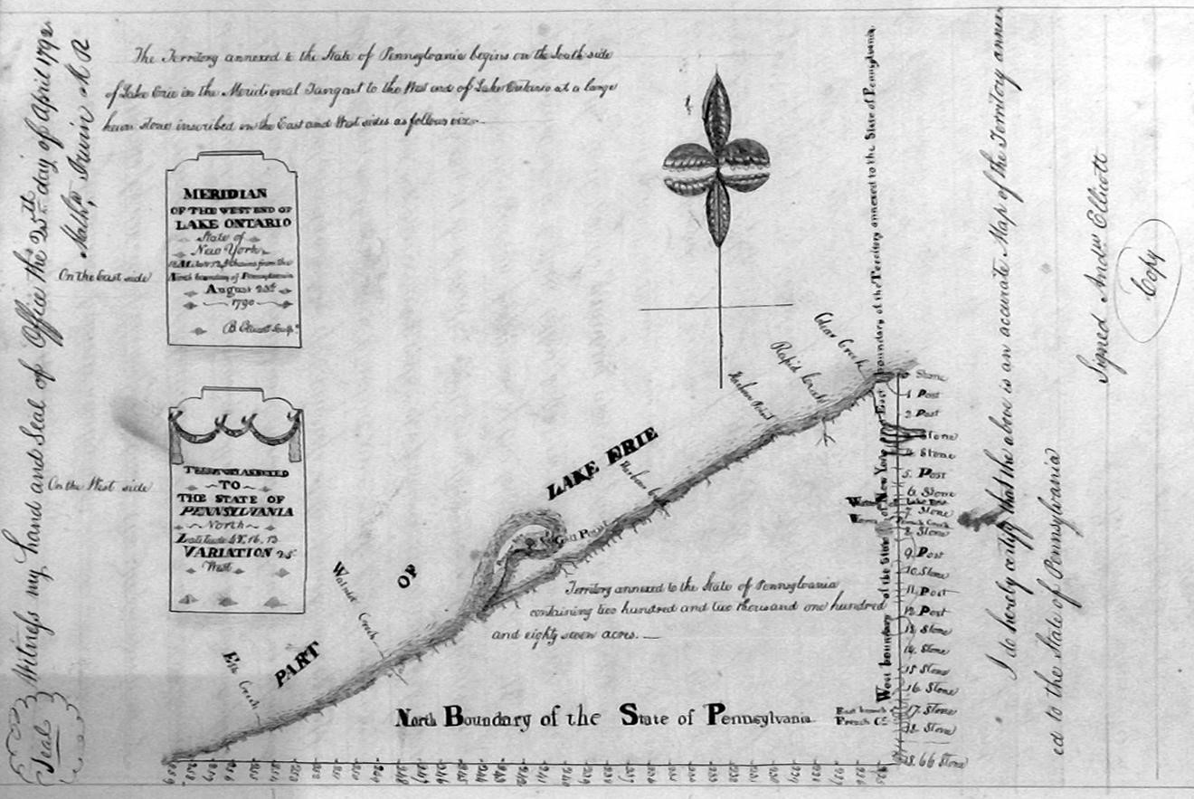
Figure 3: 1790 Survey of the Northern Boundary of the State of Pennsylvania

^{lxxiii} Andrew Ellicott, Survey of the Erie County Triangle, Erie, Pennsylvania, 1790.
lxxivPennsylvania, U.S., Land Warrants and Applications, 1733-1952, Erie, PA-1806.
lxxvLaura G. Sanford, History of Erie County, Pennsylvania, (Philadelphia: J.B. Lippincott & Co.), 1862, 200. ^{lxxvi} John Kelley, “Many Famous Personages Born in Little Borough,” Girard Centennial, January 16, 1932, 12. ^{lxxvii} History of Erie County, (Chicago: Warner, Beers & Co.), 1884, 234.

Girard Township was formed by petition in 1832 from land given by Elk Creek, Fairview, and Springfield Townships (Figure 4). Early settlements in what is now Girard Township are the Hollow (known as West Girard) and the Mouth of Elk Creek, both settled in 1800, as well as Settlement on the Hill. The name Girard was put on the list of possible names for the town due to the recent death of Stephen Girard, the great Philadelphia philanthropist who died in 1831. Girard owned large tracts of land in Erie County.^{lxxviii} When the name was put to a vote, Girard was selected, and the town was named for him posthumously.
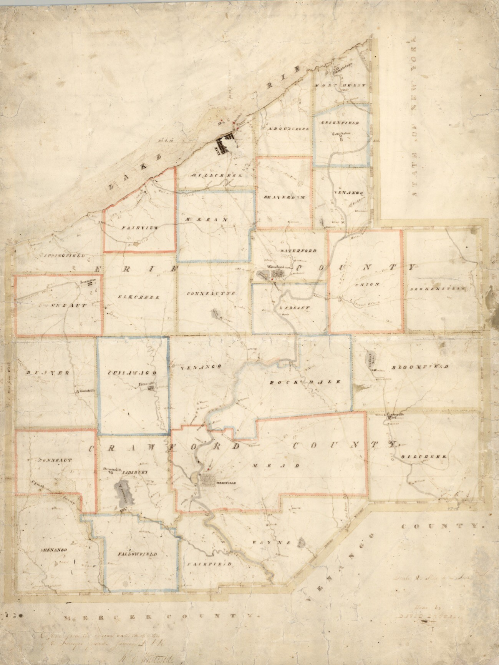
Figure 4: 1822 Map of Erie and Crawford Counties^{lxxix}

^{lxxviii} Gwindle, “About,” Girard Borough, Erie County, Pennsylvania, n.d., accessed December 20, 2021, https://girardborough.com/about/.
^{lxxix} 1822 Map of Erie and Crawford Counties accessed January 11, 2022, http://www.phmc.state.pa.us/bah/dam/rg/di/r17- 534WhitesideMaps/r017_0534_0000_3357_ErieAndCrawfordCounties.pdf.

As American settlement moved westward, settlers focused their efforts and resources on the construction of centralized towns in order to distinguish their locales and foster economic enterprise. As a result, the prosperity of a settlement depended on the presence of an attractive and concentrated built environment for conducting commerce, which often took the form of a dense business district oriented along a single axis. Architectural historian Richard Longstreth summarizes the pattern of development:
Even in the frontier town, many of the earliest and finest permanent buildings were erected to house commercial enterprises. Businesses were intentionally clustered in more or less central districts. This was not only instrumental in giving a town its identity, but also provided a focus for its activities. Main Street became to America what the piazza was to Italy.^{lxxx}
Girard Borough developed similarly, initially, as a result of an important transportation route that cut through the area: the Erie Extension Canal which was completed in 1842.^{lxxxi} Walter Jack explains the canal’s construction in Girard:
Girard possessed a great aqueduct over Elk Creek, south of the boro. This carried the canal from one high bank to another. It was supported by timbers 125 feet in length, which bore the great wooden trough and tow path line. The aqueduct was nearly a quarter of a mile long. It was considered one of the world’s stupendous jobs of engineering, in which timber was used.^{lxxxii}
As the borough attracted canal traffic, commercial activity in the village expanded to accommodate the influx of travelers. Much of the development in the area occurred in the commercial district that grew just east of the Erie Extension Canal. One enterprising settler, Theodore Ryman, came to Girard prior to the construction of the canal to enter the hat manufacturing business and built his hat and cap shop (31 Main Street East, extant, Photo 1) at the intersection of Main Street and Walnut Street around 1832, making this the oldest commercial building within the boundaries of the Girard Historic District.^{lxxxiii} He was joined by other men who each built a section for their business of what would become known as Keystone Block. A middle section was added to this building shortly after 1832 and an end section about twelve years after that. The middle and end sections have since been demolished.^{lxxxiv} Upon Theodore’s death in 1884 his son, William T. Ryman took over the hat and cap shop and changed the business to a retail boots and shoes shop sometime between 1896 and 1900.^{lxxxv} William operated the shop until at least 1946.^{lxxxvi}
Completion of the canal ushered in the early stages of Girard as an admittance point for goods and gave passengers a direct north-south route to connect with the burgeoning railroads that largely traveled east and west at the time. A trip from Erie to Pittsburgh that once took days by wagon or horseback over rough country roads and Indian trails, could now be accomplished in thirty-six hours by packet-boat at a cost of four dollars.^{lxxxvii} This pioneering waterway encouraged the development of Girard to provide services for tourists and trade.

^{lxxx} Richard Longstreth, The Buildings of Main Street: A Guide to American Commercial Architecture, (California: AltaMira Press), 1987, 13.
^{lxxxi} Girard was originally established in a location west of the current borough. It was moved to its present spot to encompass a stretch of the Erie Extension Canal that cut through the borough on its western end.
^{lxxxii} Walter Jack, “Girard, Rich in Traditions,” The Erie Motorist, February 1946, 10, 13, 19.
^{lxxxiii} “Ryman Store The Oldest on Route 20,” Erie Daily Times, August 14, 1946. ^{lxxxiv} “Ryman Store The Oldest on Route 20,” Erie Daily Times, August 14, 1946. ^{lxxxv} United States Federal Census, 1900; Erie County Directory, 1896, 353.
^{lxxxvi} Erie Daily Times, August 15, 1946.
^{lxxxvii} “Erie Extension Canal,” Erie Extension Canal, n.d., accessed December 21, 2021, https://eriehistory.blogspot.com/2017/04/erie- extension-canal.html.

Although settlement had been slow before the construction of the canal, once it was completed, settlers began rapidly moving to the area. Subsequently, Girard grew and was incorporated as the Borough of Girard in 1846.^{lxxxviii} Joseph Wells, a major landowner, donated property for the centrally located Village Green (extant) when the town was first laid out.^{lxxxix} By 1850, the population of Girard had grown to 400.^{xc} The organization of a school, two churches, and a post office soon followed.^{xci}
The specificity and density of the building forms along a typical main street distinguished a commercial district from the residential districts it served.^{xcii} A map of properties in the area from 1855 (Figure 5) depicts commercial buildings lining either side of Main Street between Walnut Street and the Erie Extension Canal, while the remaining blocks of Main Street remain much less densely settled.
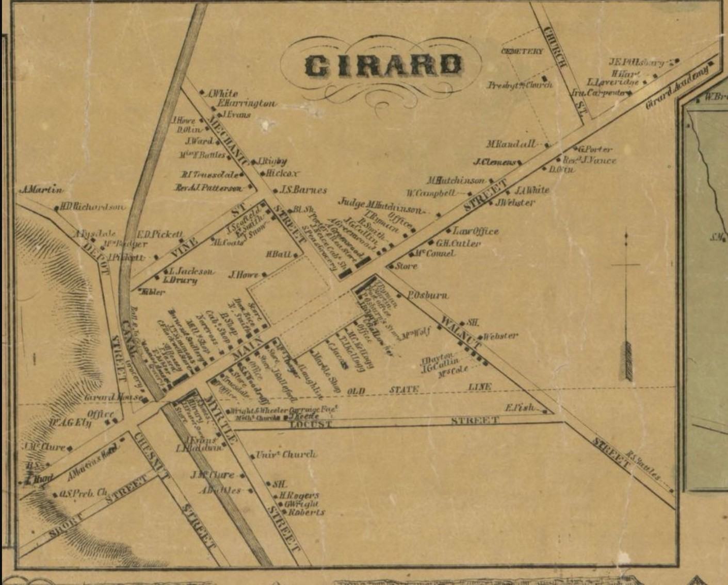
Figure 5: Chase, Map of Erie County, 1855

^{lxxxviii} “History & More,” accessed December 21, 2021, https://girardlakecity.org/history.
^{lxxxix} History of Erie County, 1884, 846.
^{xc} History of Erie County, (Chicago: Warner, Beers & Co.), 1884, 84.
^{xci} Sanford, History of Erie County, 1862, 99.
^{xcii} Richard Francaviglia, Main Street Revisited, (Iowa City: University of Iowa Press), 1996, xx; Longstreth, The Buildings of Main Street, 16.

By 1855, two hotels as well as commercial buildings including a lawyer’s office, two groceries, two cabinet makers, a millinery, hat manufacturer, saddlery, and carriage shop had been constructed along Main Street.^{xciii} Josiah Nece, a successful cabinet maker constructed his cabinet shop (18 Main Street East, extant, Photo 3) on Main Street just east of Mechanic Street around 1855. The shop housed his cabinet business until at least 1880 and later became a harness shop and carriage shop operated by Emmett L. Hanson from 1898 through the early 1920s.^{xciv} John T. Simmons opened his saddlery shop (138-140 Main Street, extant, Photo 4) in the mid-1850s and operated his business through at least 1880, housing apprentices in his home while training them. Simmons died sometime between 1880 and 1898 when the property was taken over by his son-in-law, Eugene H. Hiler, who opened a jeweler business in the building and operated it until at around 1918.^{xcv}
A post office was opened in the Keystone Block (not extant) in the mid-1850s with Monroe Hutchinson serving as postmaster. Monroe’s home and farm were located just east of the post office at 172 Main Street East (ca.
1825, extant, Photo 8). The first bank (not extant) was also located in the Keystone Block. It was organized in Girard in 1859 under the name of R.S. Battles and C.F. Webster, Cashier.^{xcvi} Battles and Webster were two young men from prosperous families in Girard. Prior to organizing the bank, both gentlemen had frequently been asked by their acquaintances to hold money for safekeeping. Recognizing the potential of using these resources to finance other projects, they decided to open a bank. During the eighteenth and early nineteenth centuries, federal banks were viewed as an infringement on state rights. State banks had fewer restrictions and began organizing in larger number in the early 1800s. Bank failures were a common problem since banking institutions paid in specie or issued their own notes which were easily counterfeited. Most people had greater confidence in individuals like Battles and Webster to manage their financial matters than in the government and frequently respected merchants were the agents for money transactions.^{xcvii}
Around the same time, Dan Rice, the nationally famous circus owner, arrived by canal in 1853 and built a mansion in the middle of town (not extant) where he lived for about twenty years. Rice chose Girard because it was a prime spot to base a traveling show and he established this site as his winter quarters for his new circus troupe. Trains connected it to the east and west and the Erie Canal linked Rice’s riverboat to the great south.
Dan Rice created the touring American circus and was the premier showman of his era. His show was called “the greatest show on earth” long before Ringling Brothers formed. As well as being a one of the nation’s first professional clowns, Rice was also an actor, director, producer, songwriter, and even a presidential candidate.^{xcviii} Rice supported the Union during the Civil War and became known for wearing a flag suit and portraying the image of Uncle Sam. He would deliver humorous political monologues, a common act during this era. He put Girard on the map by erecting the first Civil War monument (extant, Photo 5) in the center of town on November 1, 1865. The unveiling was covered by Harper’s Weekly and would have been attended by President Lincoln had he not been assassinated several months prior; however, the governors of both Ohio and Pennsylvania attended.^{xcix} His arrival and residence attracted other circus acts to Girard and over time it became

^{xciii} United States Federal Census, 1860-1900; J. Chase, Map of Erie County, 1855, F. W. Beers, Atlas of Erie County, 1865; Sanborn Fire Insurance Map, 1898, 1904, 1912, 1929, 1938, 1948.
^{xciv} 1880 and 1900 Federal Census; Sanborn Fire Insurance Map, 1898.
^{xcv} 1850-1900 Federal Census; J. Chase, Map of Erie County, Pennsylvania, 1855; F.W. Beers, Atlas of Erie County, Pennsylvania, 1865; Dowling, Map of Girard, 1876; 1898 Sanborn Fire Insurance Map.
^{xcvi} History of Erie County, 1884, 849.
^{xcvii} “The Battles Bank: When Honesty Was Collateral and Chickens Paid Interest,” Pennsylvania Heritage Magazine, accessed January 14, 2022, http://paheritage.wpengine.com/article/battles-bank-honesty-collateral-chickens-paid-interest/.
^{xcviii} Barry Casselman, “Back in the Day: Erie’s Circus History, Erie Reader, August 9, 2013.
^{xcix} Gwindle, “About,” Girard Borough, Erie County, Pennsylvania, n.d.; “Girard Boasts Numerous Historical Resources,” Erie County,
August 11, 1948.

known as a “show town.” At least six shows were organized in the borough due to Dan Rice: the Thayer and Noyes Show; Dan Rice Show; the Rice and Forepaugh show; Henderson’s; Anderson and Company; and G.R. Spalding & Company. Showman and other notables came to W.T. Ryman’s Boots and Shoes shop in Girard to have their high top calfskin boots made to order.^{c}

Photo 5: Civil War Monument erected by Dan Rice in 1865, view southwest

By 1860, the population of Girard swelled over fifty percent to 616. ^{ci} By 1862, there were two carriage shops, a steam planning mill, and the requisite stores and shops for the population of the town and vicinity.^{cii} By 1865, Girard’s streets had achieved their current configuration with the exception of Pennsylvania Avenue, (Figure 6).^{ciii} Development continued as several more businesses opened in Girard in the 1860s. John H. Gulliford and David M. Olin built the Union Block (65-71 Main Street West, extant, Photo 9) around 1865 to carry on their

^{c} History of Erie County, 1884, 849; Walter Jack, “Girard, Rich in Traditions,” The Erie Motorist, February 1946, 10, 13, 19.
^{ci} J. Chase, Map of Erie County, Pennsylvania, 1855.
^{cii} Sanford, History of Erie County, 1862, 210; History of Erie County, 1884, 84.
^{ciii} French, National Register of Historic Places Nomination: Girard Historic District, 1987, Section 7, 4.

family businesses which were established in 1839 and previously housed in separate buildings. Gulliford operated his business in the western portion of the store and sold silver, hardware, and furniture, Olin sold woolens from the eastern portion. In the late nineteenth to early twentieth century, the building housed a furniture and hardware store as well as a lodge. The lodge remained in the building until at least 1948.civ From around 1865 to 1900, James H. Nichols operated his grocery at 229 Main Street West (extant).^{cv} One of the early churches was the First Methodist Episcopal Church at 48 Main Street East (1868, extant, Photo 10). The congregation was organized in 1815 and built their first church in 1828 (not extant). The cost of the church was
$30,000, a substantial sum at the time.^{cvi}

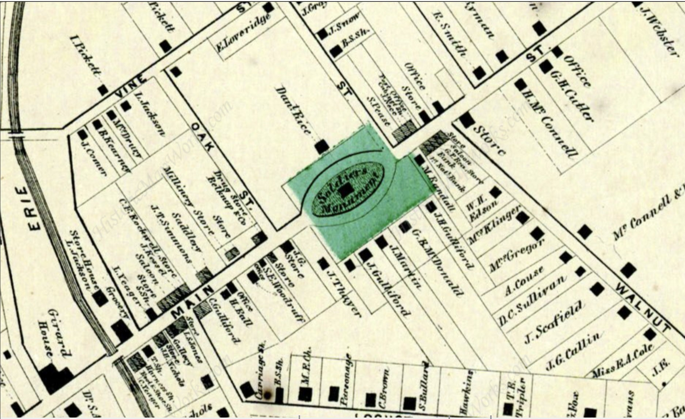

Figure 6: F.W. Beers, Atlas of Erie County, Pennsylvania. New York: 1865.
Several important developments occurred during the 1850s and 1860s as construction along Main Street accelerated, and canal transportation intensified. In the early 1850s, Girard Academy opened outside of the district with 150 students. Societies and organizations soon followed with the organization of Exodus Lodge, No. 343, and the Independent Order of Good Templars, the Young Men’s Literary Association, and the Girard Lyceum.^{cvii} T.C. Wheeler and William S. Finch published the first issue of the Girard Republican in 1854, a successor to the borough’s first newspaper, the Girard Free Press. The conservative nature of the paper was

^{civ} Sanborn Fire Insurance Maps, 1898, 1904, 1912, 1929, 1938, 1948.
^{cv} F. W. Beers, Atlas of Erie County, 1865; United States Federal Census, 1870, 1880, 1900.
^{cvi} History of Erie County, 1884, 84.
^{cvii} Sanford, History of Erie County, 1862, 147,154-155.

denoted by the motto, “Independent of all subjects, rabid on none.” By 1868, the paper was renamed Cosmopolite with Charles Stowe as editor.^{cviii} In the early 1860s, several citizens made an application for an act of incorporation to establish a cemetery in or near the Borough. The application was granted on March 14, 1861, and the cemetery is located on Church Street, just east of the district.^{cix}
Girard experienced a downturn in development after the collapse of the Erie Canal Extension in 1871 but entered a period of economic success in the late nineteenth and early twentieth century. Over time, the railroad was viewed as a more efficient mode of transportation. Unlike a canal system, it wasn’t dependent on the weather to have an adequate water level and tracks were cheaper and could be laid anywhere, providing limitless opportunities for the transportation of goods and passengers. The official end of the canal system occurred in September of 1871 when the 500 foot long aqueduct that carried canal boats 100 feet above the Elk Creek Gorge near Girard caved in.^{cx} The negotiations of Rush Battles and several businessmen to bring the Pittsburgh, Shenango and Lake Erie Railroad to Girard was the impetus for this change. The new railroad followed the route of the old canal, and a depot (extant, outside of district) was constructed off of Main Street in Lake City to the north.^{cxi} On Memorial Day in 1891, the first excursion came through accompanied by “the roar of cannon, toots and whistles, cheer after cheer from the immense crowd.”^{cxii}
With the railroad came industrial growth, providing new jobs and driving a major surge in the consumer base for the businesses along Main Street.^{cxiii} The railroad brought the raw materials to allow industry to flourish and the period between 1890 to 1910 saw the establishment of twelve industries involved in wood and metal products in the area outside of the district. The Girard Wrench Manufacturing Company and the Theo J. Ely Manufacturing Company are two examples. The Girard Wrench Manufacturing Company (incorporated in 1902) produced wrenches and Ely manufactured wooden mop buckets, mop handles, carpet beaters, crosscut saw handles, cow pokes, and buggy whips, all considered cutting edge at the time.^{cxiv}
These industries became sources of industrial employment that drew people to Girard Borough. This surge of growth caused the need for a new housing subdivision and Pennsylvania Avenue was laid out in the 1890s between Olin Avenue and Church Street. Two new commercial buildings became the products of this period, the R.S. Battles Bank at 12 Main Street East, (1893, extant, Photo 15) and Wilcox Library at 8 Main Street East (1893, extant, Photo 14). Battles Bank, owned and operated by Rush Battles, became the regional bank for the west county.”^{cxv} Mr. Robertson Wilcox, of Girard, bequeathed $5000 for the public library to be built in the borough. A number of well-known citizens and businessmen were selected as incorporators whose names appeared on the charter: Mrs. C.F. Rockwell, W.C. Culbertson, A.M. Clark, Mrs. R.S. Battles, A.R. Smith, S.S. Ely, Mrs. U.P. Rossiter, and J.C. Murphy. Five directors to serve for the ensuing year were also elected: Frank May, C.F. Rockwell, R.S. Battles, George W. Kibler, and O.D. Van Kamp. On October 17, a public ceremony was held, the cornerstone was laid, and public school children sang “America.” A prayer was offered by Rev.

^{cviii} History of Erie County, 1884, 849.
^{cix} Sanford, History of Erie County, 1862, 149.
^{cx}“Erie Extension Canal,” Erie Extension Canal, n.d.; http://paheritage.wpengine.com/article/battles-bank-honesty-collateral- chickens-paid-interest/, accessed January 14, 2022.
^{cxi}“Nickel Plate in the Erie Triangle,” Nickel Plate Road Magazine, Fall, 2015, accessed January 25, 2022, https://static1.squarespace.com/static/5be23b9196d455a4b380589c/t/5e20cbcf599a244d6ba5409c/1579207650426/NKPM+2015- 4+Falll+rez+for+web.pdf.
^{cxii} “The Battles Bank,” accessed January 14, 2022, http://paheritage.wpengine.com/article/battles-bank-honesty-collateral-chickens- paid-interest/.
^{cxiii} Jim Booth, “Girard: A community of winners,” Times-News, April 17, 1988.
^{cxiv} Gwindle, “About,” Girard Borough, Erie County, Pennsylvania, n.d.
^{cxv} French, National Register of Historic Places Nomination: Girard Historic District, Erie County, Pennsylvania, Girard, PA, Section 8, 4.

C.D. Shipman, and appropriate remarks by Dr. O. Logan. Mrs. C.F. Rockwell read a list of the contents of the box that were deposited under the library’s cornerstone. ^{cxvi}

Other businesses soon followed. Glen McClelland opened his grocery at 77-83 Main Street West (extant, Photo 6) around 1897 and continued to operate it out of the same building until at least 1940. Around the same time, another grocery and millenary opened at 103-105 Main Street West (extant) as well as two jewelers, a saloon, printing business, drugstore, two wallpaper shops, hand laundry, and a harness shop^{.cxvii} Due to the growth and development of the community and the commercial district, the population grew from 626 to 954 between 1890 and 1900. ^{cxviii}

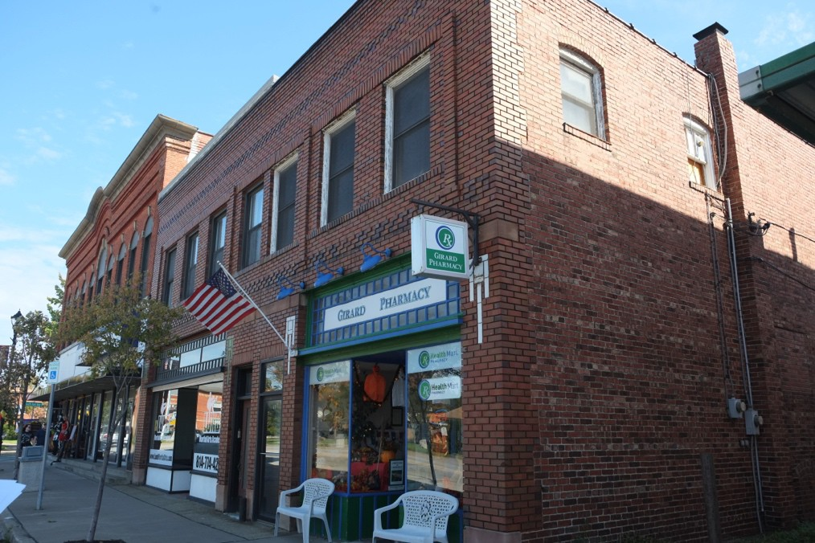

Photo 6: 77-83 Main Street West, view southeast

While only a few buildings had been constructed in the very early 1900s, many new businesses opened in the existing commercial buildings. Between 1900 and 1915, a new millinery, barbershop, steam laundry, bookkeeping exchange, furniture and carpet store, and tailor began operating in the Girard Historic District. The Independent Order of Odd Fellows (IOOF), Nickle Plate Lodge was organized on the top floor of 143-145 Main Street West (ca. 1912, extant, Photo 7) and remained there through until at least 1948. The name Nickel Plate Lodge is most probably a nod to the Nickel Plate Road.^{cxix} The IOOF was a global, altruistic and benevolent

^{cxvi} Laura G. Sanford, The History of Erie County, Pennsylvania from its first settlement, (Erie County: Laura G. Sanford), 1894, 432.
^{cxvii} Sanborn Fire Insurance Maps, 1898, 1904, 1912, 1929, 1938, 1948; United States Federal Census, 1900-1940.
^{cxviii} American Agriculturist Farm Directory and Reference Book of Erie County Pennsylvania, 1918, (Chicago: Orange Judd Company), 1918, 8.
^{cxix} Nickel Plate Road is the nickname for a railroad line that ran through Girard. It earned the nickname because when it was being planned, there were four lines surveyed for the position. The competition was fierce for not only the line but also the money that would be earned by having the railroad in the respective towns and cities. It was referred to as “Nickel Plated” due to the money that it would bring: “History of the Trail – Nickel Plate Trail,” n.d., accessed January 25, 2022, https://www.nickelplatetrail.org/about-the-nickel-plate-trail/history-of-the-trail/.

fraternal organization derived from the British service organizations of the seventeenth century. The organization was founded in Baltimore, MD on April 26, 1819.^{cxx}

R.S. Battles Bank had been the sole operating bank in Girard Borough until the early 1900s. Having identified the need for a second bank in the area to support the district’s rapid commercial development, the National Bank organized in Girard in 1904 and constructed a bank at 110 Main Street West around 1915 (extant, Photo 19) .^{cxxi} During this time, Girard Borough’s population grew to 1165. ^{cxxii}

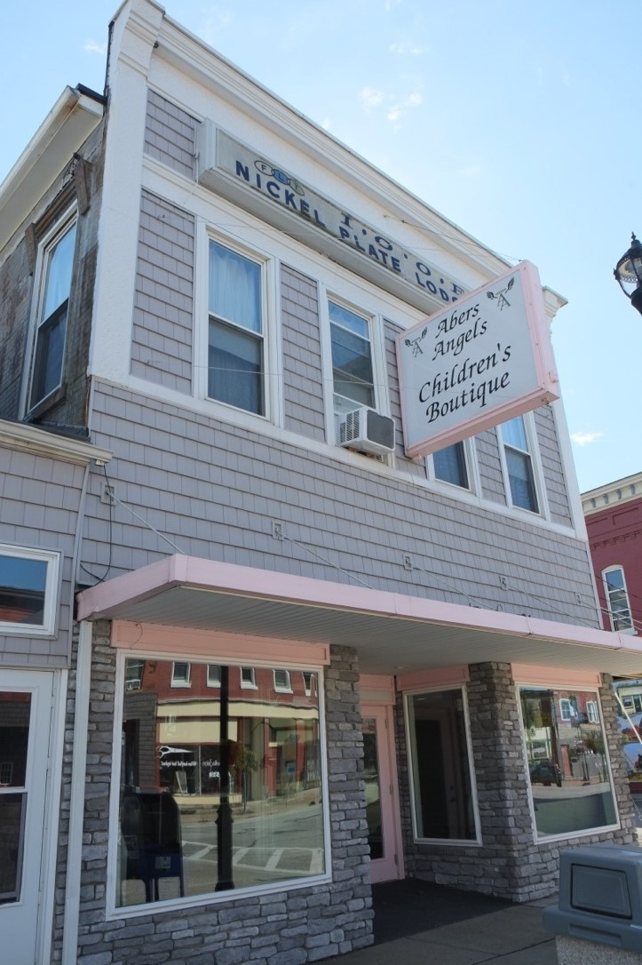
Photo 7: 143-145 Main Street West, view southwest

Girard’s population continued to increase into the 1920s and rose to 1,242.^{cxxiii} Around this time, the Girard Model Works, manufacturer of tin toys, opened up on Prospect Street just outside of the district.^{cxxiv} The new

^{cxx} “Odd Fellows,” Independent Order of Odd Fellows, September 29, 2017, accessed January 26, 2022, https://odd- fellows.org/about/odd-fellows/.
^{cxxi} “The Battles Bank: When Honesty Was Collateral and Chickens Paid Interest,” http://paheritage.wpengine.com/article/battles- bank-honesty-collateral-chickens-paid-interest/.
^{cxxii} American Agriculturist Farm Directory and Reference Book of Erie County Pennsylvania, 1918, (Chicago: Orange Judd Company), 1918, 8.
^{cxxiii} “Girard, PA Population,” accessed January 26, 2022, https://population.us/pa/girard/.
^{cxxiv} Sanborn Fire Insurance Maps, 1912, 1929.

industry drew more people into the area for employment opportunities and the rising population bolstered the commercial enterprises in the Girard Historic District. Additionally, automobile ownership in the 1920s increased greatly, with the number of drivers nationally almost tripling to 23 million by the end of the decade. The rapid growth of the industry led to dozens of spin-off industries, and during this time Lutz Garage, an auto sales and service station, opened up at 66 Main Street West (extant, Photo 2) to meet the needs of local residents.^{cxxv}
Another new enterprise opened in Girard around this time. The Mutual Telephone Exchange, an independent telephone company, at 123 Main Street West (extant) began operations in the commercial district in the 1920s.The independent telephone industry began to develop in rural America in the 1890s. After the publication of a manual that explained to farmers how they could develop their own telephone systems on a mutual or cooperative basis, many mutual systems emerged throughout rural America. By 1912, the number of rural telephone systems had grown to more than 3,200 and increased after World War I. At its high point in 1927, the rural telephone industry included some 6,000 mutual systems and other organizations.^{cxxvi} The Mutual Telephone Exchange continued to operate in Girard until at least 1948.^{cxxvii}

The population of Girard Borough continued to climb in the decades leading up to the middle of the twentieth century. Between 1930 and 1950, the population of the Borough rose from 1,554 to 2,121, in part due to the abundance of employment opportunities available as companies increased production during World War II.^{cxxviii} Government and commercial enterprises also continued to develop during this period. In 1941, a new Post Office was constructed at 113 Main Street East as part of a WPA project (extant, Photo 21). Previously, the post office had been housed in the western section of 103-105 Main Street West (extant). Around the same time, a commercial building was constructed next to the Post Office at 11 Main Street West (extant, Photo 20).

In the post-war era, Americans streamed back to church in unprecedented numbers from a renewed interest in religion and faith. With the onset of the post-World War II “baby boom,” parents of this generation moved to the suburbs and joined local churches, establishing church and family as the stalwarts of security and respectability. Religious membership, church funding, and institutional building all increased in mid-century America.^{cxxix} This religious resurgence had a positive effect on St. John the Evangelist Church (extant, 101 Olin Avenue), and the First Methodist Episcopal Church (extant, 48 Main Street East). St. John the Evangelist constructed a new church at 101 Olin Avenue (extant, Photo 24) in 1945, replacing their first church (not extant) which had been built in 1857.^{cxxx} The First Methodist Episcopal Church added a school to the rear of the church (Photo 23) in 1955, the last building to be constructed in Girard prior to the 1956 construction of I-90

^{cxxv} “Saint John the Evangelist – Girard, PA – Roman Catholic Churches on Waymarking.Com,” https://www.waymarking.com/waymarks/wm12Z5T_Saint_John_the_Evangelist_Girard_PA.
^{cxxvi} “History of Rural Telecommunications,” NTCA – The Rural Broadband Association, accessed January 26, 2022, https://www.ntca.org/ruraliscool/history-rural-telecommunications.
^{cxxvii} Sanborn Fire Insurance Maps, 1929, 1938, 1948.
^{cxxviii} “Girard, PA Population,” accessed January 26, 2022, https://population.us/pa/girard/.
^{cxxix} “Religion in Post-World War II America, The Twentieth Century, Divining America: Religion in American History, TeacherServe, National Humanities Center,” accessed January 25, 2021. http://nationalhumanitiescenter.org/tserve/twenty/tkeyinfo/trelww2.htm.
^{cxxx} “Saint John the Evangelist – Girard, PS – Roman Catholic Churches on Waymarking.Com,” https://www.waymarking.com/waymarks/wm12Z5T_Saint_John_the_Evangelist_Girard_PA.

through Pennsylvania, effectively ending further development in the Borough.^{cxxxi} The highway permitted travelers to bypass the small shops in town and Girard experienced its first ever slow growth in population between 1950 and 1960. The population of Girard continued to plateau through 1980.^{cxxxii}

Architectural Development
Architecturally and spatially, the district reflects Main Street’s development as a commercial center during the nineteenth to mid-twentieth centuries. The buildings in the district embody a variety of distinctive characteristics associated with nineteenth and early-mid-twentieth-century commercial architecture illustrating the popular architectural styles and practices of the day. Characteristic of the type and period, these buildings are primarily one-to-three-story of brick and frame construction distinguished by vertical orientation and ornamentation, particularly around window openings and cornice lines. The buildings display a general consistency of scale, forms, rooflines, orientations, and setbacks from the street, quality materials (clapboard, stone, and brick), and continuity, yet variety, in design. While many of the storefronts of these buildings have been modernized, the upper stories are largely intact.
Very few buildings survive in the historic district from the first half of the nineteenth century. And, despite its early prominence as an important commercial thoroughfare in the Township of Girard, the research did not reveal any architects or builders for the district’s antebellum buildings of the early-mid-nineteenth century. This is most likely due to the nascent status of the architectural profession in the area at that time. However, the district contains many building styles from the mid-to-late nineteenth century. One of the oldest surviving resources in the historic district is the Wells-Hutchinson House, a two-story, five-bay brick Georgian brick residence at 172 Main Street East (northwest corner of Penn Avenue, Photo 8). This early-nineteenth century building features a segmental pediment with keystone over the entry and single end chimneys, elements usually only found in high style examples.^{cxxxiii} The only other building in the district surviving from the early- nineteenth century is the Keystone Block at 31 Main Street East (Photo 1). With elements of the Greek Revival style, the building features a wood store front with simple Doric columns beneath a plain cornice.

^{cxxxi} “Pennsylvania Highways: Interstate 90,” accessed December 28, 2021, https://www.pahighways.com/interstates/I90.html.
^{cxxxii} “Girard, PA Population,” https://population.us/pa/girard/.
^{cxxxiii} Virginia Savage McAlester, A Field Guide To American Houses: The Definitive Guide to Identifying and Understanding American’s Domestic Architecture, (New York: Alfred A. Knopf), 2013, 205-206.

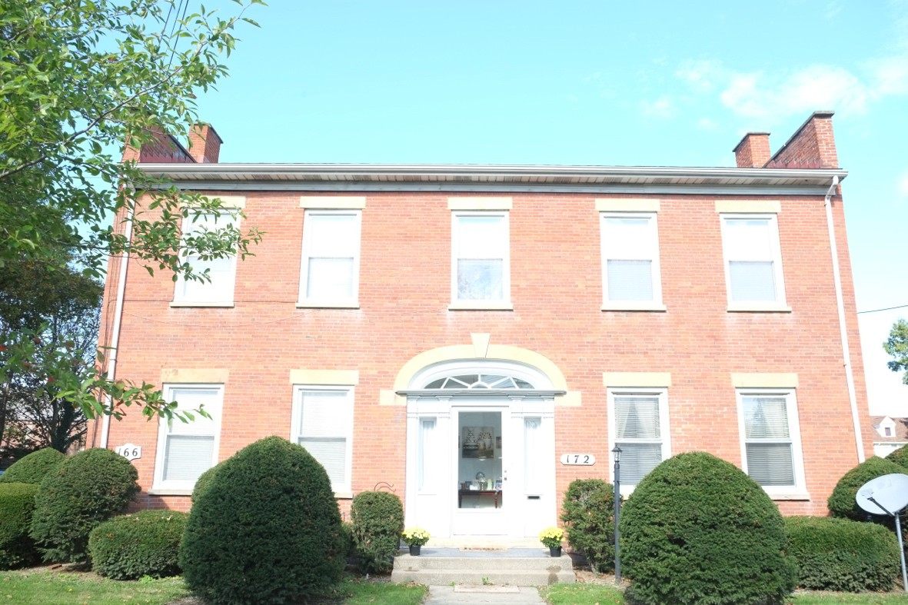

Photograph 8: 172 Main Street East, view north
Several excellent examples of mid-nineteenth century architectural style survive in the district. A vernacular interpretation of the Italianate style, 18 Main Street East (ca. 1855, Photo 3) features a wide eave overhang with single decorative brackets and pedimented window hoods.^{cxxxiv} A Greek Revival style building with Italianate updates, 138-140 Main Street West (ca. 1855) contains a wide front gable roof with overhanging eaves and single Italianate brackets (Photo 4). The trim band features dentils and modillions, typical of the Greek Revival style. Pedimented window crowns, typical of the Italianate style, are featured on the second floor of the main block.^{cxxxv} Another example of the Italianate style from this period is 65-71 Main Street (ca. 1865, Photo 9).
This building features upper story windows headed by round arches with projecting keystones and richly profiled moldings. A horizontal stone belt course separates the first from second floor.^{cxxxvi} The only example of the Gothic Revival style in the district can be found at 48 Main Street East, the First Methodist Episcopal Church (1868, Photo 10). The church creates a picturesque effect by its utilization of variety, irregularity, and contrasts and features many elements of the style: front-facing gable; round-arch windows; and a bell tower. Its tower with belfry is an important symbol as a design element. Additionally, the use of quatrefoil, stepped buttresses on the front and side elevations and a deeply recessed opening at the entrance are all signatures of the style.cxxxvii

^{cxxxiv} McAlester, A Field Guide To American Houses, 284.
^{cxxxv} McAlester, A Field Guide To American Houses, 248, 284.
^{cxxxvi} Carole Rifkind, A Field Guild to American Architecture, (New York: Penguin Group), 1989, 194.
^{cxxxvii} Rifkind, A Field Guild to American Architecture, 138.

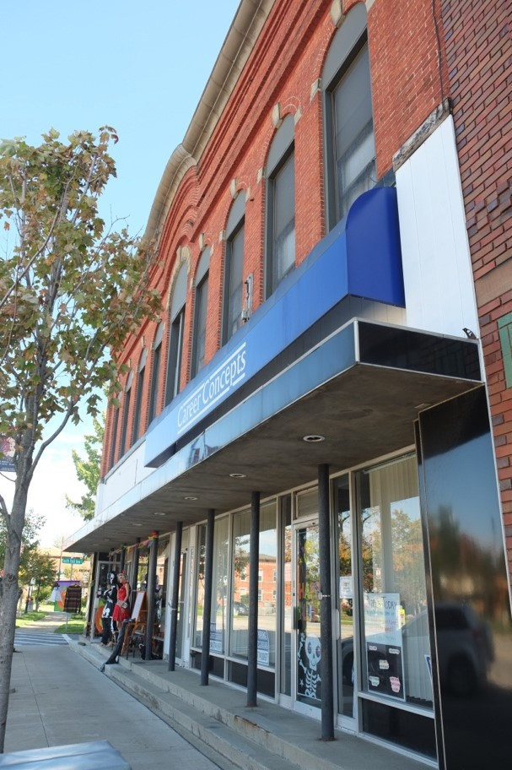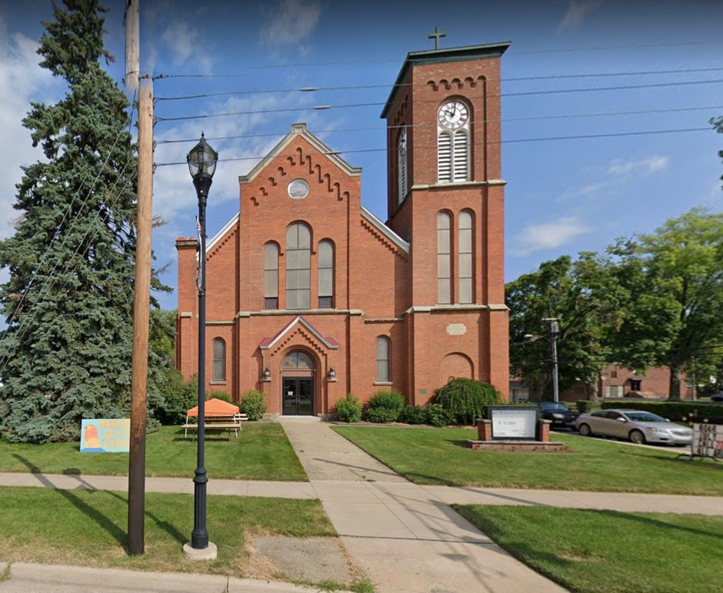

Photo 9 (left): 65-71 Main Street West, view southeast | Photo 10 (right): 48 Main Street East, view north
There are also several commercial buildings constructed in various architectural styles during the late nineteenth century. The Italianate style continued to dominate and can be seen at 146-150 Main Street West (ca. late 1800s, Photo 11), 202 Main Street West (ca. late 1800s, Photo 12) and 209-217 Main Street West (ca. 1886, Photo 13). Characteristic features employed in one or more combinations in these buildings include bracketed cornices with trim bands that feature either panels or molding as well as tall windows with flat or segmental arches. cxxxviii

^{cxxxviii} McAlester, A Field Guide To American Houses, 284.

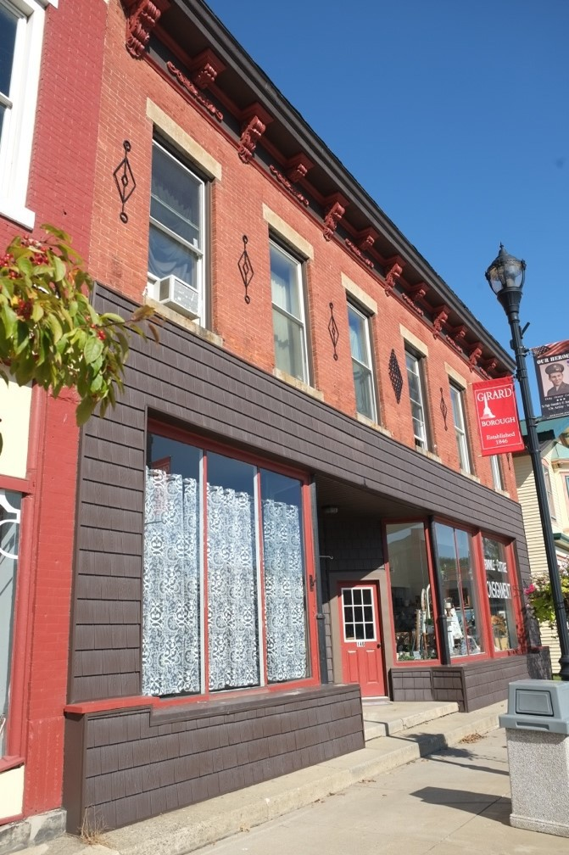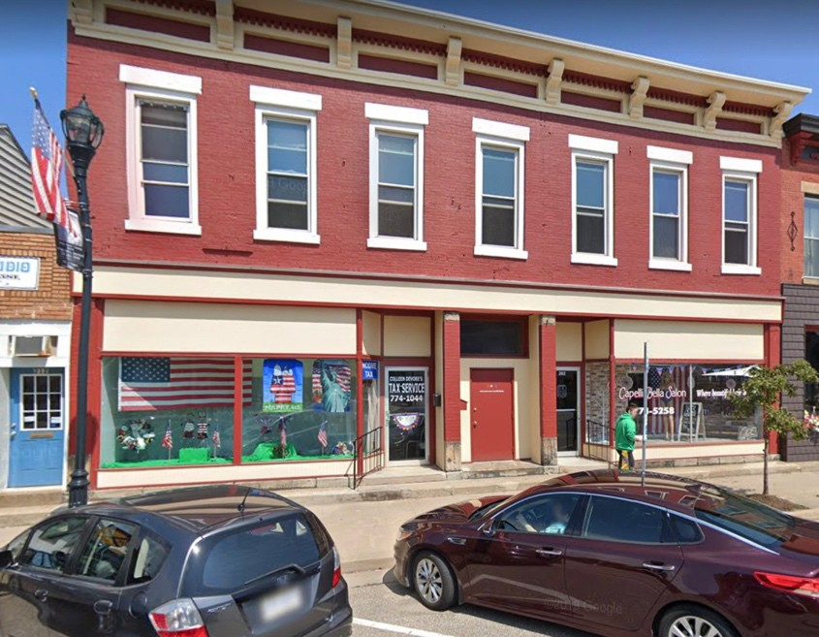

Photo 11 (left): 146-150 Main Street West, view northeast | Photo 12 (right): 202 Main Street West, view north
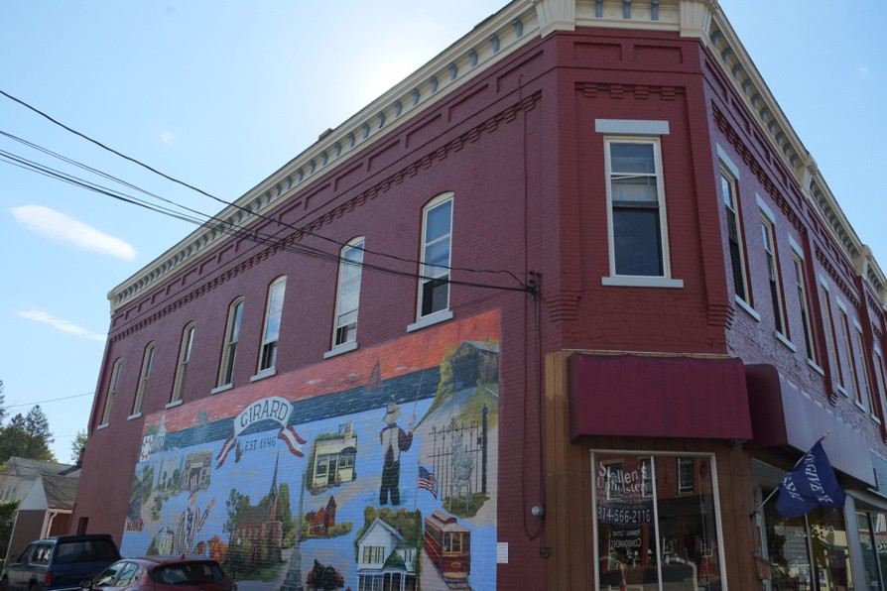
Photo 13: 209-217 Main Street West, view southwest
Two Romanesque Revival style buildings were constructed at 8 and 12 Main Street East (Photos 14 and 15) in 1893. This style depends on the heaviness, solidity, and ruggedness of brick and stone masonry, massive low arches and imaginative towers, turrets, and dormers. Heights generally range from five to six stories.^{cxxxix} These

^{cxxxix} Rifkind, A Field Guild to American Architecture, 195.

two smaller scale buildings both employ heavy brick construction, round-arch windows with stone lintels on the first floor and flat arch stone lintels on the second floor, and intricate stone patterns on the facade.

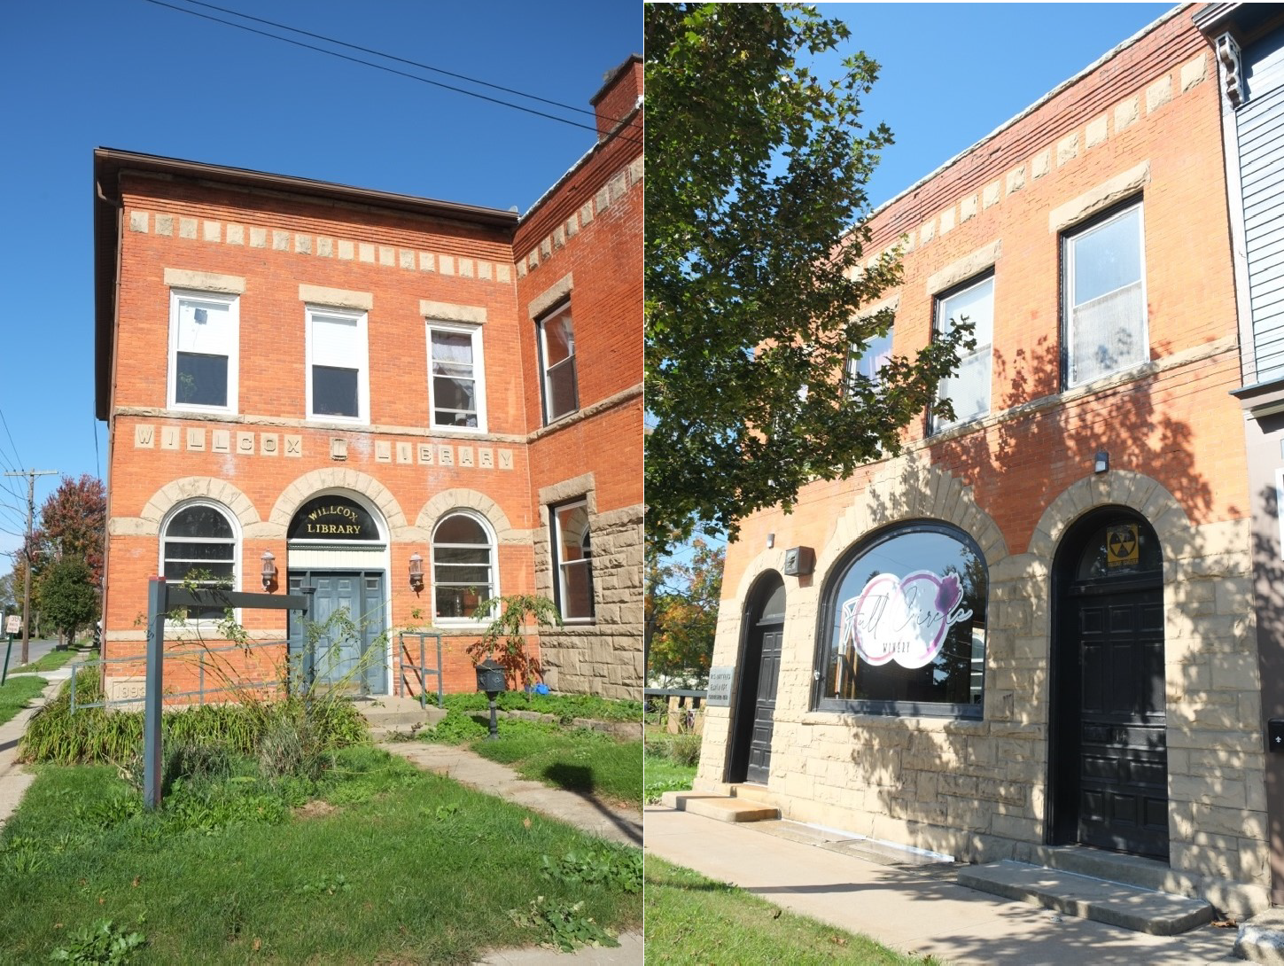

Photo 14 (left): 8 Main Street East, view north | Photo 15 (right): 12 Main Street East, view northwest
From 1900 to the 1940s, Main Street’s rising prominence as a commercial thoroughfare is reflected in its architecture. Commercial retailing was booming at this time, thanks in part to the railroad and later, the automobile. Stylistic trends that were popularly applied to commercial architecture across the United States in the early twentieth century reflect an emphasis on Classical Revival styles.^{cxl} Buildings designed in these styles are stately, notable for their weightiness, solidity, and pretentious figural and ornamental motifs.^{cxli} The earliest example of the Classical Revival style is 219-223 Main Street West (Photo 16) constructed circa 1900. The style’s formal symmetry and classical Greek and Roman decorative elements are evident in this building with its pilasters featuring Corinthian capitals that separate the bays as well as decorative facade elements such as floral and geometric patterning. This is the only building in the district that is clad in ornamental sheet metal.
Stamped sheet metal facades had begun to compete with the older cast iron versions in the 1880s and 1890s.

cxl Walter Richard Wheeler, “Downtown Genesee Historic District, City of Utica, Oneida County, New York,” National Register Nomination, May 10, 2018, Section 8, 92-93.
^{cxli} Rifkind, A Field Guild to American Architecture

Ornamental sheet metal was widely available and affordable. Manufacturers advertised their products in catalogs and took orders by telegraph and mail. Products were then distributed by rail, thus utilizing the whole infrastructure of mass communication and transportation that had transformed business practice in the United States during the second half of the nineteenth century.^{cxlii}
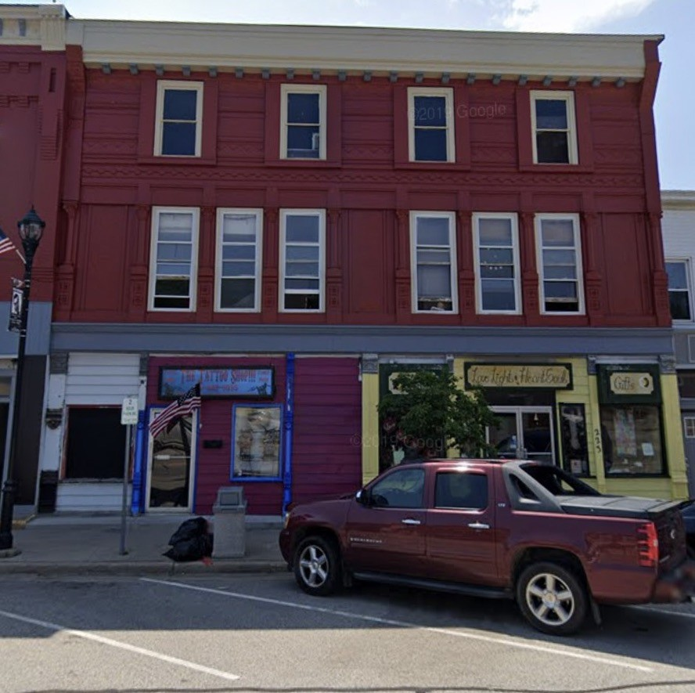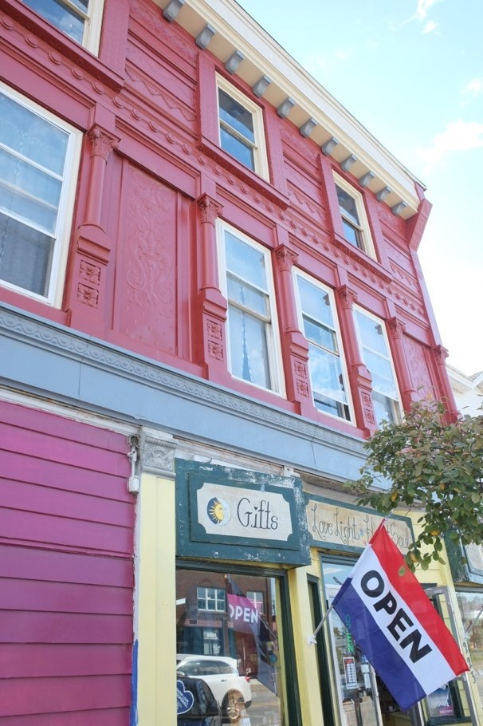

Photo 16 (left): 219-223 Main Street West, view south | Photo 17 (right): 219-223 Main Street West, detail, view southwest
An excellent example of the Dutch Colonial Revival style can be found at 142 Main Street East (Photo 18). Built in the early 1900s, this former residence features a side gambrel roof and a Palladian window in the half- story. Other decorative elements of the style include fluted Doric and Ionic columns and pilasters as well as dentils and modillions on the porch cornice and window surrounds on the first and second stories.^{cxliii} The Neoclassical style bank at 68 Main Street West (Photo 19) was constructed ca. 1915 and features a full-height short porch with a flat roof supported by classical Ionic columns. The façade shows symmetrically balanced windows and a center door with dentiled pediment supported by scrolled brackets. Round arches with keystones and engaged pilasters frame the windows on the front and side elevations of the building.

^{cxlii} Pamela H Simpson, “Ornamental Sheet Metal in the United States, 1870-1930,” Journal of Architectural and Planning Research
11, no. 4, Locke Science Publishing company, Inc., 1994, pp.294-310, http://www.jstor.org/stable/43029135.

^{cxliii} McAlester, A Field Guide To American Houses, 410-419.

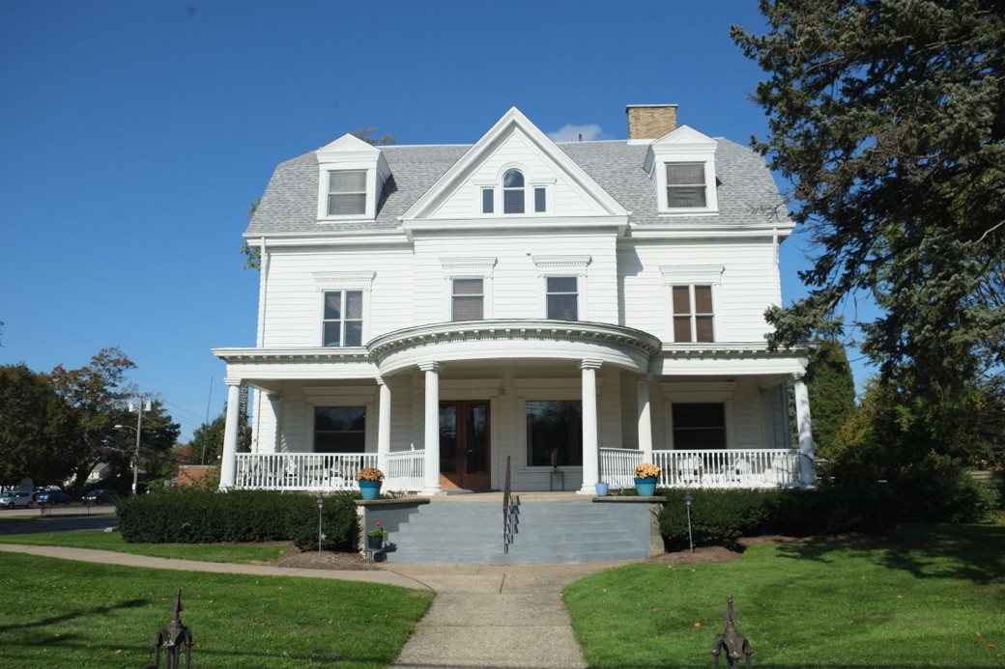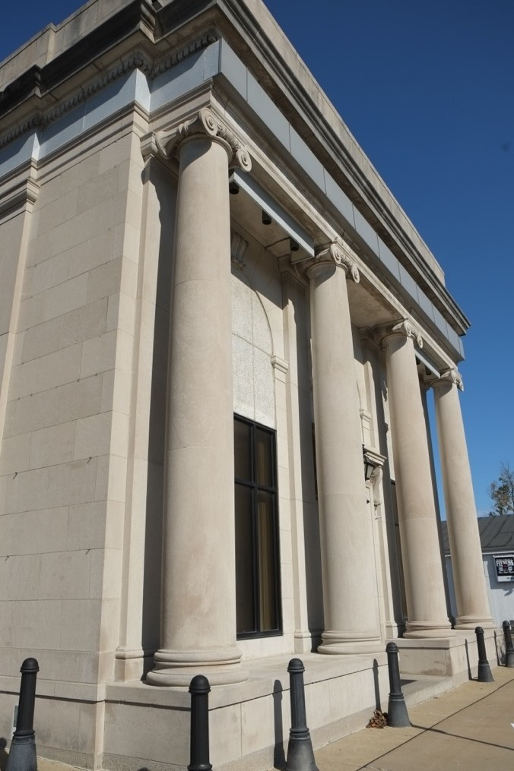

Photo 18 (left): 142 Main Street East, view north | Photo 19 (right): 68 Main Street West, view northeast
Two later examples of the Colonial Revival style are a commercial building at 11 Main Street West (Photo 20) built in the early 1940s and the Post Office at 113 Main Street East (Photo 21) constructed in 1941. As in earlier prototypes, the principal elaboration in these buildings are entrances, cornices and windows.^{cxliv} Elements of the style featured on both buildings are symmetrical facades and elaborate entrances. Additionally, the Post Office employs decorative brick at the cornice line as well as inset windows with segmental brick lintels.

cxliv McAlester, A Field Guide To American Houses, 412.

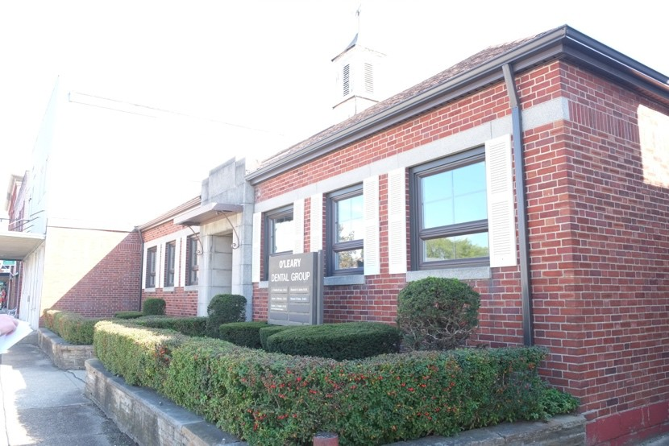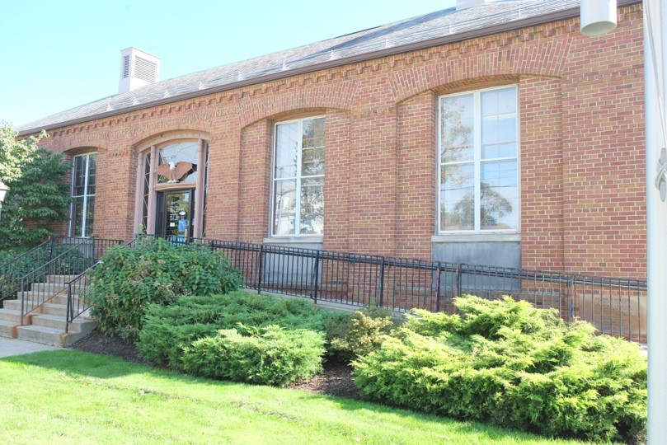

Photo 20 (left): 11 Main Street West, view southeast | Photo 21 (right): 113 Main Street East, view southeast
There are also several excellent examples of early twentieth-century commercial style buildings in the district. One to four story brick buildings dating from this era have large pane windows on the ground floor and flat roofs, frequently with decorative parapets.^{cxlv} Lutz Garage, a former automotive sales and service shop at 66 Main Street West (Photo 2) was constructed circa 1920. It is representative of the one part commercial block popular in the late nineteenth and early twentieth centuries in small cities. Lutz Garage is a one-story multi- colored brick rectangular building with an ornate façade featuring a clipped gable parapet capped in stone and copper and flanked by stone-capped brick piers. Its distinctive facade features a central oval panel inlayed with stone above two rectangular stone panels that define the large pane storefront windows below. Another more austere example of the one-story commercial block is 238 Main Street West (Photo 22) constructed circa 1920s. This one-story rectangular brick building features a flat stone-capped parapet on the front elevation and a stepped parapet on the west elevation. Decorative brick frames a panel above the storefront as well as a soldier course of brick above the large pane windows below.
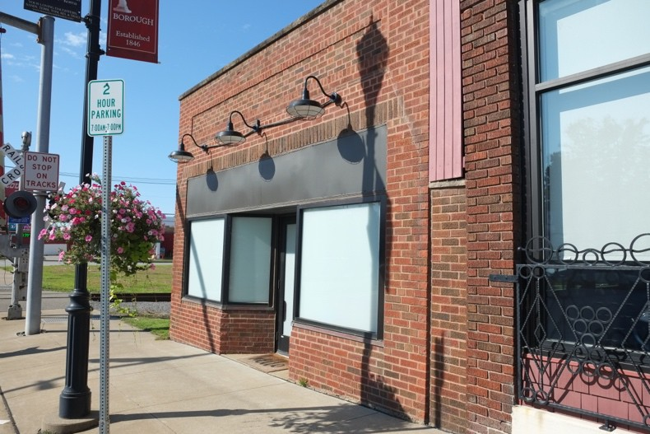
Photo 22 (right): 238 Main Street West, view southwest

^{cxlv} “Commercial Style 1890-1920 |PHMC>Pennsylvania Architectural Field Guide,” accessed January 21, 2022, http://www.phmc.state.pa.us/portal/communities/architecture/styles/commercial.html.

Although most prevalent from 1930 into the 1960s, the influence of the International Style continued long after its period of popularity. Schools and churches were common building types for this style. Elements of the International style are featured in the two latest contributing buildings in the district. The school addition of the First Methodist Episcopal Church (1955, Photo 23) and St. John the Evangelist Church (1945, Photo 24) both utilize flat roof lines, rectangular forms, cantilevered projections over the entrances, and an overall lack of ornamentation.

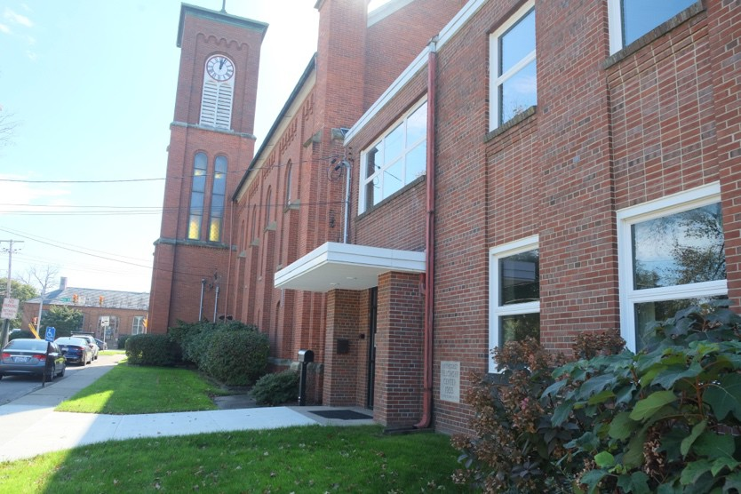

Photo 23 (left): First Methodist Episcopal Church School addition, 48 Main Street East, view southwest |
Photo 24 (right): St. John the Evangelist Church, 101 Olin Avenue, view, northeast
Overall, the Girard Historic District contains significant examples of a number of styles that fall within the period of significance from the nineteenth through mid-twentieth century.

Conclusion
The Girard Historic District has throughout its history served as an important commercial corridor for the Borough of Girard. It possesses a high level of visual and architectural integrity and continues to reflect its historic identity as the western commercial core of the Township of Girard. The historic district retains the scale, massing, and architectural details characteristic of a small, early nineteenth to mid-twentieth-century business district in Erie County, Pennsylvania. Together, the buildings in the district embody the history of the community from 1825 to 1955 – its period of significance – including the development of the district beginning with the construction of the town’s first extant historic building in 1825, its subsequent incorporation in 1846, through mid-century with the last major development project, the addition of a school to the First Methodist Episcopal Church at 48 Main Street East in 1955. As a group, the buildings represent the commercial history of the district from the construction of the first extant building to the end of its community development era.
Buildings and associated landscapes within the district offer examples of major architectural styles and planning approaches current at different times, including commercial and retail buildings constructed during Girard’s
late-nineteenth and early-twentieth-century transportation and commercial heyday, civic-minded projects from the late nineteenth century, less architecturally distinguished structures from the city’s post-industrial period after World War II, and the variations on Modernism. As a group, these structures represent the public face of the district as known and recognized by its citizens and chart the progress of local commerce and the architecture during that period.

- Major Bibliographical References Bibliography (Cite the books, articles, and other sources used in preparing this form.)
1822 Map of Erie and Crawford Counties. Accessed January 11, 2022. http://www.phmc.state.pa.us/bah/dam/rg/di/r17- 534WhitesideMaps/r017_0534_0000_3357_ErieAndCrawfordCounties.pdf.

“About EG-Emsco Group.” Accessed December 22, 2021. https://www.emscogroup.com/about-eg-main.

American Agriculturist Farm Directory and Reference Book of Erie County Pennsylvania, 1918.
Chicago: Orange Judd Company, 1918.

“Barbershop claims to be county’s oldest,” article from unspecified newspaper in Girard Town archives, October 27, 2001.

Beers, F.W. Atlas of Erie County, Pennsylvania. New York: F.W. Beers, A.D. Ellis & G.G. Soule, 1865. Map.

Booth, Jim “Girard: A community of winners.” Times-News, April 17, 1988.

Casselman, Barry. “Back in the Day: Erie’s Circus History. Erie Reader, August 9, 2013.

Chace, J, O. McLeran, and Isaac W. Moore. Map of Erie County, Pennsylvania; from actual surveys. Philadelphia: O. McLeran: Isaac W. Moore, 1855. Map. https://www.loc.gov/item/2012592169/.

Claridge, John R. Historic Resource Survey of Erie County: Girard Historic District. Erie, Pennsylvania: Erie County Historical Society, January 1987.

Commercial Style 1890-1920 | PHMC>Pennsylvania Architectural Field Guide.” Accessed January 21, 2022. http://www.phmc.state.pa.us/portal/communities/architecture/styles/commercial.html.

“Community Gem: Girard Dinor.” Accessed January 17, 2017. https://www.erienewsnow.com/story/45366552/community-gem-girard-dinor.

Domowicz, Geoffrey. Girard and Lake City Through Time. Arcadia Publishing, 2017. Dowling, P.H. Map of Girard, 1876. www.ancestry.com.
Ellicott, Andrew. Survey of the Erie County Triangle, Erie, Pennsylvania, 1790.

Erie Daily Times, August 15, 1946.

Erie Extension Canal.” Erie Extension Canal, n.d. Accessed December 21, 2021. https://eriehistory.blogspot.com/2017/04/erie-extension-canal.html.

Esperdy, Gabrielle. Modernizing Main Street: Architecture and Consumer Culture in the New Deal. University of Chicago Press: Chicago) 2008.

Francaviglia, Richard. Main Street Revisited. Iowa City: University of Iowa Press, 1996.

French, Shirley R. National Register of Historic Places Nomination: Girard Historic District, Erie County, Pennsylvania. Girard, PA, December 30, 1987.

“George W. Kibler, Sr. (1852-1937) Buried in Girard Cemetery Located in Girard, PA| People Legacy.” Accessed January 14, 2022.
https://peoplelegacy.com/george_w_kibler_sr-0N3M4t.

“Girard Boasts Numerous Historical Resources.” Erie County, August 11, 1948. “Girard, PA Population.” Accessed January 26, 2022. https://population.us/pa/girard/.
“Girard Wrench Mfg. Co.| Tool Archives.” Accessed January 14, 2022. https://toolarchives.com/node/149.

Gwindle. “About.” Girard Borough, Erie County, Pennsylvania, n.d. Accessed December 20, 2021.
https://girardborough.com/about/.

“History & More.” Accessed December 21, 2021. https://girardlakecity.org/history.

“History of Rural Telecommunications.” NTCA – The Rural Broadband Association. Accessed January 26, 2022.
https://www.ntca.org/ruraliscool/history-rural-telecommunications.

“History of the Trail – Nickel Plate Trail,” n.d. Accessed January 25, 2022. https://www.nickelplatetrail.org/about-the-nickel-plate-trail/history-of-the-trail/.

“Index of/Prod2/Decennia/Documents.” Accessed December 22, 2021. https://www2.census.gov/prod2/decennial/documents/.

Jack, Walter. “Girard, Rich in Traditions.” The Erie Motorist, February 1946.

Kelley, John. “Many Famous Personages Born in Little Borough.” Girard Centennial,
January 16, 1932.

Longstreth, Richard. The Buildings of Main Street: A Guide to American Commercial Architecture. California: AltaMira Press, 1987.

McAlester, Virginia Savage. A Field Guide To American Houses: The Definitive Guide to Identifying and Understanding American’s Domestic Architecture. New York: Alfred A. Knopf, 2013.

“Monkey Wrenches: Part IV.” Tooling Around the Matheson History Museum.
Accessed January 14, 2022. http://mathesontools.weebly.com/1/post/2015/10/monkey-wrenches-part-iv.html.

Nickel Plate in the Erie Triangle.” Nickel Plate Road Magazine, Fall, 2015. Accessed January 25, 2022.
https://static1.squarespace.com/static/5be23b9196d455a4b380589c/t/5e20cbcf599a244d6ba5409c/1579 207650426/NKPM+2015-4+Falll+rez+for+web.pdf.

“Odd Fellows.” Independent Order of Odd Fellows, September 29, 2017. Accessed January 26, 2022.
https://odd-fellows.org/about/odd-fellows/.

“Pennsylvania Highways: Interstate 90.” Accessed December 28, 2021. https://www.pahighways.com/interstates/I90.html.

Pennsylvania, U.S., Land Warrants and Applications, 1733-1952. Erie, PA-1806.

“Post Office – Girard PA.” Living New Deal, n.d. Accessed January 18, 2022. https://livingnewdeal.org/locations/post-office-girard-pa/.

“Religion in Post-World War II America, The Twentieth Century, Divining America: Religion in American History, TeacherServe, National Humanities Center,” accessed January 25, 2021.
http://nationalhumanitiescenter.org/tserve/twenty/tkeyinfo/trelww2.htm.

Rifkind, Carole. A Field Guild to American Architecture. New York: Penguin Group, 1989. “Ryman Store The Oldest on Route 20.” Erie Daily Times, August 14, 1946.
Sanborn Fire Insurance Maps: 1898, 1904, 1912, 1929, 1938, 1948.

“Saint John the Evangelist – Girard, PA – Roman Catholic Churches on Waymarking.com.” Accessed January 4, 2022. https://www.waymarking.com/waymarks/wm12Z5T_Saint_John_the_Evangelist_Girard_PA.

Sanford, Laura G. The History of Erie County, Pennsylvania from its first settlement. Erie County: Laura G. Sanford, 1894.

Sanford, Laura G. The History of Erie County, Pennsylvania. Philadelphia: J.B. Lippincott & Co., 1862.

“Satellite Girard Map // USA, Pennsylvania.” Accessed January 11, 2022. https://satellites.pro/Girard_map.Pennsylvania_region,USA#42.000920,-80.

Simpson, Pamela H. “Ornamental Sheet Metal in the United States, 1870-1930.” Journal of Architectural and Planning Research 11, no. 4, Locke Science Publishing company, Inc.,
1994. http://www.jstor.org/stable/43029135.

“ THE 347 – Past Masters.” Accessed January 17, 2022. https://www.lakeerielodge347.com/past-masters.

“The Battles Bank: When Honesty Was Collateral and Chickens Paid the Interest.” Pennsylvania
Heritage Magazine. Accessed January 14, 2022. http://paheritage.wpengine.com/article/battles-bank- honesty-collateral-chickens-paid-interest/.
The History of Erie County. Chicago: Warner, Beers & Co., 1884. United States Federal Census, 1850-1940.
Wheeler, Walter Richard. “Downtown Genesee Historic District, City of Utica, Oneida County, New York.” National Register Nomination, May 10, 2018.

Previous documentation on file (NPS): Primary location of additional data:
preliminary determination of individual listing (36 CFR 67 has been State Historic Preservation Office requested) Other State agency
previously listed in the National Register Federal agency
previously determined eligible by the National Register Local government
designated a National Historic Landmark University

recorded by Historic American Buildings Survey #
recorded by Historic American Engineering Record #
recorded by Historic American Landscape Survey #
Other
Name of repository:

Historic Resources Survey Number (if assigned):

- Geographical Data

Acreage of Property 15.6 (Do not include previously listed resource acreage.)

UTM References
(Place additional UTM references on a continuation sheet.)

- 3
Zone Easting Northing Zone Easting Northing

- 4
Zone Easting Northing Zone Easting Northing

Verbal Boundary Description (Describe the boundaries of the property.)

The boundary is indicated by a heavy line on the enclosed map, Figure 2.
Boundary Justification (Explain why the boundaries were selected.)

The district boundaries are drawn to include the most intact stretch of buildings within the historic commercial core of Main Street in Girard Borough, a part of the Township of Girard that began settlement in the early- nineteenth century, twenty years after the opening of the Ridge Road (Route 20), linking Girard to New York and Ohio. The district is characterized by a great number of commercial buildings interspersed with a few religious, civic, and social buildings dating from the early-nineteenth to mid-twentieth century. In addition to the east-west spine of Main Street, the boundaries also take in an adjacent religious property on Olin Avenue which is similar to the Main Street resources in period, type and function.

- Form Prepared By

name/title Karen A. Kennedy, Director of Architectural History, Joseph Duggan, Associate Architectural Historian organization Preservation Studios date January 31, 2022 street & number 170 Florida Street telephone 716-725-6410 city or town Buffalo state NY zip code 14208
e-mail Info@PreservationStudios.com

Additional Documentation

Submit the following items with the completed form:

- Maps: A USGS map (7.5 or 15 minute series) indicating the property's location.

A Sketch map for historic districts and properties having large acreage or numerous resources. Key all photographs to this map.

- Continuation Sheets

- Additional items: (Check with the SHPO or FPO for any additional items.)

Photographs:

Submit clear and descriptive photographs. The size of each image must be 1600x1200 pixels at 300 ppi (pixels per inch) or larger. Key all photographs to the sketch map.

Name of Property:

City or Vicinity:

County: State:

Photographer:

Date Photographed:

Description of Photograph(s) and number: 1 of .

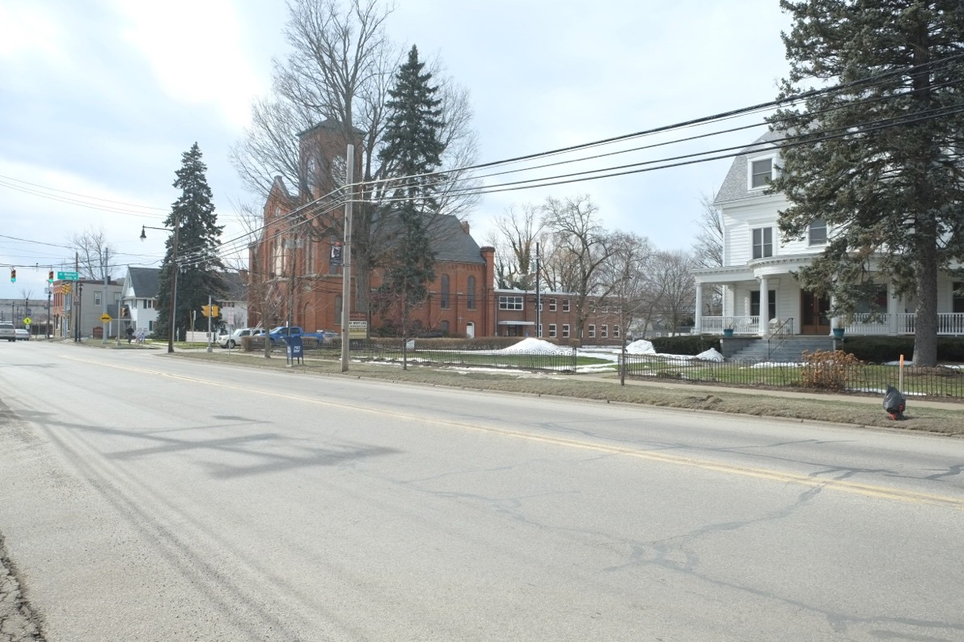

Photo 25: Main Street, north side, view northwest

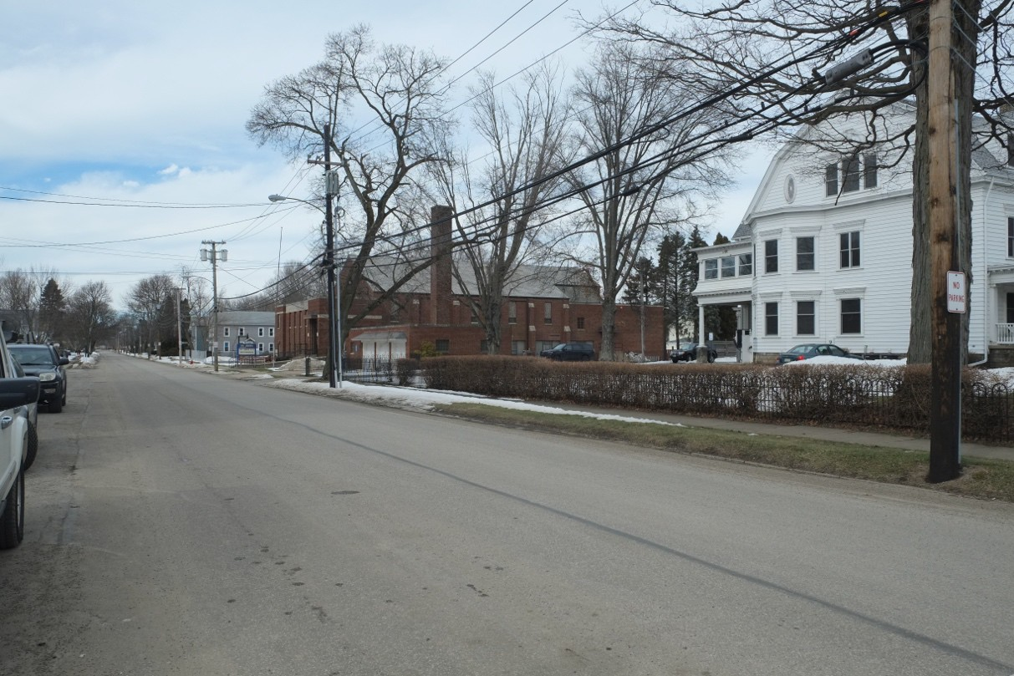
Photo 26: Olin Avenue, east side, view northeast

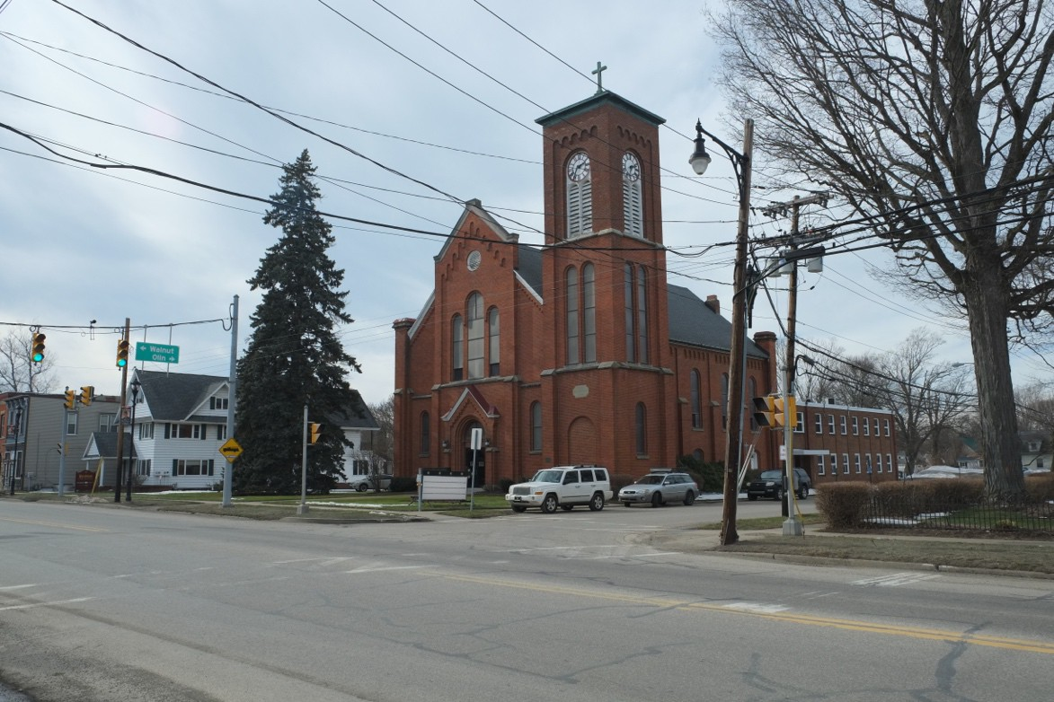
Photo 27: Main Street, north side, view northwest
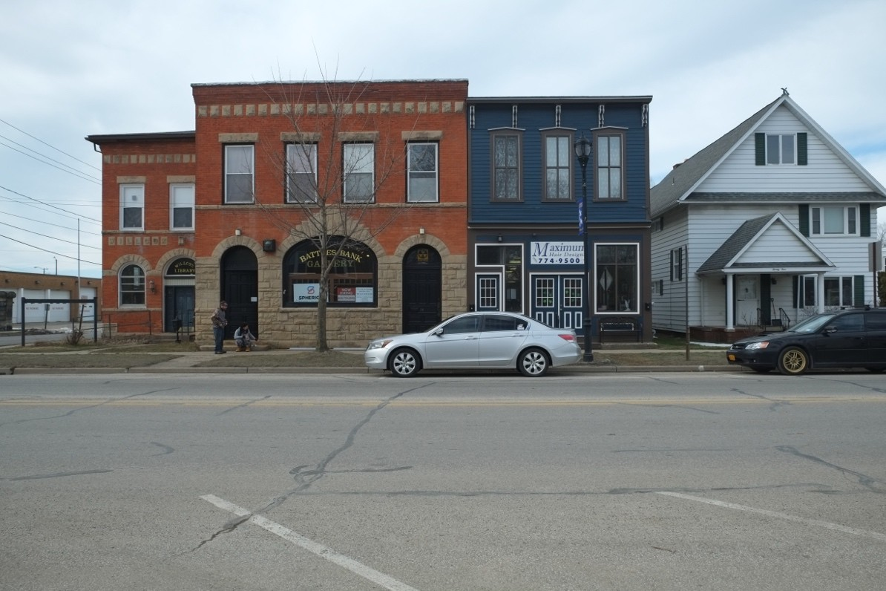
Photo 28: Main Street, north side, view north

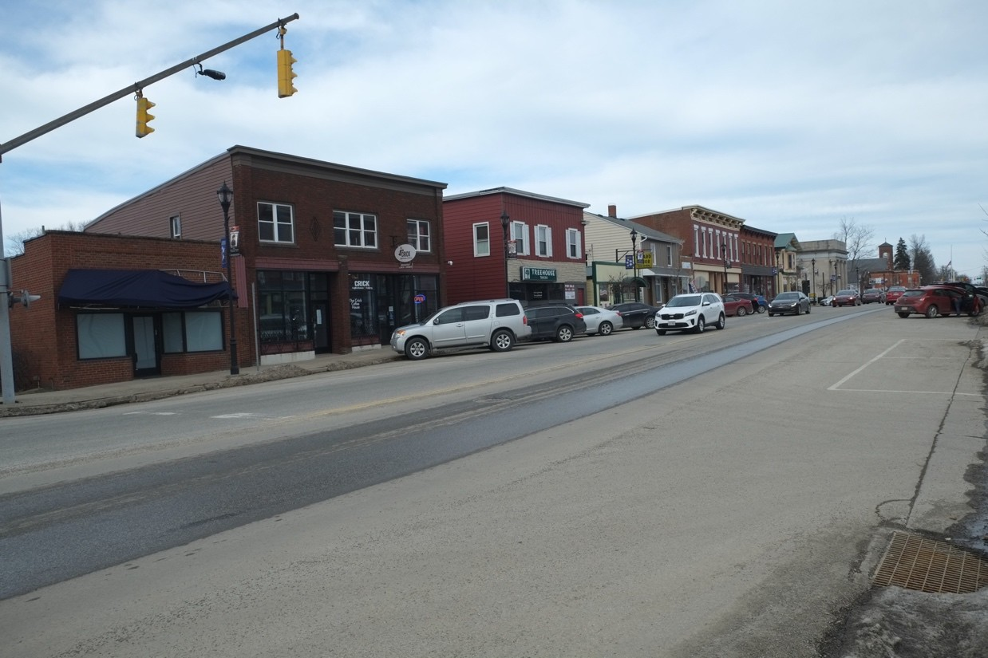

Photo 29: Main Street, north side, view northeast

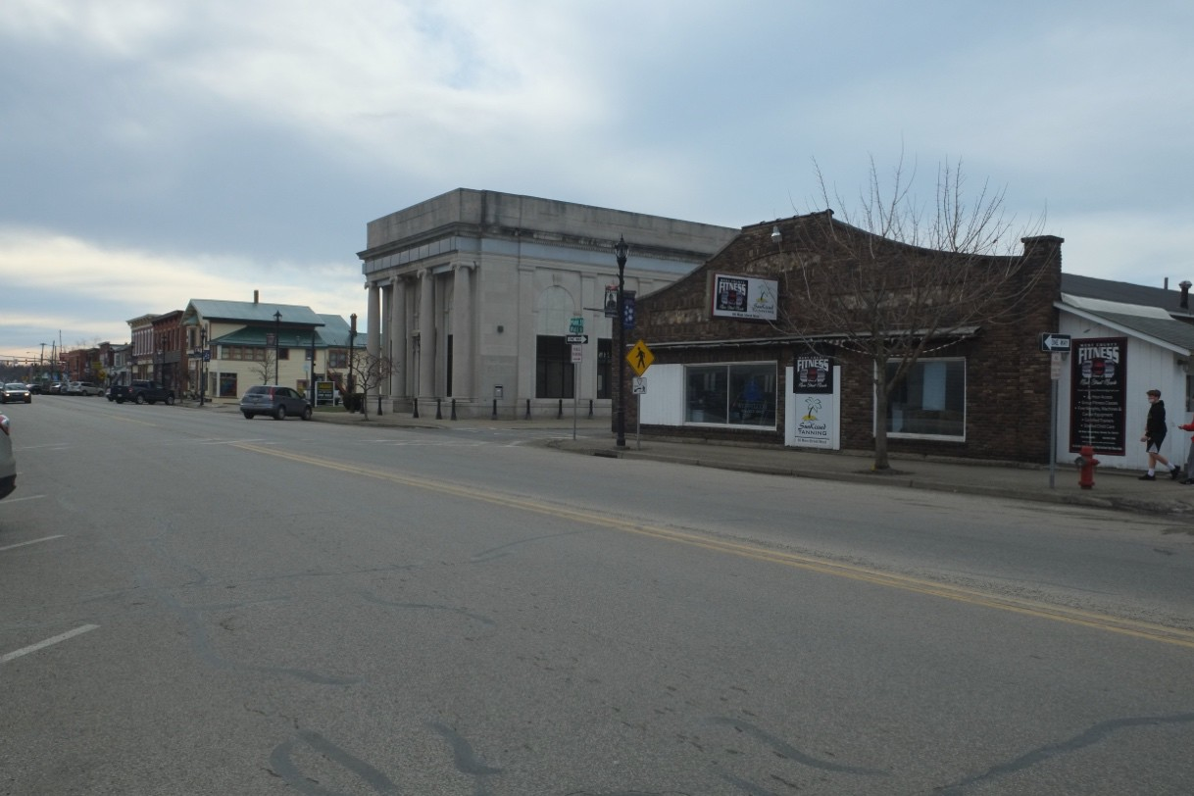

Photo 30: Main Street, north side, view northwest

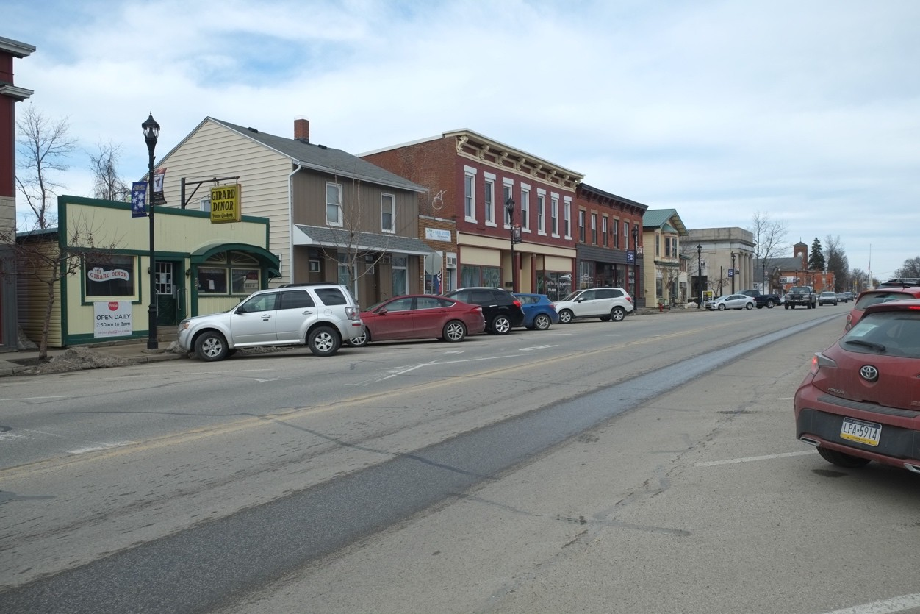
Photo 31: Main Street, north side, view northeast

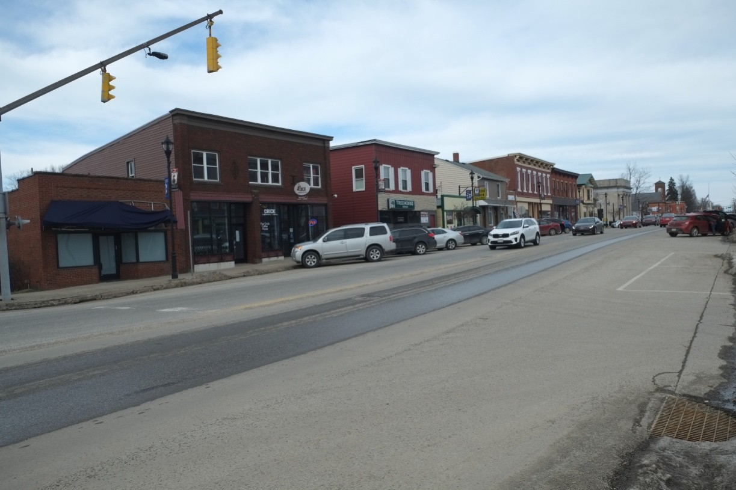

Photo 32: Main Street, north side, view northeast

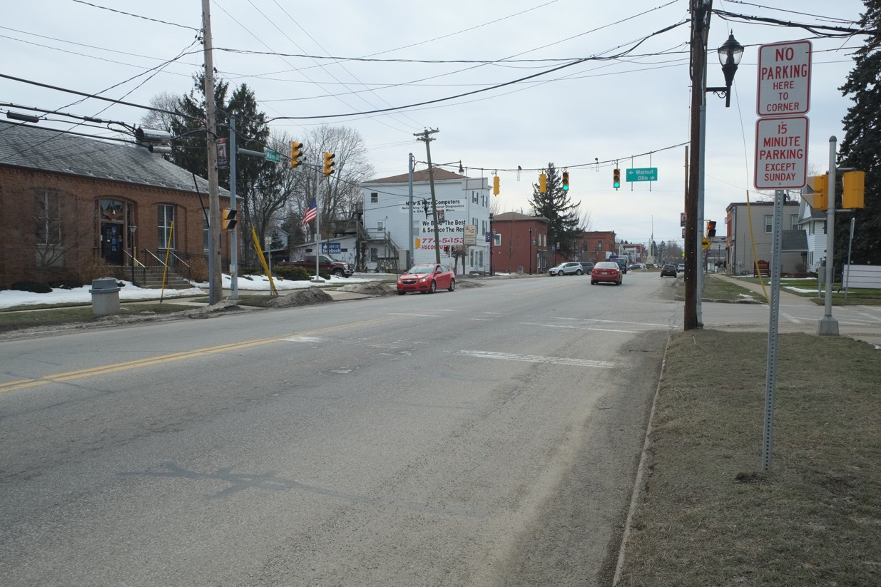

Photo 33: Main Street, south side, view southwest

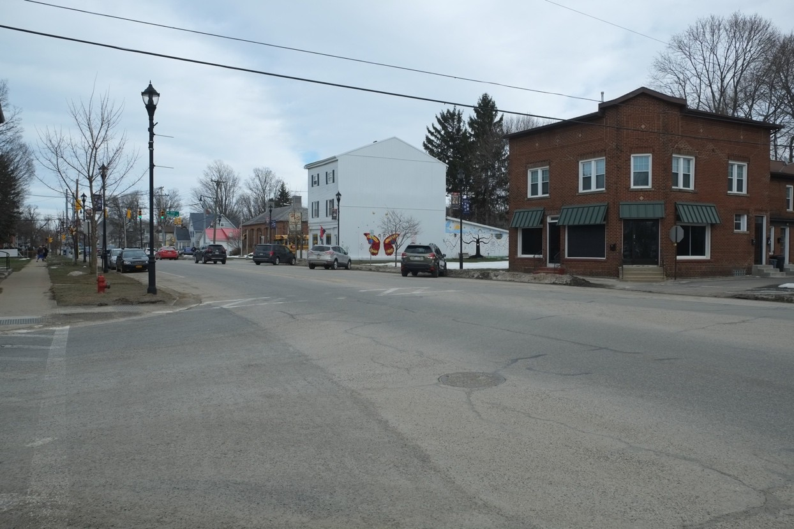

Photo 34: Main Street, south side, view southeast

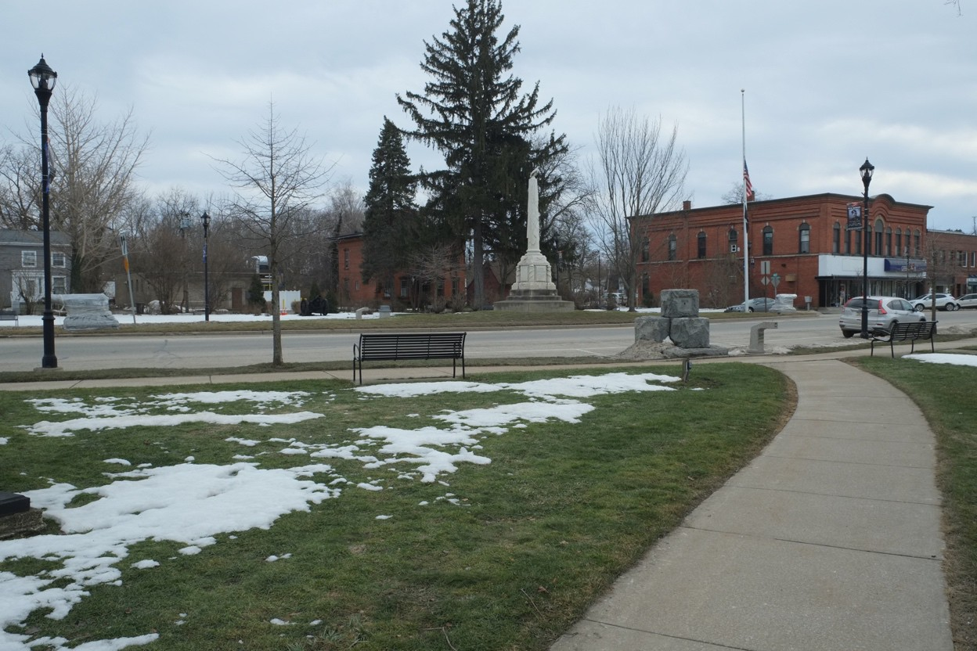

Photo 35 Main Street, south side, view southwest

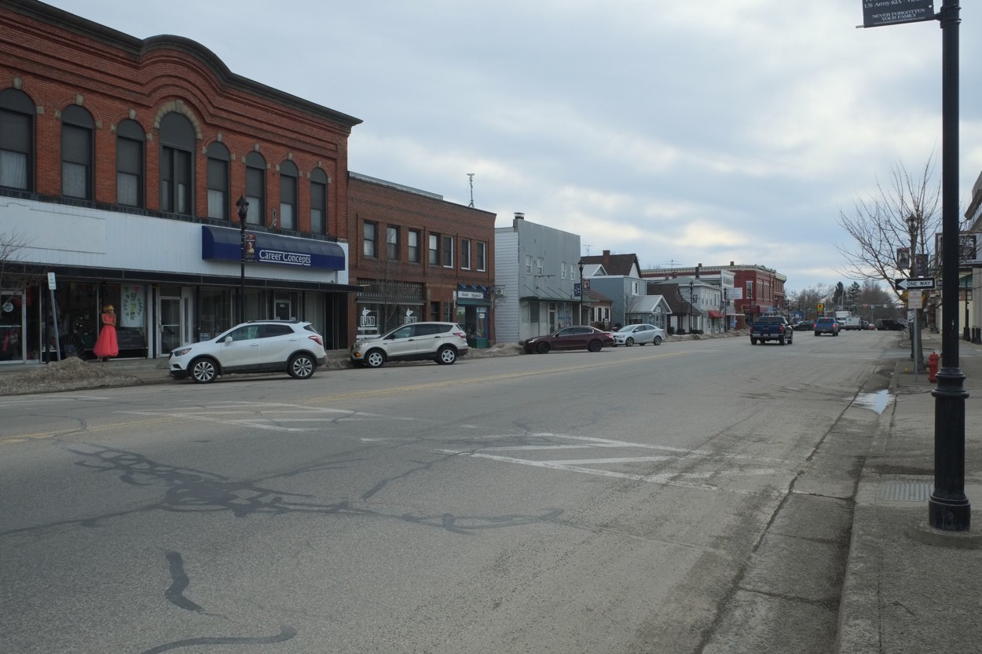

Photo 36: Main Street, south side, view southwest

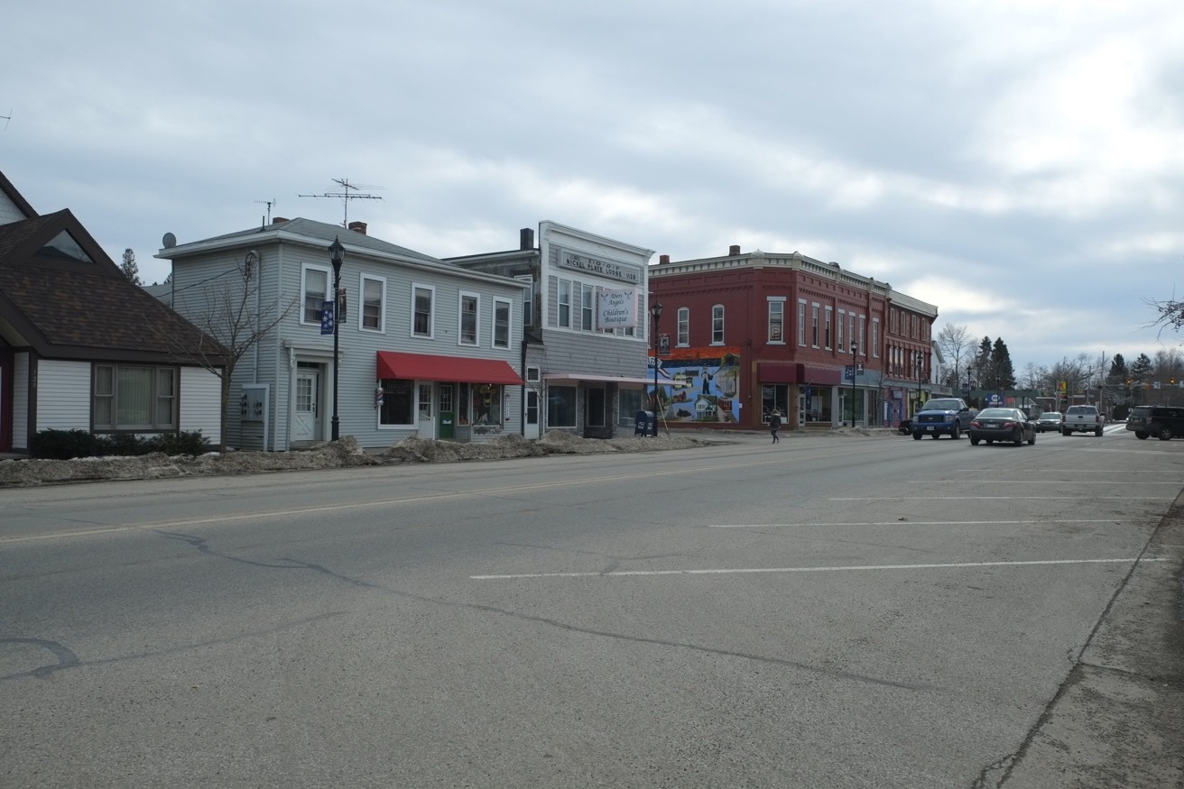

Photo 37: Main Street, south side, view southwest
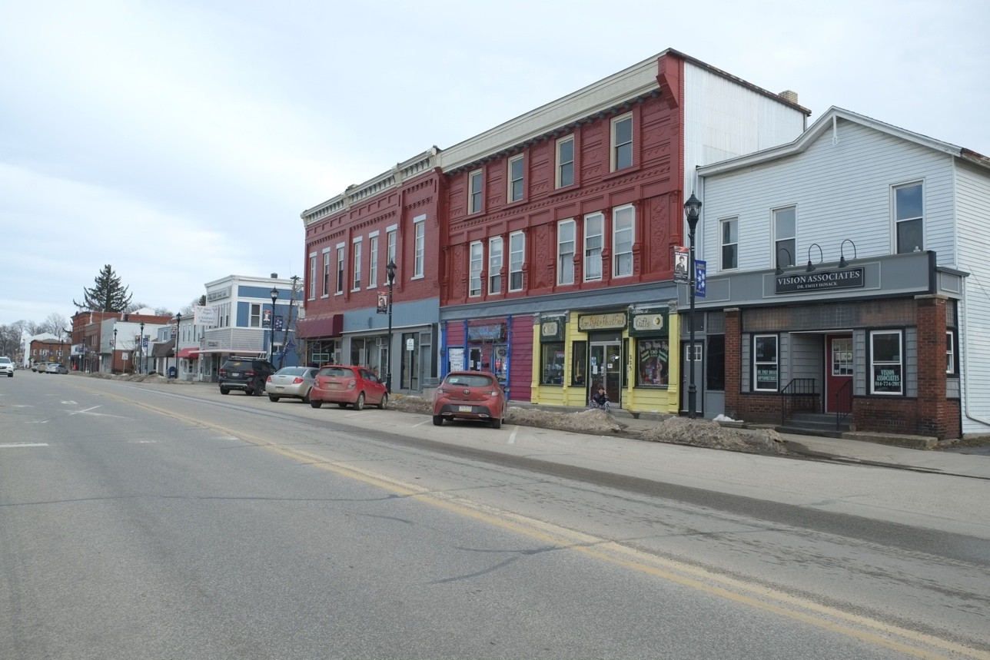

Photo 38: Main Street, south side, view southeast

Property Owner:
(Complete this item at the request of the SHPO or FPO.)

name N/A street & number telephone city or town state zip code

Paperwork Reduction Act Statement: This information is being collected for applications to the National Register of Historic Places to nominate properties for listing or determine eligibility for listing, to list properties, and to amend existing listings. Response to this request is required to obtain a benefit in accordance with the National Historic Preservation Act, as amended (16 U.S.C.460 et seq.).

Estimated Burden Statement: Public reporting burden for this form is estimated to average 18 hours per response including time for reviewing instructions, gathering and maintaining data, and completing and reviewing the form. Direct comments regarding this burden estimate or any aspect of this form to the Office of Planning and Performance Management. U.S. Dept. of the Interior, 1849 C. Street, NW, Washington, DC.

