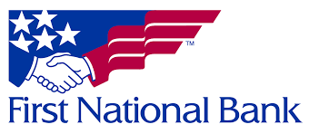
Shred Day
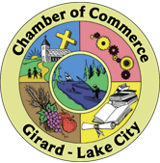
Sponsored by First National Bank
and
Girard-Lake City Chamber of Commerce
11AM to 2PM
June 10, 2023
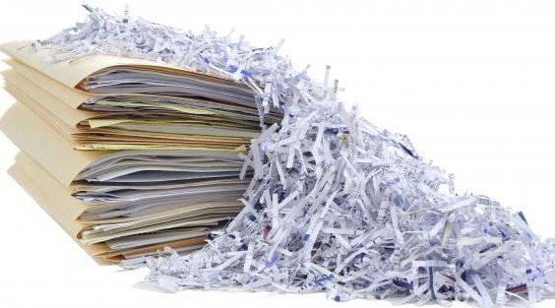
A F Dobler Hose & Ladder Company Grounds
Food Available
Donations Accepted
